Place and Wellbeing Assessment Checklist

Place and Wellbeing Outcomes

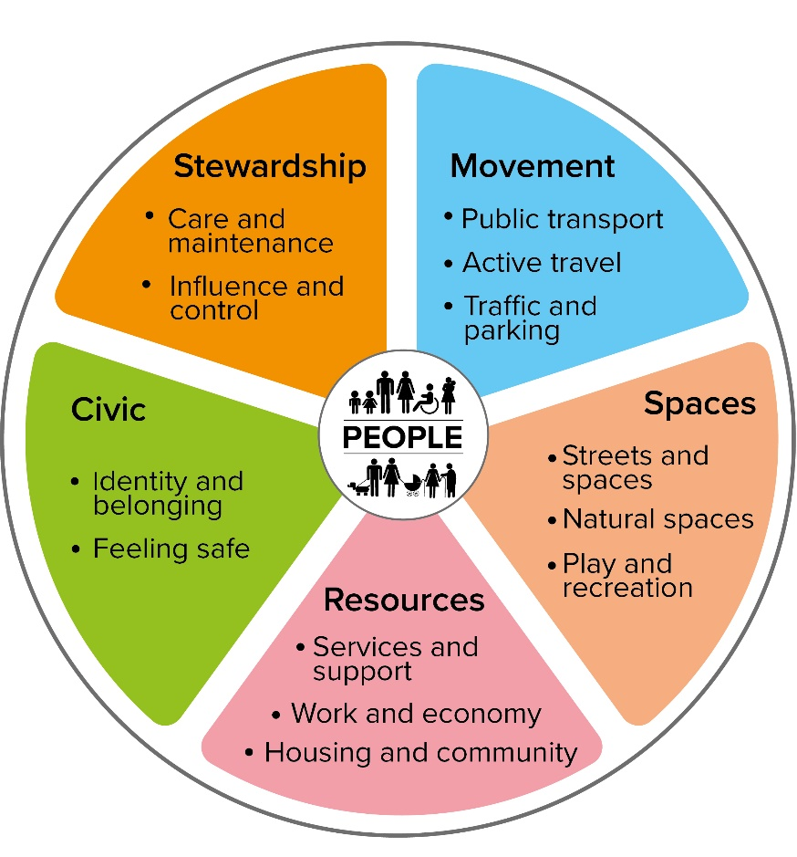

The Place and Wellbeing Outcomes are the evidenced features of what every place needs to enable those who live, work and relax there to experience wellbeing.

These Outcomes require all of the following to be considered:

Supporting the system | All of the themes become embedded in the right policies, plans and proposals both nationally and locally.
Equitable outcomes for all | All of the themes consider the needs of different populations and are applied in a way that ensures they achieve equal outcomes for all.
Climate change, sustainability and biodiversity | All of the themes take into account climate impacts in Scotland and globally and the need to achieve net zero greenhouse gas emissions as well as enhance broader environmental sustainability and biodiversity. All are applied in a way that contributes to both greater climate resilience and reduced emissions.

How will the proposal impact positively or negatively on these outcomes?
How will the proposal impact those most impacted by inequality?

 | Theme | Outcomes | How does the plan, policy or proposal contribute to the delivery of this outcome? | Is there an opportunity for the plan, policy or proposal to delivery more in this area?
Movement | Active Travel | Everyone can:  - Easily move around using good-quality, accessible, well-maintained and safe segregated wheeling, walking and cycling routes and access secure bike parking.  - Wheel, walk and cycle through routes that connect homes, destinations and public transport, are segregated from, and prioritised above, motorised traffic and are part of a local green network.
Movement | Public Transport | Everyone has access to a sustainable, affordable, accessible, available, appropriate, and safe public transport service.
Movement | Traffic and Parking | Everyone can benefit from:  - Reducing traffic and traffic speeds in the community.  - Traffic management and design, where traffic and car parking do not dominate or prevent other uses of space and car parking is prioritised for those who don’t have other options.
Spaces | Streets and Spaces | Everyone can access:  - Buildings, streets and public spaces that create an attractive place to use, enjoy and interact with others.  - Streets and spaces that are well-connected, well-designed and maintained, providing multiple functions and amenities to meet the varying needs of different population groups.
 | Natural Spaces | Everyone can:  - Access good-quality natural spaces that support biodiversity and are well-connected, well-designed, safe, and maintained, providing multiple functions and amenities to meet the varying needs of different population groups.  - Be protected from environmental hazards including air/water/soil pollution or the risk of flooding.  - Access community food growing opportunities and prime quality agricultural land is protected.
 | Play and Recreation | Everyone can access a range of high quality, safe, well-maintained, accessible places with opportunities for play and recreation to meet the varying needs of different population groups and the community itself.
Resources | Services and Support | Everyone can access:  - Health enhancing, accessible, affordable and well-maintained services, facilities and amenities. These are informed by community engagement, responsive to the needs and priorities of all local people.  - A range of spaces and opportunities for communities to meet indoors and outdoors.  - Information and resources necessary for an included life in a range of digital and non-digital formats.
 | Work and Economy | Everyone benefits equally from a local economy that provides:  - Essential goods & services produced or procured locally  - Good quality paid and unpaid work  - Access to assets such as wealth & capital and the resources that enable people to participate in the economy such as good health and education  - A balanced value ascribed across sectors such as female dominated sectors and the non-monetary economy
 | Housing and Community | Everyone has access to:  - Home that is affordable, energy efficient, high quality and provides access to private outdoor space.  - A variety of housing types, sizes and tenancies to meet the needs of the community. And of a sufficient density to sustain existing or future local facilities, services and amenities.  - A home that is designed and built to meet need and demand, is adaptable to changing needs and includes accessible/wheelchair standard housing.  - New homes that are located and designed to provide high levels of climate resilience and use sustainable materials and construction methods.  -Homes that are designed to promote community cohesion.
Civic | Identity and Belonging | Everyone can benefit from a place that has a positive identity, culture and history, where people feel like they belong and are able to participate and interact positively with others.
Civic | Feeling Safe | Everyone feels safe and secure in their own home and their local community taking account of the experience of different population groups.
Stewardship | Care and Maintenance | Everyone has access to:  - Buildings, spaces and routes that are well cared for in a way that is responsive to the needs and priorities of local communities.  - Good facilities for recycling and well organised refuse storage and collection.
 | Influence and Control | Everyone is empowered to be involved in a place in which:  -Local outcomes are improved by effective collaborations between communities, community organisations and public bodies.  -Decision making processes are designed to involve communities as equal partners.  -Community organisations co-produce local solutions to issues.  -Communities have increased influence over decisions.  -Democratic processes are developed to be accessible to all citizens.

