


Our Lettable Standard – A Guide for Perth and Kinross Council Tenants
May 2025

Author(s)
Perth and Kinross Council’s Housing Service

Approved by Housing Management Team
TBC

We want you to enjoy turning our property into your home. For our part, we commit that on moving day your new home will be:

- Subject to a Secure Tenancy Agreement
- Safe and secure
- Clean, cleared and ready to let

Please note: All our properties are let unfurnished with no floor coverings. You may also be expected to decorate the property.

That commitment to you is our Lettable Standard. This document sets out what our Lettable Standard means for you and your tenancy.

The Lettable Standard defines the condition that of properties before they are let. However, if there is a time when we get things wrong, the Lettable Standard helps us put it right for you.

We welcome your feedback – if you have any issues or concerns please contact your Locality Housing Team. (Contact details are available at the end of this guide).

We are responsible for ensuring that your property meets the necessary safety checks before the keys are handed over. This is a legal responsibility that the Council must comply with as a social landlord.

We will:
- Carry out an electrical check (including all smoke alarms).
- Carry out a Gas Safety Check
- Check for asbestos, ensuring any damaged asbestos is removed and our records are updated.

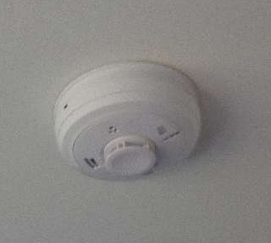

Smoke Alarm

In your kitchen we will:

- Ensure that there are no loose kitchen units/worktops.
- Repair any damage, or renew doors or drawers
- Ensure that surfaces are not scraped or chipped – so that they are hygienic for food preparation
- Repair/replace any hinges
- Repair/replace any handles
- Repair/replace any taps so they do not leak or drip
- Ensure that there is plumbing in place to connect a washing machine
- Ensure that there is enough room in the property for a fridge freezer (this could be an undercounter fridge with ice box or a tall fridge freezer).
- Ensure there is enough room for a standard size cooker. However, it is your responsibility to arrange the connection of your cooker (electric or gas) by a qualified tradesperson.
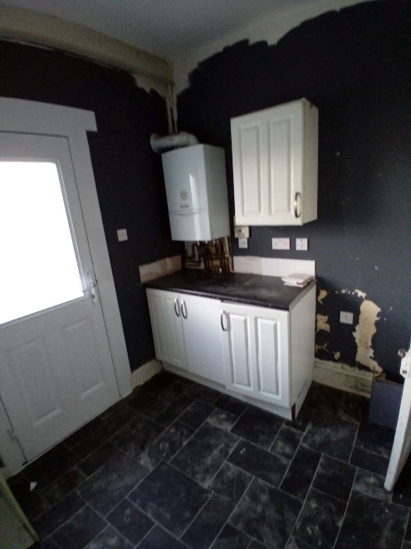
- Ensure that there is running hot and cold water
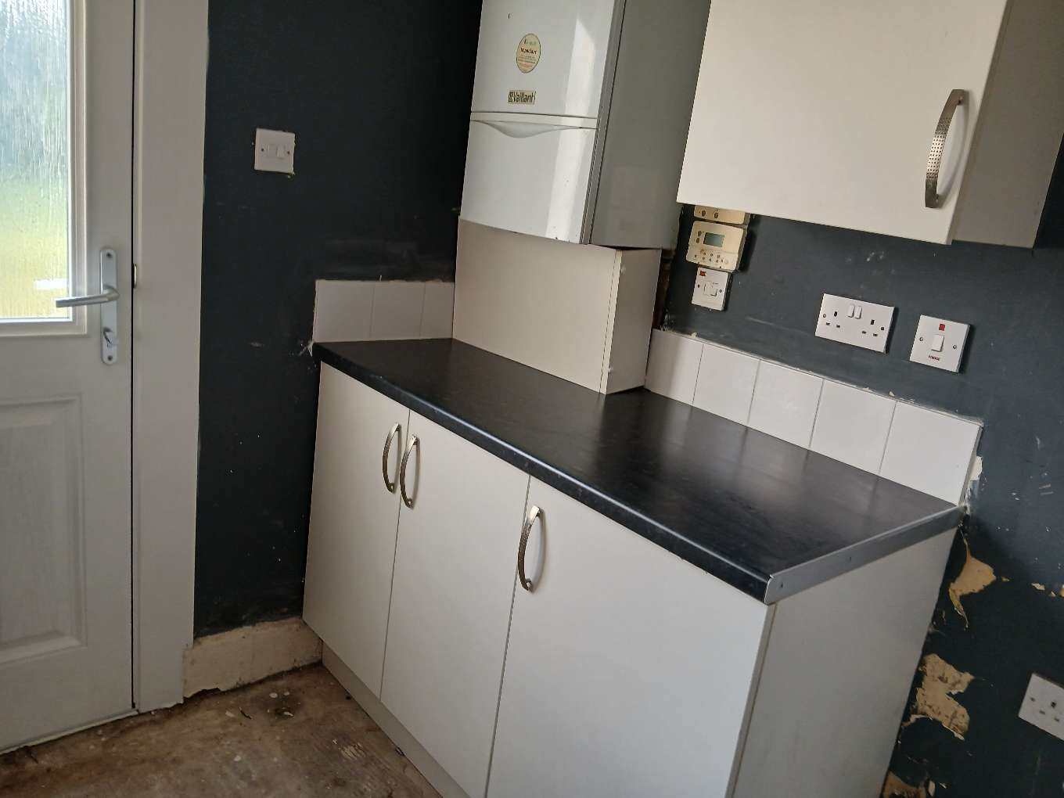



In your bathroom we will:
- Replace any sanitary-ware which is broken/cracked/heavily stained
- Repair any leaks to the supply and waste pipes which are evident at the time of inspection
- Replace missing or broken sink plugs or chains
- Fix any loose taps
- Ensure you have a working shower
- Ensure that you have a working toilet.
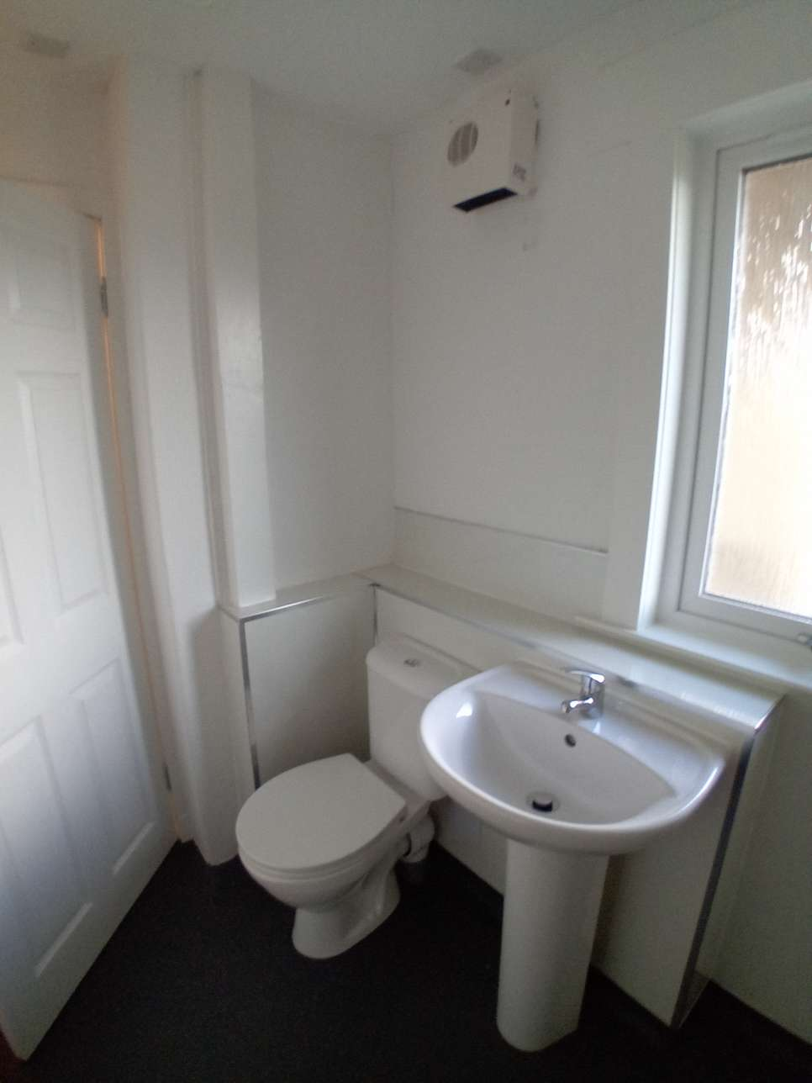
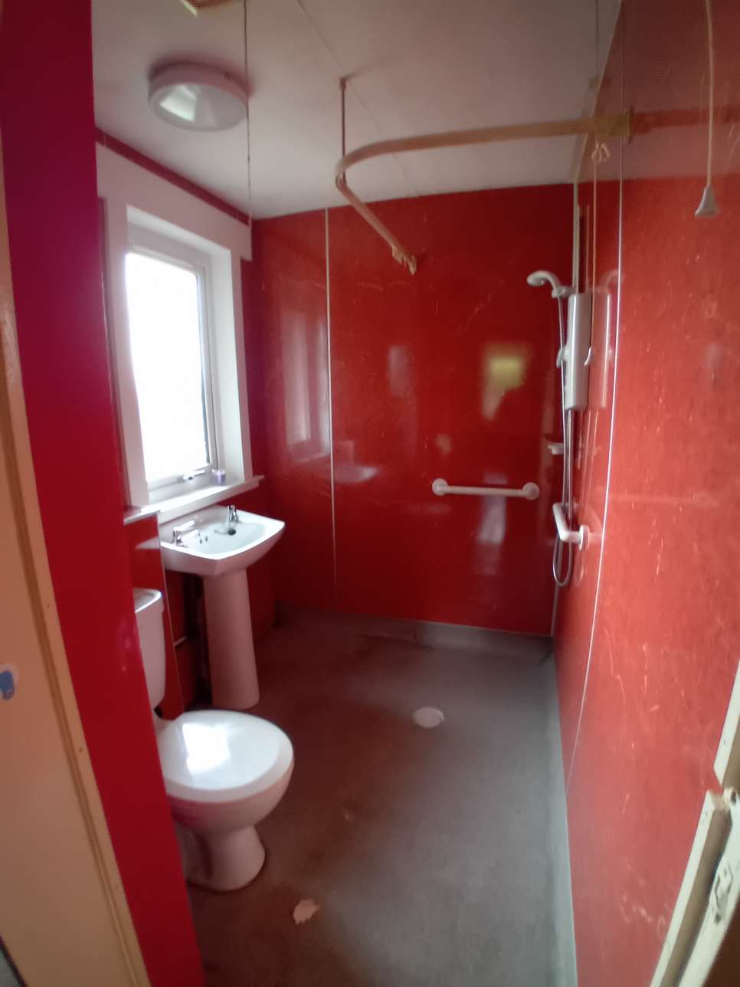

We will:

- Replace broken or cracked panes of glass
- Ensure that all windows are secure
- Ensure that all locks/safety mechanisms on the windows work
- Replace handles where they don’t work.
- Ensure that trickle vents work

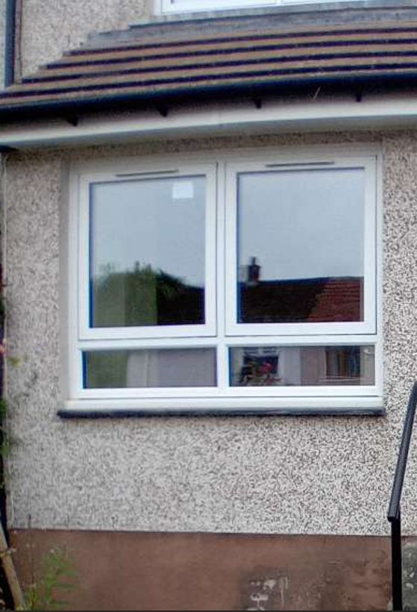
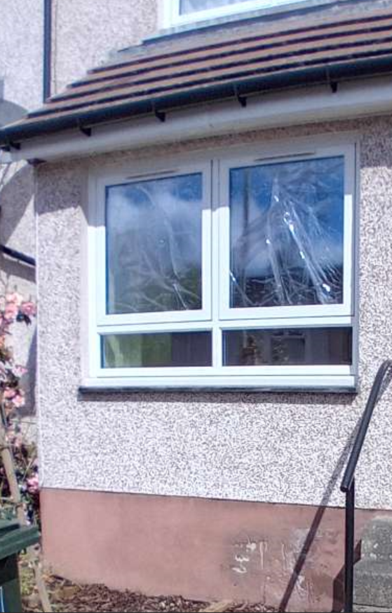

We will:

- Change all locks on all external doors
- Ensure that all doors can be opened and closed
- Repair or replace any damaged internal doors
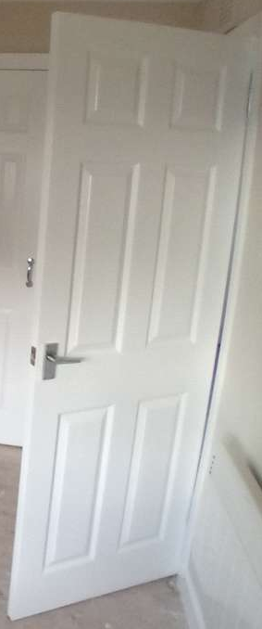
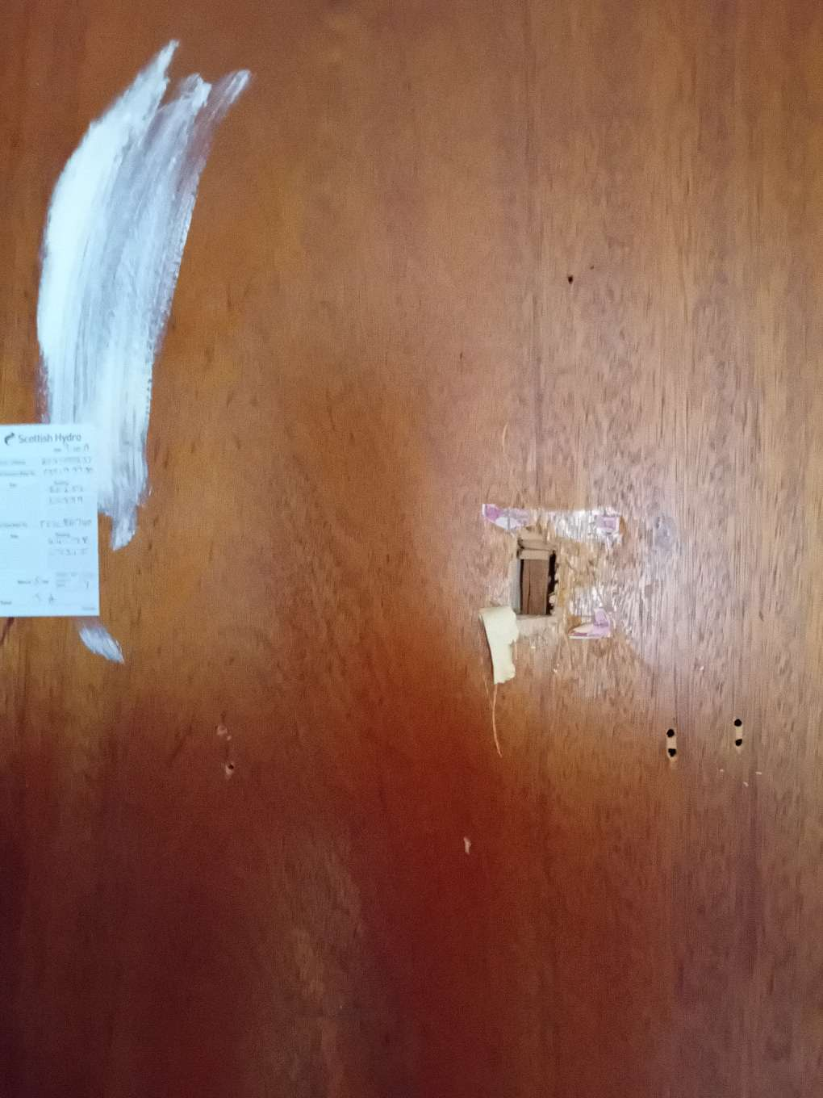

- Decorating is your responsibility. We would only carry out decoration in exceptional circumstances, such as the new tenant having medical reasons that would prevent them from decorating the property.
- However, we may provide a paint pack to help you with the cost of re-decorating.
- We will not provide any floor coverings. However, if floor coverings are left by the previous tenant they can be gifted to you. You will need to sign a form accepting responsibility for the floor coverings. Please note we are not responsible for the maintenance of floor coverings left by the previous tenant.
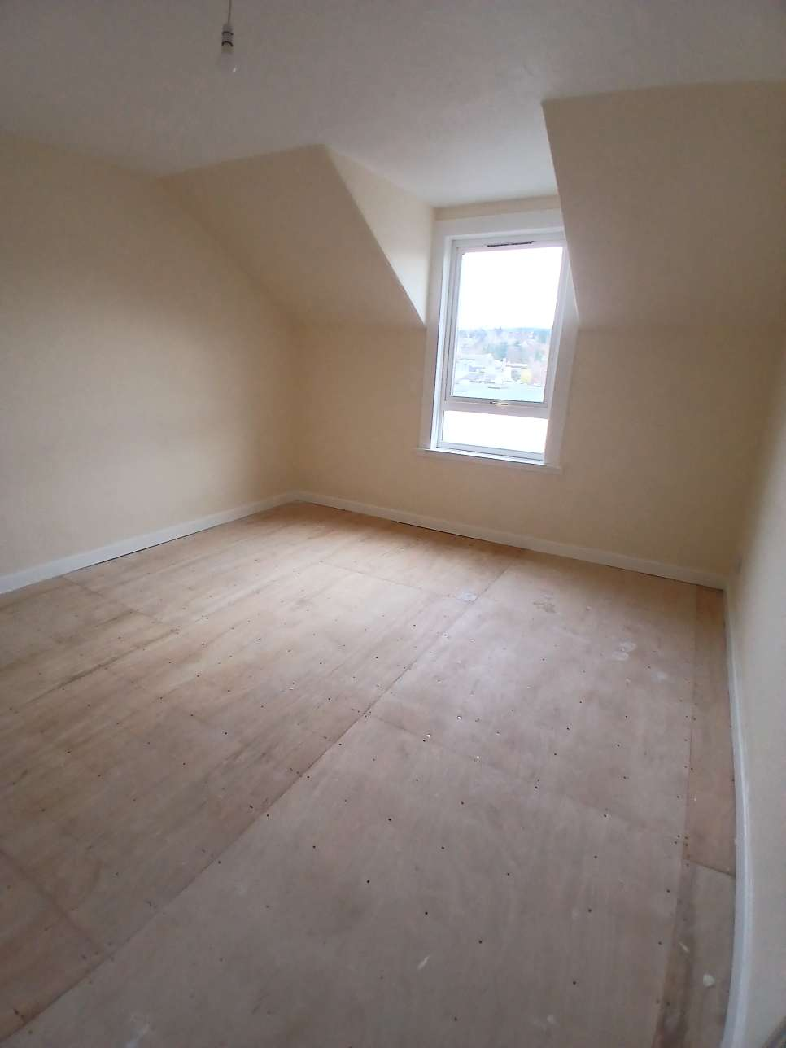
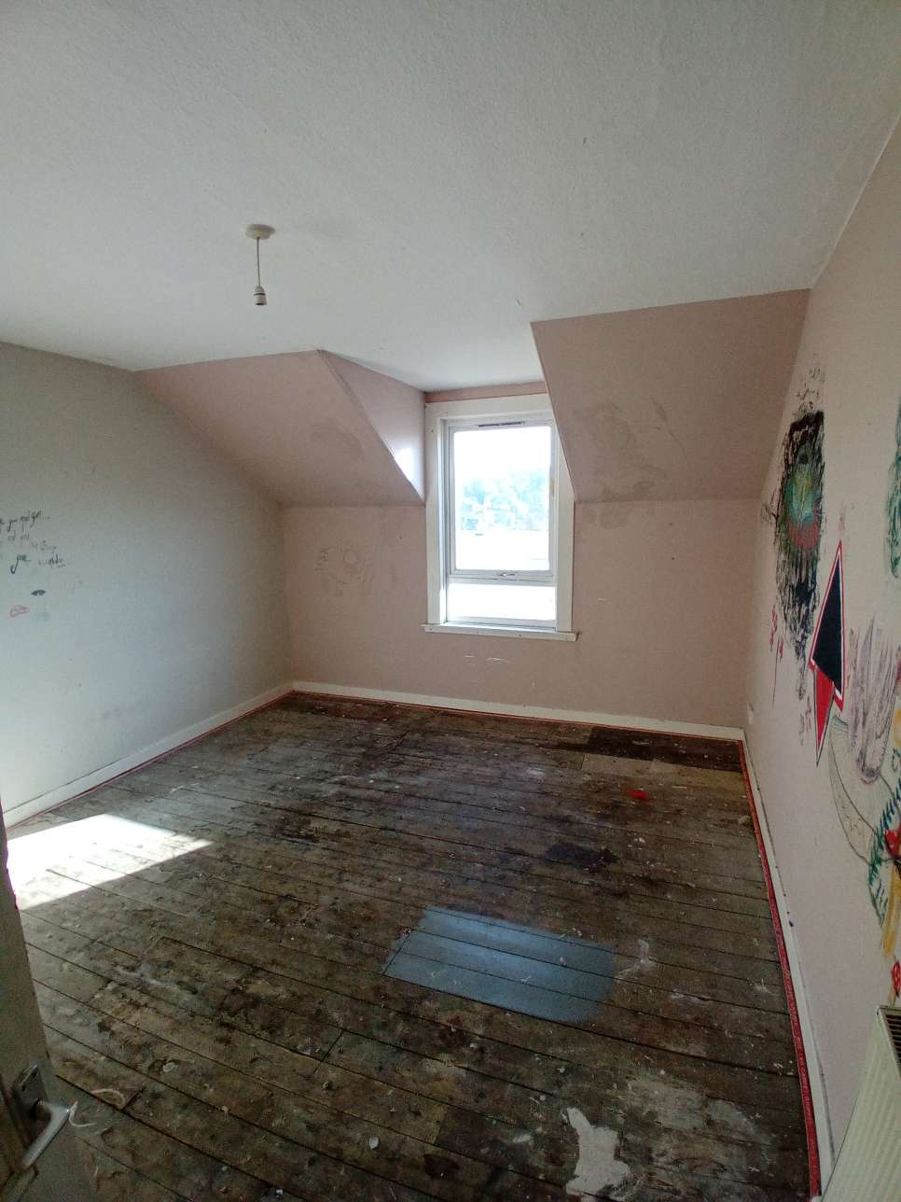

Cleaning

We will also ensure that:
- Upon completion of void repair works, properties will be presented in a clean, sanitary, secure and safe condition
- All internal areas will be free from any mould, damp, dust, dirt, grease, graffiti, cobwebs, rubbish and debris
- All bare floors will be brushed, and all debris will be removed
- All external areas, including pathways, patio areas, driveways, gardens, garages and outbuildings, will be free of any debris and trip hazards.

However, in some circumstances and if agreed with you , we may provide a cleaning pack.



Keys
We will provide
- Keys for each front and back door (these should be returned in addition to any keys for any stores/sheds).

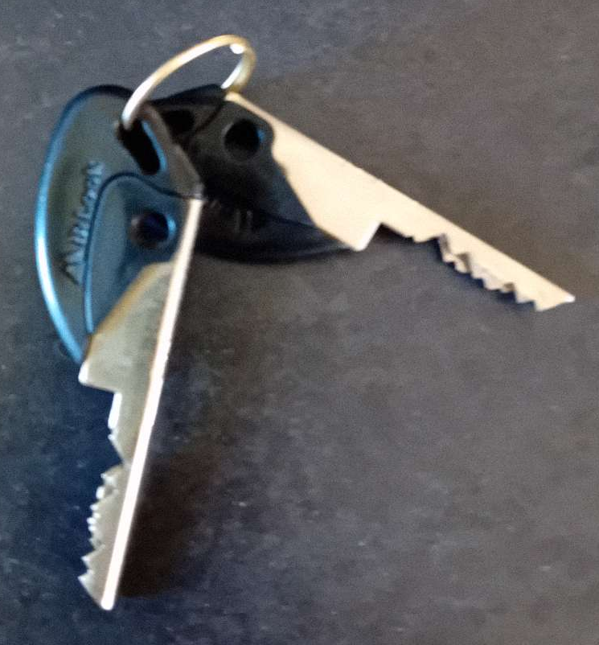

Perth City

Address | Pullar House, 35 Kinnoull Street, Perth PH1 5GD
Phone | 01738 476000
E-Mail | CityCentralHousing@pkc.gov.uk

Letham and Hillyland

Address | Letham Area Office, Marlee Road, Letham, Perth PH1 2HL
Phone | 01738 476000
E-Mail | LethamHousing@pkc.gov.uk

South

Address | Crieff Area Office, 32 James Square, Crieff PH7 3EY  Loch Leven Community Campus, Muirs, Kinross KY13 8FQ
Phone | 01738 476000
E-Mail | SouthAreaTeam@pkc.gov.uk

North

Address | Blairgowrie Area Office, 46 Leslie Street, Blairgowrie PH10 6AW  Pitlochry Area Office, 26 Atholl Road, Pitlochry PH16 5BX
Phone | 01738 476000
E-Mail | NorthAreaTeam@pkc.gov.uk

