# STRATEGIC CASE FOR A LOCAL GOVERNMENT DATA PLATFORM

## Summary

The Local Government Data Platform represents an ambitious transformation programme to deliver improvements in the way Local Government manages and uses data. This ground-breaking initiative represents a collaboration between the Improvement Service, COSLA, SOLACE and the Digital Office for Scottish Local Government.

The current arrangements for providing data returns to external agencies present a number of challenges to Local Government in terms of volume, frequency and lack of co-ordination of reporting requirements. The COVID-19 emergency has exacerbated existing challenges, particularly operational impacts associated with providing reports manually, and has shone a spotlight on improvements that could be made. The Local Government Data Platform aims to improve and streamline the management of data returns and to provide enhanced value from the process by providing greater insight and intelligence to Local Government itself. The Platform will also provide improved data quality, improved timeliness of data, and greater assurance for stakeholders such as Scottish Government.

As the public sector helps to lead the way in Scotland’s recovery from Covid-19, data and intelligence will be more important than ever in helping Local Government respond to changing patterns in need and vulnerability, to learn lessons from its response, and to grasp some of the positive opportunities emerging from this period. The importance of this is further underlined in the newly launched Scottish Government Covid Recovery Strategy which highlights the critical role of data and intelligence in supporting recovery and has set out clear expectations on Local Government to support wider public service efforts to measure the impact of Covid recovery measures and pace of change and reform.

Our response to the pandemic to date has underlined the critical role of data and intelligence within public services, highlighting the importance of timely, relevant and good quality intelligence for decision-making. This has in turn enabled rapid progress around data sharing, data collaboration and data innovation across the sector. The Local Government Data Platform represents an opportunity to build on these gains and ensure that longer term transformation in the data landscape underpins collective recovery efforts.

The Local Government Data Platform will support the following three main functions

1. Collection and exchange of data
2. Validation and enhancement of data
3. Visualisation and presentation of data

The high-level design of the Data Platform is set out below:

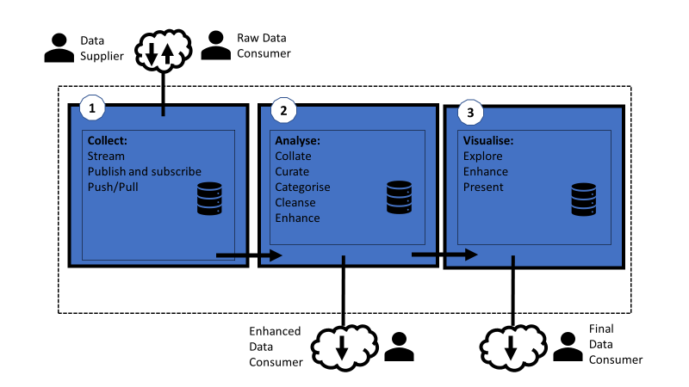

The Local Government Data Platform will help to drive the much-needed transformation in the current data reporting landscape, delivering the following benefits for Local Government:

1. Improving the governance arrangements for managing the lifecycle of data returns
2. Reducing the effort required to collate and provide data within councils
3. Improving the coordination of data collection across Local Government to reduce the impact on service delivery teams
4. Improving the timeliness and quality of data collected to increase the value of the data for Local Government, and improve trust in Local Government data and decision-making
5. Providing richer insight from the data collected for Local Government and individual councils
6. Delivering efficiency savings through greater automation and use of shared systems

Given the scale and ambition behind this programme, a phased delivery of the Data Platform is proposed. Each phase of the roadmap would be designed to be standalone and would enable tangible benefits to be delivered on an incremental basis. The expected benefits for each phase are set out in pages 16-21 of the strategic case.

A route map setting out indicative timings and costs for each of these phases is included.

Phase 1 – Improved Governance. This aims to deliver improved control of the lifecycle of LG returns

Phase 2 – Improved Co-ordination. This aims to reduce the effort for manual data collection and improve the re-use of data collected

Phase 3 – Increased Timeliness, Scale and Sophistication. This aims to scale up automation and integration and introduce enhanced data analytics and data visualisations. In practice, this is likely to represent a larger investment, and itself would likely be broken into separate phases once we learn from the experience of phases 1 and 2.

The timings and costs included in the route map are indicative at this stage due to the uncertainty and complexity of council back-office systems. The basis for these assumptions is as follows:

* Phase one will be a tightly scoped piece of work and can be costed with confidence based on other similar projects. It may have to be run several times as our understanding of the data landscape increases. Phase one will inform all subsequent phases. It is estimated from previous experience that this phase will cost in the region of £60k. Subject to approval from the Improvement Service Board, the Improvement Service has agreed to fund the resourcing for phase one.
* Phase two will only proceed with sufficient information has been collected from phase one to ensure clear scope. Phase two should be costed with confidence based on similar projects. Phase two may be repeated if phase one is repeated
* Phase three cannot be fully scoped until phase one and two have been completed to a level that will provide enough input to the requirements capture. The costings for phase three are estimated on previous experience as we are not yet sure of the solution requirements. A case study of the costs and benefits for implementing similar solutions has been provided by the Improvement Service, entitled “**Cloud Connector Framework Study”**. This relates to the One Scotland Gazetteer and Planning and Building Standards data.

The Strategic Case that follows sets out the

* Strategic Context for Change
* Current Process & Data Flow
* Objectives & Business Needs
* Risks & Dependencies
* Critical Success Factors
* Route Map for phased delivery of the Data Platform

### Recommendations

We are seeking your support for the vision and purpose set out in the Local Government Data Platform approach. Given the scale and complexity of the ambition, it will be essential for Local Government to work together to make this desire a reality. If there is a strong appetite to pursue this direction of travel, we will develop a formal programme for delivery including a gateway review in each phase. We will continue to engage regularly with and provide reports on progress to COSLA Leaders and SOLACE to ensure this development meets the wider needs of Local Government and Scottish Government and is able to play an instrumental role in supporting recovery efforts.

## STRATEGIC CONTEXT

As the public sector helps to lead the way in Scotland’s recovery from Covid-19, data and intelligence will be more important than ever in helping Local Government respond to changing patterns in need and vulnerability, to learn lessons from its response, and to grasp some of the positive opportunities emerging from this period. The importance of this is further underlined in the newly launched Scottish Government Covid Recovery Strategy which highlights the critical role of data and intelligence in supporting recovery, and has set out clear expectations on Local Government to support wider public service efforts to measure the impact of Covid recovery measures and pace of change and reform.

The pandemic is a once in a generation opportunity to transform. Our response to the pandemic to date has underlined the critical role of data and intelligence within public services, highlighting the importance of timely, relevant and good quality intelligence for decision making. This has in turn enabled rapid progress around data sharing, data collaboration and data innovation across the sector. It is essential Local Government is able to build on these gains and ensure longer term transformation in the data landscape underpins recovery efforts.

Prior to COVID-19 a review of the data returns provided by local government to external agencies was already underway by COSLA. The review highlighted that there were approximately 180 different data returns provided to external agencies, typically on an annual or quarterly basis. These data returns are completed by councils on behalf of the external agency on an individual and independent basis. Taking into account the frequency of the returns, and the number of councils required to complete the returns this equates to approximately **6,000 individual instances of the statutory and non-statutory data returns (typically spreadsheets) in circulation within local government per year** (not including examples where an individual return might also be passed between different members of staff within individual councils). These data returns are typically used to monitor the implementation of policy and inform investment decisions.

The response to COVID-19 increased the demand for local government data from external agencies, it also required more frequent reporting (for example monthly, weekly, and even daily reporting) than has previously been required. **At the height of the initial response to the emergency there were 25 different COVID-19 specific data returns (800 instances across the 32 councils) being prepared by local government to external agencies on a monthly, weekly, and daily basis** capturing information about shielding, public protection, deaths, additional expenditure, childcare, school meals, business grants, housing, care, and operational information such as absence, and more.

In both cases of pre-COVID-19 and during the initial COVID-19 initial response;

* There has been no coordinated governance arrangements between local government and external agencies to manage the introduction, change and retirement of data returns,
* There are many different formats being used to gather data (spreadsheets sent via email, word documents, through to online forms),
* Although there is some automated data collection in use within local government for the address and street gazetteers, there is little automation of data collection in place for managing data returns, resulting in high levels of manual activity to collate data, complete data returns, and sending data returns to appropriate contacts in external agencies, which often results in resources being taken away from service delivery,
* The data gathered by local government on behalf of external agencies has typically not been re-used by local government as a sector itself, other than for the Local Government Benchmarking Framework (LGBF) which does re-use some of the non-COVID-19 data returns. For the LGBF however, this is achieved through arrangements with the relevant external agencies to request access to the data on behalf of local government.
* It is evident from some of the data quality assurance and analysis work carried out by the Improvement Service during the COVID response period which identified significant outliers that data was not being rigorously checked by the requesting bodies. Data returns that had been requested for a number of years were quite clearly not being interrogated/ used to inform decision making in any sophisticated way bringing into question the purpose of continuing to report this volume of data.
* In short there is a significant burden on data collation and reporting without proper governance and little use of the data sets to inform local government decision making (effectively collecting for others).

The “**Crerar Review**: the report of the independent review of regulation, audit, inspection and complaints handling of public services in Scotland”[1] recommends placing the primary responsibility for demonstrating compliance and performance with the service provider. In other words, it is the responsibility of Local Government/individual local authorities to develop robust performance management and outcome focused self-assessment. Local Government is already demonstrating this through it’s collaboration on the LGBF, to the point that publication of the LGBF forms part of each council’s statutory public performance reporting. The LGBF reflects a commitment by SOLACE Scotland and COSLA since 2010-2011, to develop a better measurement and comparable data in order to help councils improve services, target resources to areas of greatest impact and enhance public accountability.

## ORGANISATIONAL OVERVIEW

Figure 1 provides a high-level illustration of the process and information flow;

1. External agencies typically request data returns from Councils through a formal request direct to each individual Council,
2. Data Returns are then provided to the external agency to the frequency requested. As highlighted above, for business as usual reporting (pre-COVID-19).
3. The LGBF makes use of some of the data collected from external agencies through data requests with the relevant agencies. Data is typically passed from the external agency to the Improvement Service via spreadsheets that are emailed.

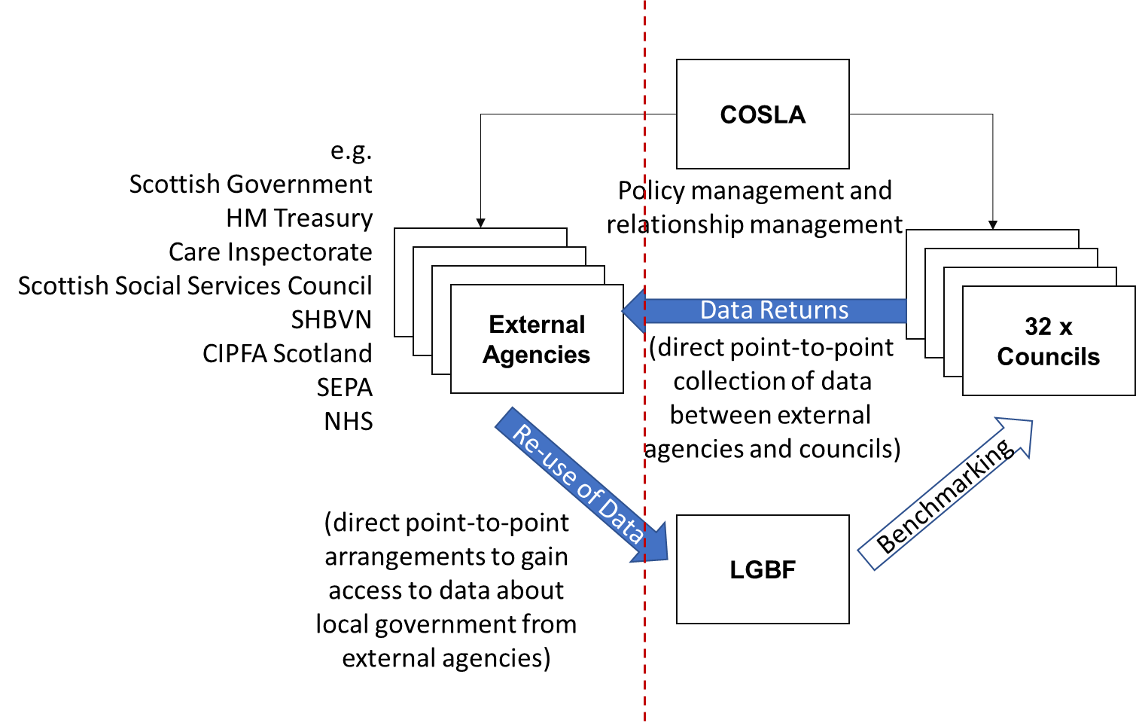

Figure 1 Current Organisational Overview

## KEY BENEFITS FOR LOCAL GOVERNMENT

The Local Government Data Platform will help to drive the much-needed transformation in the current data reporting landscape, delivering the following benefits for Local Government:

1. Improving the governance arrangements for managing the lifecycle of data returns
2. Reducing the effort required to collate and provide data within councils
3. Improving the coordination of data collection across local government to reduce the impact on service delivery teams
4. Improving the timeliness and quality of data collected to increase the value of the data for local government, and improve trust in local government data and decision-making
5. Providing richer insight from the data collected for local government and individual councils
6. Delivering efficiency savings through greater automation and use of shared systems

## OBJECTIVES AND BUSINESS NEEDS

The current arrangements for providing data returns to external agencies already present a number of challenges to local government. The COVID-19 emergency has exacerbated existing challenges, particularly operational impacts associated with providing reports manually, and has shone a spotlight on improvements that could be made. The basic data dashboard that was developed at pace during the emergency has helped local government to understand what is required to improve the management of data returns and to provide greater value from the process by providing greater insight and intelligence to local government itself. These are expressed below through the following objectives;

|  |  |
| --- | --- |
| **Objective 1.** | **Improve the governance arrangements for managing the lifecycle of data returns** |
| **Existing Arrangements** | Governance arrangements for the introduction of data returns, changes to returns, and the cessation of returns are usually managed on a case-by-case basis with individual external agencies. There is no coordinated review process for evaluating and approving new (or changes to) requests for data returns or cyclically confirming returns are still valid.. |
| **Business Needs** | There is a need to adopt a more strategic, proactive, and coherent approach to managing the lifecycle of data returns from the point they are introduced to the point they are retired in order to;   * Ensure that requests for new data returns are agreed with external agencies based upon a common understanding of the value that the data will provide to the external agency, and the impact that the request would have on local government, * Avoid introducing new data returns that duplicate existing data collection, * Ensure that the reporting requirements are clear so that Councils fully understand how to provide data in order to avoid different interpretations of requirements that could lead to discrepancies in the data, * Ensure that there are adequate, appropriate, and consistent mechanisms and controls in place to coordinate the collection of data returns, * Ensure that any changes to the requirements for data returns are minimised, but where they are required they are clearly communicated and understood by Councils, * Ensure that the continued relevance of data returns are evaluated on a period basis, and data returns retired if they no longer deliver value and agreement on any subsequent publication of data, |

|  |  |
| --- | --- |
| **Objective 2.** | **Reduce the effort required to collate and provide data within councils** |
| **Existing Arrangements** | The provision of data to external agencies is extensively a manual activity that requires a single member of staff, or multiple members of staff having to divert attention away from service delivery to collating data and populating data returns on a period basis.  There are various mechanisms for providing returns however the majority of returns are provided using Excel spreadsheets that are emailed between the external agency and (in some cases) between members of staff). |
| **Business Needs** | Where manual input is required to provide data returns there is a need to;   * Simplify data collation for staff members, * Remove duplicate data collection, * Make it easy for multiple staff members to populate the same data returns where there is a need to gather data from multiple sources, * Reduce the need to re-work data collection.   Where justifiable and achievable, opportunities to semi-automate or fully-automate data returns should be considered to enable data to be published directly from source systems or data warehouses where they exist within councils in an automated manner without (or with minimal) manual input. |

|  |  |
| --- | --- |
| **Objective 3.** | **Improve the coordination of data collection across local government to reduce the impact on service delivery teams** |
| **Existing Arrangements** | The coordination of data collection by external agencies is managed with individual councils on a case-by-case basis by the requesting agency itself. There is typically no coordination of data collection provided by local government itself. |
| **Business Needs** | Where manual input is required to provide data returns there is a need to;   * Better schedule and coordinate data collection across different data returns to reduce the impact on service delivery * Improve the consistency of data collection by reducing the variety of data collection mechanisms (e.g. excel, word, forms, etc) * Improve the control of collection of data by removing (or reducing) the dependency on standalone documents and/or spreadsheets being transferred between parties using email. * Retain data in a single repository to facilitate trend analysis over time or present rates in terms of a core set of demographic data (e.g. present comparative data per 1,000 population). |

|  |  |
| --- | --- |
| **Objective 4.** | **Improve the quality of data collected in order to increase the value of the data for local government, and improve trust in local government data and decision-making** |
| **Existing Arrangements** | There is no local government review process to assure the quality of data returns provided to external agencies like the quality assurance processes that are in place for the Address and Street Gazetteers.  Where new data returns are introduced (in particular) there is a risk that insufficient guidance provided by the external agency could result in different interpretation of the requirements that can result in discrepancies in data when it is aggregated to provide an overall local government view by the requesting agency. This could result in mis-trust in local government data and/or mis-informed decision-making.  There are a number of examples of data discrepancies caused by different interpretation of the requirements for data returns that were introduced rapidly to understand the initial response to the COVID-19 emergency because of inadequate guidance from the external agency and in some cases unrealistic expectations of what data was available. |
| **Business Needs** | There is a need to ;   * Ensure that there is adequate guidance in place to councils in advance of data being collected, * Where manual activity is required to provide data, there should be sufficient validation of data entry in place to ensure the quality at the point of data input, * Data standards should be established and enforced to minimise misinterpretations and to enable automated data feeds to be developed (where appropriate), * Enable data collected across local government to be reviewed by local government in order to identify data inconsistencies and assure the quality that is provided to external agencies, * Automation of data collection is required (where appropriate and possible) to reduce or remove manual input. |

|  |  |
| --- | --- |
| **Objective 5.** | **Enable greater re-use of the data collected by external agencies by local government and by individual councils** |
| **Existing Arrangements** | The Local Government Benchmarking Framework (LGBF) already makes use of data collected on behalf of external agencies as well as additional external data sources (such as the results of surveys and reference data like SIMD) however there a variety of arrangements in place with external agencies to gain access to the data, and the provision of the data back to Improvement Service is typically manual (e.g. Excel).The dependency on external agencies providing data back to local government therefore increases the time period between data being collected and being made available.  For reference data, it is worth also adding that the Address and Street Gazetteer data collection is actively reused by the sector.  The COVID-19 dashboard that was developed by Improvement Service with support from the Digital Office for Scottish Local Government and COSLA demonstrated how data collected for external agencies could be used to create value to local government and individual councils. |
| **Business Needs** | There is a need to;   * Create a central repository of the data collected through data returns so that it can more easily be re-used by local government (for example for the LGBF) and by individual councils, * Provide external agencies with direct access to the data that has been requested by them, equivalent to current data returns (only), * Establish a data catalogue that allows staff within councils to easily discover and understand the data that would be available from the central repository, * Enable data held within the central repository to be combined with other data sources to create further insight where applicable and appropriate, * Provide council-specific access to the central repository so that data about an individual council (and benchmark data, or aggregated data where applicable) can be made available back to the council in an automated manner. |

|  |  |
| --- | --- |
| **Objective 6.** | **Provide richer insight from the data collected for local government and individual councils** |
| **Existing Arrangements** | The LGBF provides valuable benchmarking insight to councils.  There is no ability for councils to interact and interrogate data through a holistic set of customisable interactive maps and dashboards.  Although it resulted in a large overhead, the increased frequency of reporting during the COVID-19 emergency did demonstrate how the ability to analyse timelines and trends could improve decision-making and enable more proactive decision-making. |
| **Business Needs** | Given the volume of data collected there is an opportunity to create more value from the data within local government by;   * Providing interactive dashboards that allow council staff to interact with, and interrogate data visually, * Provide interactive dashboards at both a sector-wide level and an individual council level to allow benchmarking, * Enabling dashboards to be configured by selecting from the suite of indicators loaded into the portal and tailored to individual council needs to present a picture of a specific topic (e.g. a picture of comparative child poverty in an area) to support decision making and resource allocation, * Upskilling council staff with basic data analysis/data visualisation skills to help councils to benefit from the technical capabilities provided * Where automation is available to enable increased frequency of data collection, providing greater access to more granular timelines and trends to enable improved and more proactive decision-making. |

## RISKS AND DEPENDENCIES

### DEPENDENCIES

|  |  |  |
| --- | --- | --- |
| **Dependency 1.** | There is a dependency on legislative owners of data returns agreeing to the solutions set out in the business case. | This will be mitigated through the creation of the governance arrangements proposed for Phase One |
| **Dependency 2.** | There is a dependency on Council staff being made available to provide practical experience and provide advice and guidance on proposals. | This will be mitigated through the use of existing forums for engaging with staff such as the Data Advisory Group and the Digital Assurance Board. |
| **Dependency 3.** | There is a dependency on collaboration with councils to adopt data standards, improve data quality, and data maturity. | This will be mitigated by aligning activity with the work of the Data Advisory Group and work it is undertaking with Scottish Government to deliver the data actions set out in the Digital Strategy for Scotland. |
| **Dependency 4.** | Any automated solutions required for Phase three of the roadmap will be dependent on ICT development being undertaken by councils to make data available in an automated manner. | This can be mitigated by ensuring that the costs and resources required for any council-side development are understood and included into further business cases and proposals and are reviewed as part of the proposed gate reviews. |

### RISKS

|  |  |
| --- | --- |
| **Objective 1.** | **Improve the governance arrangements for managing the lifecycle of data returns** |
| **Risk 1.1** | There is a risk that external agencies refuse to engage with an intermediate body to manage the lifecycle of data returns. |
| **Mitigation** | It will be important to articulate the benefits of the approach to external agencies who request data from local government in terms of;   * Improved timeliness of data * Improved quality of data * Improved re-use of existing data, where applicable |
| **Risk 1.2** | Some data returns are set out in statute and require local authorities to submit data directly to Scottish Government. There may be cases where changes to legislation may be required to allow an intermediary body to manage the lifecycle of data returns. |
| **Mitigation** | It will be important, as part of the above mitigation to engage closely with Scottish Government and other external agencies as appropriate to confirm the statutory status of returns and the degree to which this status may constrain the ability to change the management of data returns |
| **Risk 1.2** | There is a risk that the outcomes from the Independent Care Review might impact on the scope and prioritisation of the programme. |
| **Mitigation** | It is recommended that the risk be transferred to the governance arrangements proposed as part of Phase One of the project and managed as a strategic risk through those arrangements. |
|  |  |

|  |  |
| --- | --- |
| **Objective 2.** | **Reduce the effort required to collate and provide data within councils** |
| **Risk 2.1** | Although a key objective is to reduce the effort associated with providing data returns there is a risk that the value provided by the platform increases the pressure for more data to be collected and/or for data to be collected more frequently. |
| **Mitigation** | The governance arrangements for the process should ensure that increased demand for data is evaluated against the impact to local government. In addition, where new data returns are required, opportunities to automate (or semi-automate) data collection should be considered to minimise or remove the need for additional manual effort. The overall effect, however, should be to reduce volume and effort. |
| **Risk 2.2** | Some data returns are set out in statute and require local authorities to submit data directly to Scottish government. There may be cases where changes to legislation may be required to allow an intermediary body to manage the lifecycle of data returns. |
| **Mitigation** | It will be important, as part of the above mitigation to work with external agencies to confirm the statutory status of returns and the degree to which this status may constrain the ability to change the management of data returns |

|  |  |
| --- | --- |
| **Objective 3.** | **Improve the coordination of data collection across local government to reduce the impact on service delivery teams** |
| **Risk 3.1** | There is a risk that external agencies refuse to engage with an intermediate organisation and/or system for coordinating the collection of data, and insist that data collection is solely managed through their relationship with individual councils |
| **Mitigation** | The benefits of a better coordinated approach to collecting data should be presented to stakeholders in external organisations. Where appropriate equivalent approaches in other sectors such as NHS (where data is collected by NHS NSS on behalf of health boards before it is shared with agencies such as Public Health Scotland and Scottish Government) should be cited. |

|  |  |
| --- | --- |
| **Objective 5.** | **Enable greater re-use of the data collected by external agencies by local government and by individual councils** |
| **Risk 5.1** | The nature of the business problem is that it exists at the boundary between local government and other sectors (including Scottish Government). There is a risk that the development of a platform for local government specifically to manage data returns might duplicate (in part of in whole) previous, existing, or planned similar investments in other sectors. The project team are however unaware of any such proposals at this time. |
| **Mitigation** | There will be a need to engage closely with other sectors (particularly those containing external agencies that request local government data) to understand opportunities to re-use or align technical development. Particularly attention should be paid to;   * NHS NSS Data Platform * Scottish Government ProcxEd system   Technical options should be reviewed through the new Local Government Digital Assurance Board which includes representation from local government IT managers, security officers, COSLA and Improvement Service. |
| **Risk 5.2** | There is a risk that the development of a solution to centralise storage and coordination of data returns duplicates capabilities within existing systems or contracts within local government. The project team are however unaware of any such proposals at this time. |
| **Mitigation** | Options for implementing the platform should consider the re-use of existing local government assets and/or commonly available commercial off-the-shelf (COTS) products that are used across the sector, particular attention should be paid to;   * Microsoft 365 * ESRI ArcGIS * IS Spatial Hub * IS Data Hub   Technical options should be reviewed through the new Local Government Digital Assurance Board which includes representation from local government IT managers, security officers, COSLA and Improvement Service. |
| **Risk 5.3** | There is a risk that the development of a solution to centralise storage and coordination of data returns creates a new dependency for proprietary skills and resources from external organisations (particularly the private sector). |
| **Mitigation** | Options for implementing the platform should consider;   1. Availability of skills to develop and manage the platform 2. Ability for local government to manage change effectively 3. Use of commercial off-the-shelf (COTS) products rather than in-house solutions   Technical options should be reviewed through the new Local Government Digital Assurance Board which includes representation from local government IT managers, security officers, COSLA and Improvement Service. |
| **Risk 5.4** | Access to data held centrally will need to be made available to individuals from across local government and external agencies. Access control will need to be applied to ensure that data is only visible to those people/roles that have been granted access. There will be a range of security risks associated with the storage and transfer of data could have an impact on privacy, integrity and availability of the data. |
| **Mitigation** | The design of the solution should be based upon the principle of “secure by design”. The security of the solution should be assured through the new Local Government Digital Assurance Board which includes representation from local government IT managers, security officers, COSLA and Improvement Service. |

## BENEFITS

The types of benefits that could be delivered as a consequence of the addressing the business needs expressed within the strategic case include;

|  |  |
| --- | --- |
| **Cash Releasing Benefits** | * TBC following Phase One |
| **Non-Cash Releasing Benefits** | * Over time, reduced manual effort will be required within each council associated with providing data returns to external bodies, freeing up time for service delivery |
| **Quantifiable Benefits** | * Improved quality of the data that is provided to external bodies by local government * Improved strategic, tactical, and operational decision-making within councils as a consequence of greater access to local government and data about individual councils that has been collected for external agencies, * Improved control of access to local government data to external bodies |
| **Non Quantifiable Benefits** | * Improved trust in local government data and decision-making * Improved governance of local government data returns |

## Critical Success Factors

The success of the solution will be dependent on the following:

1. The success of the solution will be determined by the contribution of partner councils as much as the Digital Office and Improvement Service itself;
   * It is important that the partner councils share information on
     + existing processes,
     + Systems they use to gather information for reporting (which would also be added to the Scotland Excel and Digital Office system STAMP for collaborative procurement and common platform opportunities),
     + Enterprise Architecture diagrams,
   * It is critical that the project for this solution is fully resource planned and managed, and that individual councils are able to contribute resource to the programme.
   * It is important that individual councils take a managed approach to their active engagement with Digital Office and Improvement Service, coordinating staff engagement, ensuring that communications are disseminated, and realising benefits locally.
   * It is important for individual councils to appreciate that value gained, and benefits realised from the overall solution will be determined by their own engagement and contribution,
   * It is critical that councils consider using a national process and national platform for Data returns to support realised benefits and better quality of data for the sector as a whole.
   * The timeliness of deliverables for the solution will increasingly grow in importance due to the success of the programme in creating demand. It is therefore important that contributions from the Digital Office, Improvement Service, local government partner agencies and individual councils are delivered together in a timely manner to ensure that the needs, expectations and benefits of the collective are met.
   * It is crucial for the final stage, the automated stage, councils themselves will need to invest in integrating their own systems with the national platform.
2. The success of the Solution is dependent on Local Authorities and supporting partner organisations being made aware of ever-changing landscape of the Data Solution therefore helping capitalise and realise its benefits whilst saving time as a collective rather than approach Digital individually
   * Digital Office will take a leading role in consolidating, promoting and demonstrating sector leading knowledge and benefits of Digital tools, methods and solutions on behalf of the Digital partnership.

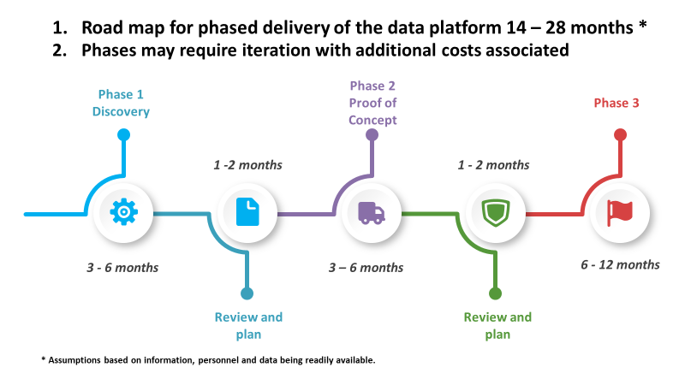

The visual above is a high level roadmap for phased delivery of the data platform project. It is comprised of 3 phases, separated by reviews. Phases may require iteration with additional costs associated.

## Case Study

## Implementation of Idox Cloud Connect Framework

### Description

In December 2019, the Improvement Service Board agreed the funding (c£300k) for the implementation of the Cloud Connector Framework (CCF) across Scottish Local Government. This is a service developed by Idox, who supply software for the One Scotland Gazetteer, and Planning and Building Standards. It runs on local authority servers and automates the transfer of data to and from the Idox Uniform system to the outside world. It can be used to input/populate data in Uniform (e.g. from the Scottish Government’s eDevelopment portal) or export data from the system to other systems (e.g. for the Gazetteer, Planning, Building Control and Food Hygiene Inspection). It does this via a web-based console and a “connector” which, once a data transfer “task” has been developed, runs based on a set of criteria. It can be scheduled to run continually or at specific times, and configured to export/import the data in a variety of different file formats.

The IS Board endorsed the funding of the CCF implementation because of the wide range of benefits, both to Local Authorities and External Stakeholders. The initial implementation was focussed around gazetteer data because of its maturity, with all 32 authorities manually updating gazetteer data on a regular basis (minimum of once per month) for the last 16 years. The One Scotland Gazetteer is used by over 85 public sector organisations in Scotland, including all Emergency Services.

The benefits are almost exclusively intangible but add up considerably across the 32 authorities and all users of the One Scotland Gazetteer and are detailed below.

### Benefits to Local Authorities - Gazetteer

* It saves resources from not having to manually upload Gazetteer exports everyday/week (about 15 mins per upload per Local Authority, around 1½ hrs per week)
* It provides daily reports on quality of data so speeds up time to identify errors/issues
* It supports quicker feedback process from users of the data as data fed into products/service much quicker
* It considerably reduces queries from users, e.g. Energy Performance Certificates about “missing” new data
* It provides the ability to provide centralised support to Local Authorities during any times of resourcing pressure

### Benefits to Local Authorities – Planning & Building Standards

* It reduces inquiries from Statutory Consultees (and other users) to Local Authorities questioning details of planning applications/building warrants.
* It reduces the time manually uploading notices to Tellme Scotland (a portal displaying Public Notices) as this can now be done automatically
* It has the potential to automate Neighbour Notification using the Planning & Building Standards data and Gazetteer data (this time saving could be substantial, as Local Authorities spend many hours doing such notifications)
* It provides potential for time saving in preparing statutory returns to Scottish Government by automating the processes using CCF data
* It has the potential to replace the IDOX Public Access for Building Standards as the CCF data could become part of the statutory register
* It is recognised to provide savings associated with Scottish Government’s Digital Planning project data is already feeding into the national cloud solution

### Benefits to External Stakeholders

* It proves a more robust, automated and reliable way of obtaining data from Local Authorities
* Guaranteed "scheduled" weekly/daily extracts of "live" data from all Local Authorities
* Reduced time lag from Local Authorities data submission to data being available to users
* It benefits existing users by providing them with high quality, reliable data more often
* Increased use of data (by new and existing users) due to better consistency and accuracy of data
* It provides sizeable increase in value due to the provision of high quality, reliable data for Local government
* It enables streamlined support request process and error/issue identification, leading to quicker issue resolution
* There is increased automated performance monitoring of data quality, leading to significant growth in the quality of Local Government data.
* Provides Scottish Government Digital Planning with high quality, reliable data to enable the recommendations of Scottish Government’s Digital Strategy

### Lessons Learned from CCF Implementation

It is nearly two years since the Board approved the funding for what is actually three connectors (gazetteer, development management and building standards) and the progress in implementation is shown in the following table:

|  |  |  |
| --- | --- | --- |
| Function | Idox site | CCF Installed |
| Gazetteer | 31 | 26 |
| Development Management | 32 | 4 |
| Building Standards | 26 | 2 |

Efforts have to date been focussed on the Gazetteer task as having the greatest user base and therefore greatest benefits, and whilst deliberations around Digital Planning are ongoing with Scottish Government.

The reasons for the length of time to implement the CFF is attributable to a number of factors including:-

* The CCF requires authorities to be running the latest version of the software and many were several versions out of date.
* There were several delays around ICT services configuring firewalls and IP whitelisting to permit access for the CCF to the authorities Idox system
* There was a lack of availability of ICT resources in many authorities and this was heightened by Covid

It was noted that the implementation by the five authorities who used Idox’s Hosted Service was straightforward.

This experience in implementing the CCF is provided to inform the Strategic Case for the Scottish local authority data platform.

1. <https://www.gov.scot/publications/crerar-review-report-independent-review-regulation-audit-inspection-complaints-handling/pages/10/>