Event Summary: “Just Transition in Local Government: From Policy to Practice”

Contents
1. Session Overview
2. Panel One: National Context
3. Panel Two: Local Implementation
4. Feedback and Next Steps
5. Further Information
6. Annex
A. Panel One
B. Panel Two
B1. Presentation Slides
C. Breakout Rooms

1. Session Overview
On 28 August 2025, the Improvement Service in collaboration with the Sustainable Scotland Network (SSN) and the Scottish Local Authorities' Economic Development Group (SLAED) hosted an online event on "Just Transition in Local Government: From Policy to Practice."
The session brought together over 110 participants from across local authorities, national government, and partner organisations to explore how national Just Transition policy can be translated into practical, local action.
The event featured two panel discussions and interactive breakout rooms, offering a platform for knowledge exchange, peer learning, and the identification of key enablers and barriers to implementation. The following sections 2 & 3 are high-level summaries of each panel discussion, for a more detailed account please see Annex A. & B. of this document. For a summary of breakout room discussions, see Annex C.

2. Panel One: National Context
The first panel focused on the national context and was moderated by Jamie Brogan from the Scottish Climate Intelligence Service. Panellists included Catriona Laing (Scottish Government), Professor Dave Reay (Just Transition Commission), and Laurie Macfarlane (Future Economy Scotland).
The discussion framed Just Transition as a holistic process that goes beyond achieving net-zero emissions, emphasising the need to embed fairness across sectors such as energy, housing, transport, and nature restoration. The panel highlighted that climate action must also address adaptation challenges like flooding and wildfires, while aligning with broader national priorities such as reducing child poverty and strengthening public services.
A key theme was the disproportionate impact of climate change on marginalised communities, who face greater risks from extreme weather and adaptation costs but have the least capacity to respond. In contrast, wealthier households, whose carbon footprints are five to six times higher, are better equipped to protect themselves. This imbalance underscores the need for climate policies that are not only effective but also equitable.
The panel also stressed the importance of local ownership and investment. They advocated for stronger community rights to energy assets and emphasised the need for investment strategies that build local supply chains, skills, and wealth through a mix of public, private, and community funding. The upcoming Community Wealth Building legislation was highlighted as a key opportunity to embed these principles.
Skills development and communication were also identified as critical areas. Chronic underfunding of colleges was seen as a barrier to preparing the workforce for emerging sectors such as renewables and low-carbon agriculture. The panel called for a shift in public narratives from global catastrophe to local benefits like cleaner air, better jobs, and healthier communities to build broader support for climate action. In conclusion, the panel issued clear calls to action: embed Just Transition across policy silos, empower communities, invest in skills, condition funding for local benefit, and promote hopeful and benefit-led messaging.

3. Panel Two: Local Implementation
The second panel focused on local authority perspectives and was moderated by George Tarvit from SSN. Panellists included Tommy Coutts (Shetland Islands Council), Julie Waldron (City of Edinburgh Council), and Anna Macpherson (Glasgow City Council). Each shared practical strategies and insights from their respective contexts, revealing diverse approaches to Just Transition. A common theme was the need for greater local empowerment, tools, and influence over national policy.
- Shetland Islands Council emphasised the importance of a “Fair Share” framework, including Energy Development Principles and evidence-based community benefits. Despite being a major energy producer, Shetland faces high local energy costs and policy fragmentation, with many community benefits still governed by voluntary guidelines.

- The City of Edinburgh Council highlighted its efforts to embed Just Transition through strategic partnerships, such as the Net Zero Edinburgh Leadership Board, and tools like Integrated Impact Assessments. The use of AI-generated “Edinburgh Personas” supports empathetic decision-making, while collaboration with the Poverty Commission ensures equity is central to climate planning.

- Glasgow City Council showcased its human-centred design approach through programmes like the Youth Climate Action Fund, the City Change Makers Climate Accelerator, and a 9-month employability City Change Makers Programme. These initiatives aim to build citizen skills, break down silos, and foster a collaborative ecosystem of local changemakers.
The panel concluded by identifying the most critical actions needed to advance a local Just Transition. These included fostering reflective leadership—encouraging decision-makers to “give space for a second thought”—strengthening data-informed communication, and building collective advocacy for stronger policy levers, such as mandatory community benefits, to address resource gaps and democratic deficits.

4. Event Feedback and Next Steps
Participant feedback collected at the end of the session reflected a positive shift in understanding and confidence.
At the start of the event, participants already viewed Just Transition holistically, focusing on fairness, jobs, inclusion, and community. However, 45% identified gaps in connecting economic development with climate action.
Key barriers identified included:
- Lack of funding.

- Shortage of skilled staff.

- Need for clearer government leadership and policy direction that is responsive to the diverse, ground-level realities of different regions.
Encouragingly, 75% recognised tangible benefits from local projects, such as job creation, health improvements, and low-carbon infrastructure such as cycle lanes. By the end of the session, 79% of participants felt equipped to apply Just Transition principles in their work.
Common next steps included:
- Taking steps to facilitate improved cross-department collaboration.

- Promoting and engaging in knowledge-sharing both internally and externally.

- Proactively seeking strategic alignment with other local authorities facing similar economic, social and environmental challenges.

The event concluded with a strong sense of momentum and shared purpose. Participants left with a deeper understanding of the Just Transition agenda and a clearer view of the practical steps needed to embed it locally. The discussions reinforced the importance of collaboration across sectors and levels of government, and the need to centre equity and community empowerment in all aspects of climate action.

5. Further information

A. Contact Details
If you have any feedback on the event or want to discuss anything in this summary further, please contact Rami Zaatari, Climate Change Manager at the Improvement Service at rami.zaatari@improvementservice.org.uk

B. Additional Resources
- Related briefings
- Shetland Energy Development Principles
- A Fair Share for Shetland
- Analysis of Community Benefits in Shetland
- Climate Ready Edinburgh Plan 2024-2030
- 2030 Climate Strategy - Edinburgh

6. Annex

A. Panel One
Moderator: Jamie Brogan, Scottish Climate Intelligence Service (SCIS), Edinburgh Climate Change Institute.
Panellists:
- Catriona Laing, Deputy Director of Energy and Climate Change, Scottish Government.
- Prof. Dave Reay, Co-Chair, Just Transition Commission.
- Laurie Macfarlane, Co-Director, Future Economy Scotland.
The panel established that a Just Transition is a broad, deep, and essential process that must be integrated across all policy areas and experienced by people in every part of Scotland. It was defined not merely as a shift to net zero, but as the imperative to make climate action fair.
The discussion emphasised that success depends on a holistic approach that simultaneously tackles climate change, reduces inequality, and builds a resilient economy, with local implementation being critical.
Key discussion points:
a) The breadth and depth of a Just Transition
- The panel emphasised that a Just Transition extends well beyond the immediate economic impacts on the energy sector. It also encompasses climate adaptation, such as responses to flooding, wildfires, and coastal erosion, as well as housing, transport, land use, and nature restoration.
- Catriona Laing highlighted that Just Transition principles are intertwined with the Scottish Government's other national priorities: the economy, child poverty, and public services. Climate action cannot be siloed from social and economic policy.
- Laurie Macfarlane emphasised that a true Just Transition must recognise Scotland's status as a high historic emitter and incorporate a reparative perspective.
b) Inequality
- The burdens of climate change (e.g., damage from extreme weather, costs of adaptation) fall disproportionately on the most marginalised communities who have the least capacity to respond.
- Macfarlane cited research showing the carbon footprint of the wealthiest households is 5-6 times larger than the poorest, underscoring the need for policies based on the "polluter pays" principle.
- Dave Reay warned that failing to address inequality "undermines the social licence we need to actually address climate change," making it the biggest barrier to effective action.
c) Local implementation
- While national strategy is vital, the panel agreed that the transition happens on the ground. Local context is everything, and communities must have a meaningful stake in the decisions that affect them.
- The panel discussed concerns that the current model of voluntary community benefits from energy projects may be insufficient. They highlighted the potential value of a stronger right to community ownership, drawing on examples like Denmark, as a way to support wealth creation rather than simply redistributing existing resources.
- A significant challenge identified is the unequal capacity of different communities to engage. Proactive support is needed to build this capacity, ensuring no community is left behind.
d) Investment and economic development
- Investment is crucial, but its quality is more important than its quantity. Investment must be conditional on delivering local benefits, building supply chains, and supporting skills development to prevent wealth extraction.
- A mix of public, private, and community investment is required. The private sector, particularly large renewable developers, must be leveraged to invest in Scottish skills and communities.
- The upcoming Community Wealth Building legislation presents an opportunity to create empowering mechanisms for communities to access finance, assets, and procurement spend, fostering local economic resilience.
e) Skills challenges
- Dave Reay expressed strong concern about the chronic underfunding of Scotland's colleges, which are a key engine for delivering the skills needed for the transition.
- Catriona Laing outlined the complex skills challenges across sectors, from transferring oil and gas skills to renewables (a more difficult task than anticipated) to training for electric vehicle servicing and low-carbon agriculture.
- The panel suggested adopting and improving upon models like Local Skills Improvement Plans, which better match local employer needs with skills provision.
f) Communicating local benefits
- The panel discussed the importance of shifting away from narratives of global catastrophe and instead emphasising the tangible, local benefits of a Just Transition, such as cleaner air, well-paid jobs, and stronger community resilience.
- It is important to demonstrate that climate action and improving living standards are interconnected, directly challenging narratives that frame them as opposing goals.
Key takeaways and next steps:
The panel concluded with clear calls to action for all levels of government and society:
- Break down silos: A Just Transition must not be treated as a standalone policy stream. It should be embedded across economic, social, and environmental policy design at both national and local government levels.
- Empower communities: Introduce mechanisms to ensure communities are genuine beneficiaries of the energy transition and nature restoration.
- Invest in skills and education: Increase investment in skills and education and develop agile, locally responsive skills plans that align with the demands of the emerging green economy.
- Strengthen investment conditions: Ensure that public and private investments are subject to clear conditions that promote community wealth, strengthen local supply chains, and generate quality jobs.
- Communicate the benefits of transition: Communicate a hopeful vision focused on local opportunities and benefits to build public support and action.
The overarching message was one of significant challenge, but also great opportunity. Delivering a successful Just Transition could enable Scotland to raise living standards, address long-standing inequalities, and realise its ambition of becoming a fairer, greener, and growing economy.

B. Panel Two
Moderator: George Tarvit - Director, Sustainable Scotland Network.
Panellists:
Tommy Coutts - Executive Manager, Economic Development, Shetland Islands Council.
Julie Waldron - Climate and Sustainability Partnerships Manager, City of Edinburgh Council.
Anna Macpherson - Project Officer, Neighbourhood Design, Centre for Civic Innovation, Glasgow City Council.
Summary
This panel provided a ground-level view of how a number of local authorities are moving from the theory of a Just Transition to practical implementation.
The presentations revealed three distinct but complementary approaches: negotiating community wealth from major energy projects (Shetland); mainstreaming fairness into internal governance and decision-making processes (Edinburgh); and building community and council capacity through innovative, human-centred design (Glasgow). A universal theme was the need for local empowerment, better tools, and a stronger collective voice to influence national policy and secure equitable outcomes.
Panellist Insights
1. Shetland Islands Council - Tommy Coutts, Executive Manager, Economic Development
Shetland's history with oil, gas, and the UK's largest onshore wind farm has provided lessons on the economic benefits and social/community tensions large-scale energy projects can create. Their vision is to ensure a "Fair Share for Shetland" from the coming wave of offshore wind, hydrogen, and related developments.
Strategic Framework
- Energy Development Principles: A framework setting expectations for all developers, focusing on environmental protection, sectoral coexistence, local supply chain integration and skills development, and maximising benefits to the Shetland community.
- The "Fair Share" Framework: Developed by an Energy Transition Task Force (collaborative activity between the Council, Highland Towns, Enterprise local industry, local youth representatives and local community representatives), it defines a "fair share" as securing a significant portion of the value from energy production, distribution, and utilisation to increase community wealth by 2045.
- Quantifying Community Benefit: Commissioned expert analysis to define evidence-based, "appropriate and viable" levels of community benefit, differentiated by technology (e.g., higher for profitable/established onshore wind, pragmatic for capital-intensive/risky offshore wind or hydrogen). This provides a benchmark for negotiations.
Challenges:
- Operating within voluntary benefit guidelines, limited legislative levers, constraints in the national grid, fragmented UK and Scottish energy policy, and a clear disconnect between high local energy bills and the scale of local energy generation.
Relevant documents
- Shetland Energy Development Principles
- A Fair Share for Shetland
- Analysis of Community Benefits in Shetland
2. City of Edinburgh Council - Julie Waldron, Climate and Sustainability Partnerships Manager
City of Edinburgh Council, as a large local authority, is focusing on embedding Just Transition into its complex organisation and partnership structures.
Governance & Strategy:
- Partnership Architecture: Integrating Just Transition into Edinburgh’s broader partnership landscape is essential. A dedicated Just Transition Partnership operates under the Net Zero Edinburgh Leadership Board, alongside established partnerships focused on Transport, Heat & Energy, and Adaptation & Nature.
- Strategic Embedding: Updating the city’s Climate Strategy to include a separate section in the appendix on Just Transition and renaming it the "Climate and Nature Strategy" to reflect its integrated scope.
- Practical Implementation Tool - Integrated Impact Assessment: A process for all projects/strategies now incorporates Just Transition considerations as part of the overall evaluation framework. To make this practical, Edinburgh is developing Edinburgh Personas which is AI-generated profiles based on robust local data to help officers visualise and empathise with diverse citizen experiences during decision-making. If a project is likely to result in unfair outcomes or unintended consequences, officers can raise concerns through a clear process that allows escalation to a director-level Sustainability Board for strategic review and intervention.
- Cross-cutting work: Actively collaborating with the Poverty Commission to ensure climate action is designed for those most in need, recognising that for those experiencing poverty, climate issues may not be a top priority.
Relevant documents:
- Climate Ready Edinburgh Plan 2024-2030
- 2030 Climate Strategy (December 2021)
3. Glasgow City Council - Anna Macpherson, Project Officer, Neighbourhood Design, Centre for Civic Innovation
The Centre for Civic Innovation uses a design-thinking approach (#DesignForPeople, #DesignForPlanet, #DesignForGood) to tackle complex challenges (climate, poverty, health) through public service reform. The core belief is that the way the council works with residents is fundamental to a socially just transition. Example projects include:
- Youth Climate Action Fund: Engages young people (15-24) to develop local projects, building green skills and capturing grassroots priorities.
- City Change Makers Climate Accelerator: A co-design programme that prototypes local climate solutions. Participants were compensated for their time in accordance with Scottish Government guidelines.
- City Change Makers Programme: An evolution into a 9-month employability programme, placing community members within council teams to work on real challenges. This builds citizen skills and breaks down internal silos, fostering collaborative and multidisciplinary teams.
Vision: To create a sustainable ecosystem of change makers, both within communities and the council, equipped with the skills (problem-solving, collaboration) and structures to tackle challenges effectively and equitably.
Conclusion
The panel concluded by prioritising the most critical actions needed to advance the Just Transition locally:
- Leadership: The need for management to "give space for a second thought." Officers should have the time, permission, and cultural support to pause and ask, "Is this fair?" within existing processes.
- Data and communication: The power of using data and human stories to communicate vision and impact effectively, securing internal buy-in and demonstrating tangible benefits to citizens.
- Empowerment and collective voice: The critical need for a stronger, collective voice for local authorities to influence UK and Scottish legislation. Councils need more than funding, they need the power and levers (e.g., moving from voluntary to mandatory community benefit frameworks) to avoid a democratic deficit in decisions that fundamentally shape their communities.
The session demonstrated that a Just Transition is not a standalone policy but a lens for all council work from economic development and energy negotiation to internal governance and community engagement. While innovative tools and processes are being pioneered, their success depends on addressing systemic challenges: national policy alignment, resource constraints, and empowering local decision-making.

B1. Presentation Slides
1. Shetland Islands Council - Tommy Coutts
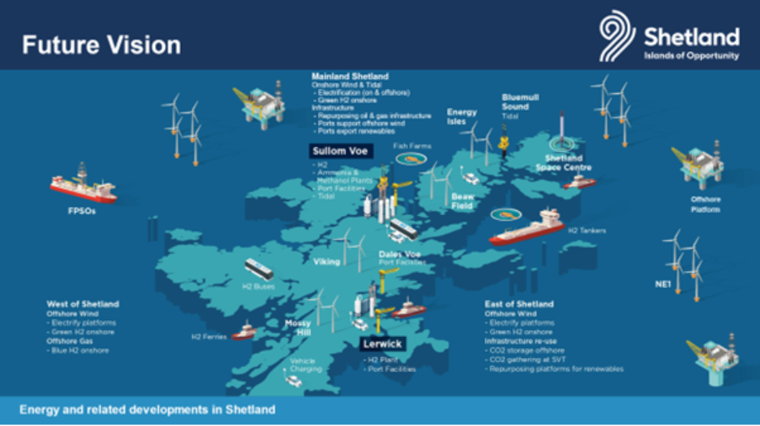

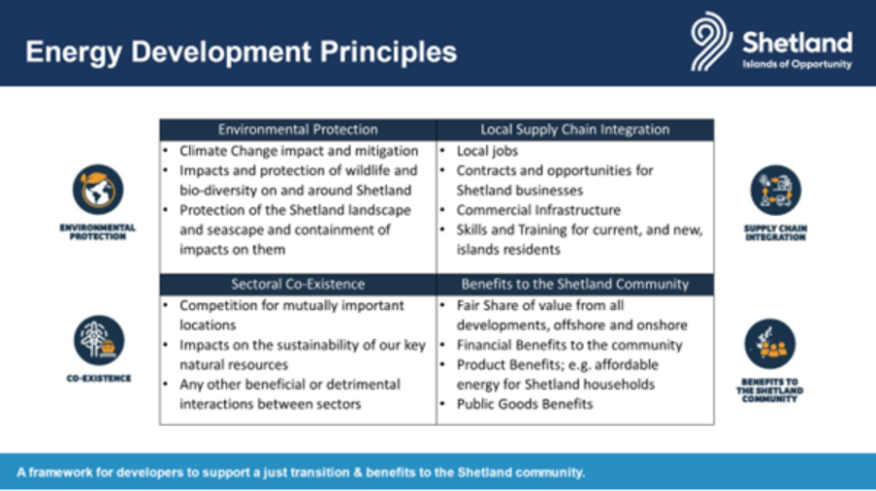

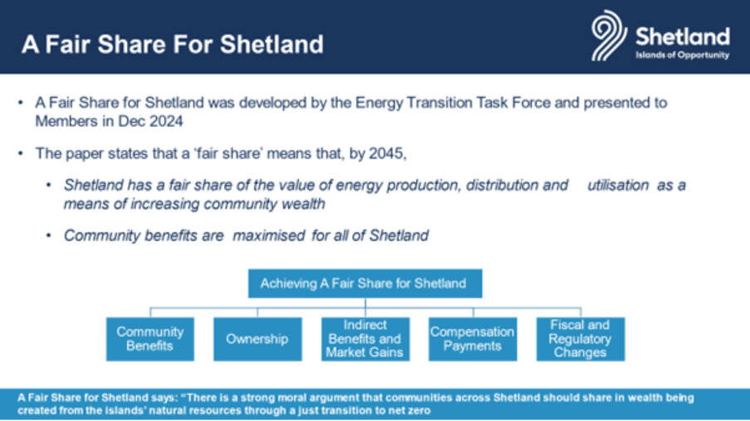

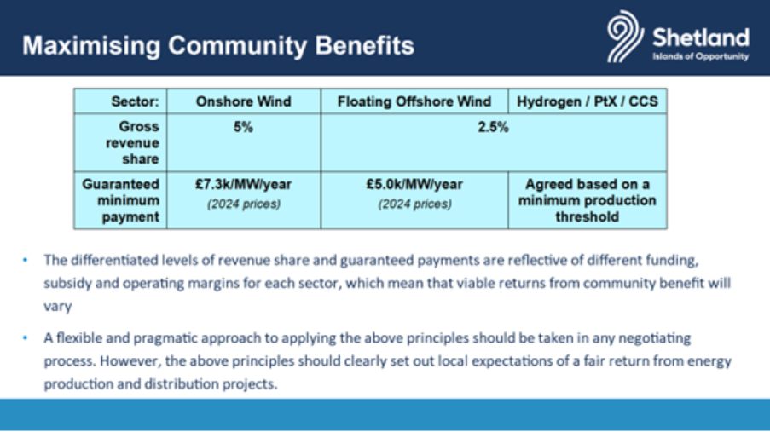

2. City of Edinburgh Council - Julie Waldron
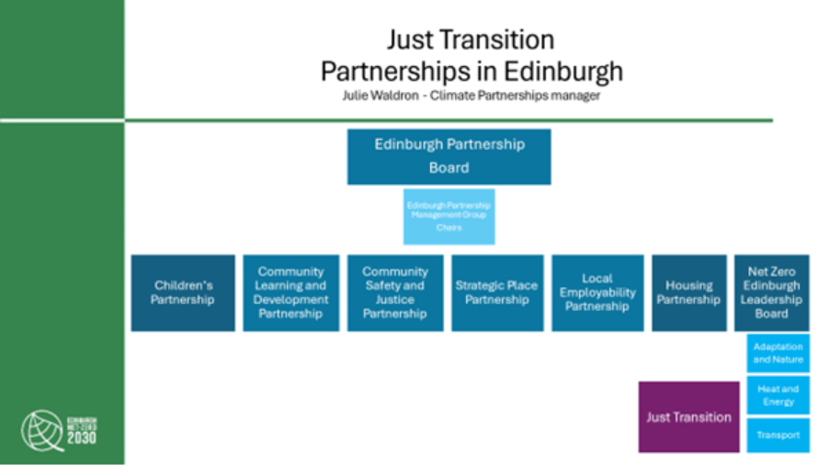

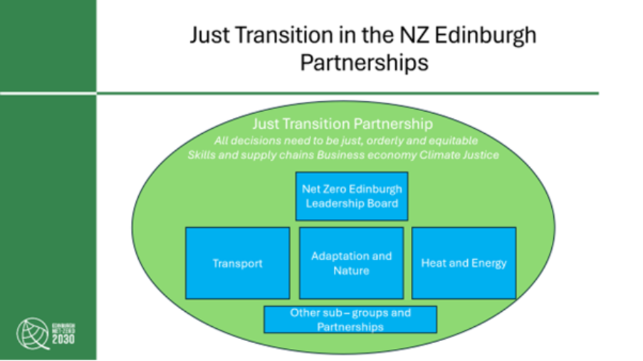

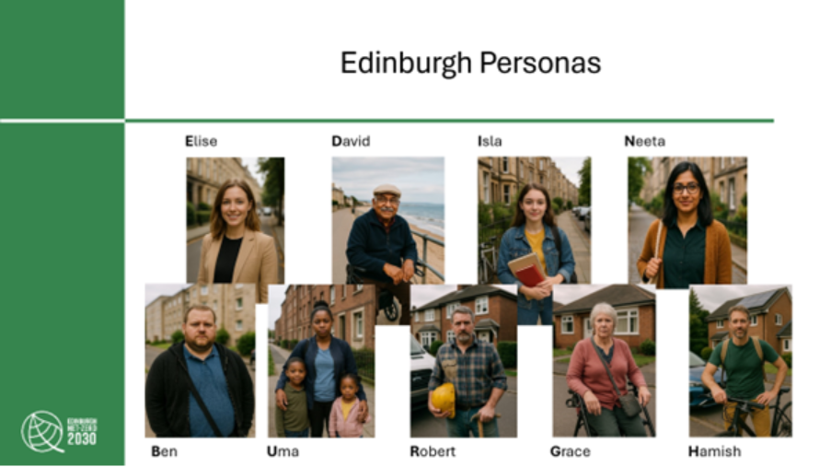
3. Glasgow City Council - Anna Macpherson
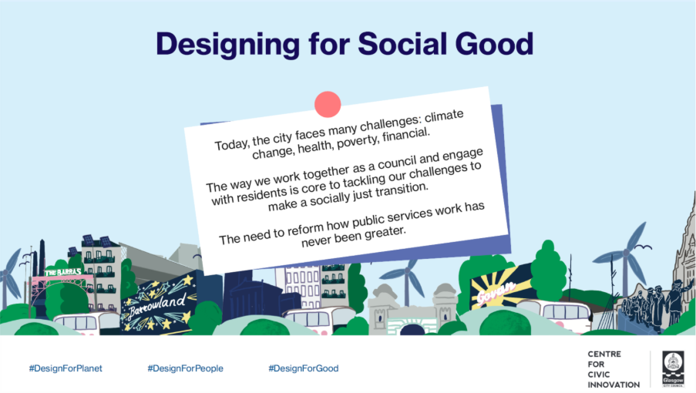

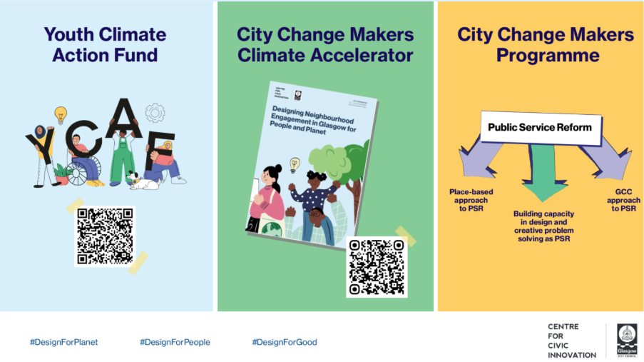

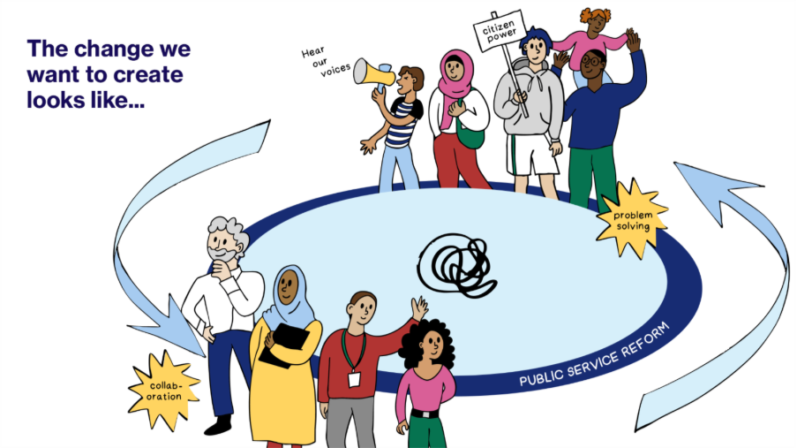

C. Breakout Rooms
This section captures the main discussion points from participants, reflecting shared priorities, challenges, and opportunities in embedding Just Transition within local government.
  - Embedding Just Transition across services: A central theme was the need to embed JT across all local authority services by providing officers with practical tools and using evidence that combines both lived experience and data.
- JT is not the responsibility of climate teams alone; it must be integrated into decision-making, service delivery, and strategy.
- Officers need tools such as checklists, training, and spaces for reflection to avoid unintended consequences.
- Evidence must combine lived experience with data to guide equitable outcomes.
  - Community and equity at the core: Discussions emphasised that no community should be left behind in the transition.
- Vulnerable and marginalised groups must be centred in JT planning to avoid widening inequalities.
- Community ownership models (e.g., solar farms) remain underdeveloped due to capital and risk barriers.
- Engagement challenges persist, including digital exclusion and dominant voices from more affluent communities.
  - Collaboration and breaking silos: Participants noted that systemic silos weaken delivery, highlighting the need for stronger internal and external partnerships.
- Internal silos reduce effectiveness; cross-department boards and shared frameworks are essential.
- External partnerships with health services, universities, voluntary groups, and regional networks are critical.
- A stronger collective voice from local authorities can influence national priorities and funding approaches.
  - Skills, jobs, and local economy: There was strong recognition of the role of JT in building inclusive local economies and addressing skills shortages.
- Local employment pathways should target all groups, not just young people.
- Skills shortages in renewables, GIS, and district heating are pressing issues.
- Apprenticeship models remain too rigid, while underfunding in FE/HE limits delivery of green skills.
- JT is closely linked to community wealth building and inclusive economic development.
  - Funding and resources: Funding structures were seen as one of the most significant barriers to delivery, with calls for stability and fairness.
- Current short-term and competitive funding (e.g., Just Transition Fund) limits ambition and planning.
- Costs (e.g., retrofitting) often fall on LAs, while benefits accrue elsewhere (e.g., NHS).
- Need for core, long-term funding to reduce inequalities and build local capacity.
  - Political and communication challenges: The group reflected on political realities and the importance of reframing messages to connect with local priorities.
- Conflicting priorities between national and local levels, high staff turnover, and lack of political will impede progress.
- The public conversation around climate change is often complicated by competing narratives and incomplete information, which is a particular challenge in fossil fuel-dependent regions.
- Messaging should shift from global climate framing to local co-benefits (jobs, health, savings).
  - Good practice examples: Participants identified practical actions and existing initiatives that can help accelerate progress. These examples provide inspiration for scaling up and adapting JT approaches across different local authority contexts:
- Cross-department collaboration: such as Edinburgh’s AI personas, Climate Change Board, and decision-making checklist.
- Community engagement: such as working with universities and communities to shape projects, capacity-building model when engaging with communities, especially those who face barriers to participation.
- Skills and training: such as Youth Climate Action Fund and retrofit apprenticeships.
- Funding and advocacy: such as Fair Share framework; collective lobbying for multi-year funding.
- Communication: such as local storytelling, museums, and cultural spaces to share JT benefits.
  - Conclusions: The discussions revealed clear areas of consensus and shared ambition among local authorities:
- Mainstreaming JT: Just Transition must be embedded across all council functions, not confined to climate or sustainability teams.
- Highlighting co-benefits: Health, jobs, affordable warmth, and community wealth are compelling drivers that make JT relevant to broader policy goals.
- Strengthening collaboration: Working within and beyond councils is essential to overcome funding, resource, and capacity barriers.
- Using stories and narratives: Sharing real-life examples helps make JT relevant, tangible, and inclusive for communities.
- Building confidence and momentum: Empowering officers and communities will be critical to sustaining progress and keeping JT high on the agenda.

