# Highland

# Local Child Poverty Action Update Report

# 2021 - 22

**November 2022**

|  |
| --- |
| Contents |

The Approach in Highland 3

Section 1: Background and Context 4 - 8

The Child Poverty (Scotland) Act 2017

Poverty in Highland

Section 2: Action in Highland 9 - 20

Summary of Actions to Address Child Poverty 2021/22

Section 3: Action in Highland 21 - 25

Actions to be taken to Address Child Poverty 2022/23

|  |
| --- |
| The approach in Highland |

There is a strong commitment in Highland to address poverty and inequality within individual agencies and across the Community Planning Partnership. The vision for the Community Planning Partnership through its Highland Outcome Improvement Plan is:

“To work together to reduce inequality within Highland communities”

The Highland Community Planning Partnership brings together public agencies, third sector organisations and other key community groups to work collaboratively with the people of Highland to deliver better outcomes.

The Highland Community Planning Partnership works strategically at a Highland level, through a series of nine geographical local Community Partnerships as well as regional thematic groups. Ultimately these deliver our Local Outcome Improvement Plan.

The Highland Outcome Improvement Plan sets out the vision, purpose and focus for the Highland Community Planning Partnership from 2017-2027. The five core outcomes have been chosen and agreed upon with communities. The partnership believes working towards these outcomes will have a significant impact on reducing inequalities in Highland.

Reducing child poverty is a priority theme within the Highland’s Integrated Children’s Service Plan which sits within a context of the Community Planning Partnership and delivering the Highland Outcome Improvement Plan.

Our partnership recognises that children’s services planning and planning to reduce child poverty is an ongoing process and that central to good planning is to ensure robust connections between all national and local strategic planning. Our child poverty plan connects the partnership strategic planning within a single framework. This framework provides both the tools for planning, self-evaluation, reporting, performance management and assurance.

The use of shared improvement language and tools strengthens and aligns the partnership approach across Highland.

Our child poverty plan articulates how partners work together to provide services which are organised, equipped to deliver high-quality, joined-up, trauma-informed and responsive and preventative support to children, young people and families.

Highland’s Integrated Children’s Service Plan uses an improvement model to determine outcomes, identify priorities and quality assure the plan.

Highland’s Integrated children’s Services Board provides oversight to the on-going work of the plan. This group has broad membership, including lead officers from The Highland Council, NHS Highland, Police Scotland, Scottish Fire and Rescue Service and a number of Third Sector organisations. The Board reports to the Community Planning Partnership Board with additional reporting to Highland Council and NHS Highland Board.

|  |
| --- |
| Section 1: Background and Context |

|  |
| --- |
| Child Poverty (Scotland) Act 2017 |

In 2017, the Scottish Government introduced the [Child Poverty (Scotland) Act](http://www.legislation.gov.uk/asp/2017/6/contents/enacted). This replaced the previous UK Child Poverty Act 2010 and included duties on both the Scottish Government and local partners to address child poverty. It also introduced income targets as a driver for reducing child poverty across Scotland. Child poverty can have negative effects on the health, wellbeing and educational attainment of the children who experience it. It also has a wider cost for society[1]. By introducing a Child Poverty Act, which sets out clear targets for reducing the number of children living in poverty, progress can be monitored on meeting these targets.

The legislation requires:

The Scottish Government to produce a Child Poverty Delivery Plan every four years highlighting how it intends to meet the child poverty targets laid out in the Act. It must also publish annual progress reports setting out progress towards meeting the child poverty targets. The Scottish Government’s second Delivery Plan – [Best Start Bright Futures](https://www.gov.scot/binaries/content/documents/govscot/publications/strategy-plan/2022/03/best-start-bright-futures-tackling-child-poverty-delivery-plan-2022-26/documents/best-start-bright-futures-tackling-child-poverty-delivery-plan-2022-2026/best-start-bright-futures-tackling-child-poverty-delivery-plan-2022-2026/govscot%3Adocument/best-start-bright-futures-tackling-child-poverty-delivery-plan-2022-2026.pdf), sets out policies and proposals to help reach the child poverty targets set for 2030.

Local authorities and health boards to jointly prepare annual Local Child Poverty Action Reports which set out activities that have been undertaken in the local authority area during the previous year to reduce child poverty and contribute to the delivery of the national targets and any planned future activities.

Evidence suggests that there are three key drivers which influence the experience of child poverty. These are income from employment, costs of living and income from social security and benefits. These drivers are set out in figure 1 below.

Figure 1: Scottish Government, Local Child Poverty Action Report Guidance 2018

Diagram showing the three drivers of poverty and what contributes to them.

Increasing incomes and reducing costs of living are mechanisms for reducing child poverty but there are many other actions that take place to improve children’s quality of life and life chances.

|  |
| --- |
| Poverty in Highland |

#### Child Poverty

Research shows that 53 per cent of children in Scotland have experienced poverty in the last 12 years. Families move in and out of poverty and can easily be pushed into poverty[2]. In 2020/21, around one in five children under 16 were considered to live in relative poverty (below 60 percent of median income after housing costs) in Highland. This figure is comparable to Scotland as a whole [3].

The latest figures from the End Child Poverty Coalition suggest a reduction in child poverty across Scotland, including Highland, however this is unlikely to yet reflect the impact of covid on low income households nor the more recent challenges related to the cost of living as outlined below.

**Figure 2: Percentage of children aged under 16 years living in income poverty after housing costs by Local Authority in Scotland**

Line chart shows the percentage of children living in poverty in each local authority area with Glasgow, East Dunbartonshire, Highland and Scotland average highlighted. Highland sits at 20.5%, just below the Scotland average of 21%.

Source: End Child Poverty Coalition

In October 2022, the Joseph Rowntree Foundation (JRF) published its report *Poverty in Scotland 2022[4].* Its findings note that:

* One in four (26%) of families with children have cut back on things their child needs, such as food or childcare
* 18% of low income households have skipped or reduced the size of meals *and* not heated their home
* 85% of families in arrears have cut back on essentials and 39% of those in arrears with kids have cut back on items for their children
* 7% of households have accessed a food bank. This rises for single parents (12%), minority ethnic families with children (13%) and low income families (10%).

#### Deprivation

Deprivation, as measured by the Scottish Index of Multiple Deprivation, provides further context for Highland. Figure 3 highlights that the majority of the Highland child population live in areas ranked in deciles five to seven nationally i.e. outwith those areas classified as the most deprived. 8% of Highland’s children and young people live in the 15% of areas categorised as most deprived.

Data from the income and employment domains of the SIMD illustrates this, as 81.1% of income deprived and 81.3% of employment deprived people in Highland do not live in the 15% most deprived areas in Scotland.[5]

**Figure 3: Number of children and young people aged under 18 years of age living in Highland in 2021 by national decile of the Scottish Index of Multiple Deprivation**

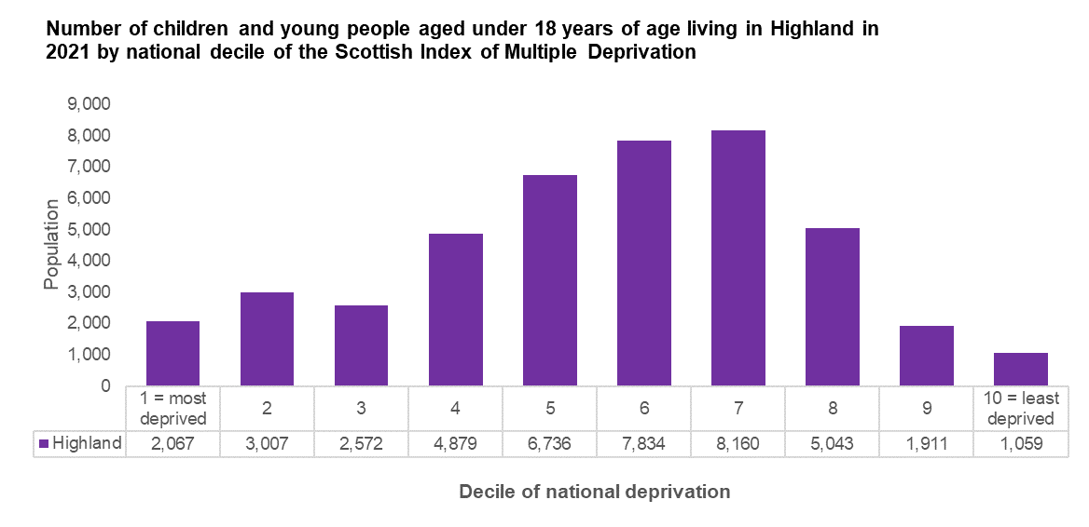

Source: Scottish Index of Multiple Deprivation 2020v2 and National Records of Scotland Small Area Population Estimates 2021

#### Remote and Rural Factors

In Highland, one in three children and young people under 18 years reside in remote rural areas, with one in five living in very remote rural areas. In contrast, one in twenty children lives in remote rural areas in Scotland, with one in forty living in very remote rural areas.

**Figure 4: Percentage of the population aged under 18 years of age living in urban and rural areas in Highland and Scotland in 2021**

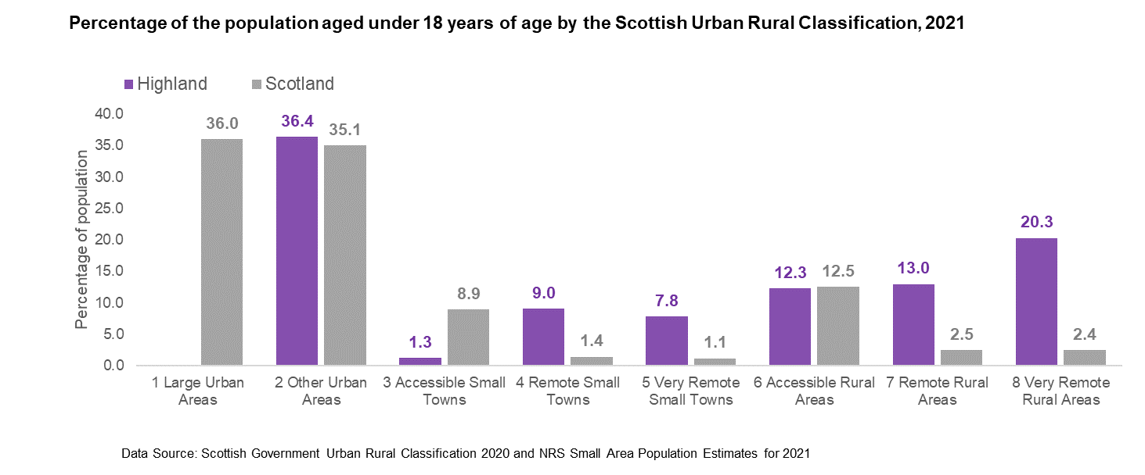

*Source: Scottish Government Urban Rural Classification 2020 and NRS Small Area Population Estimates for 2021*

Remoteness from services and facilities is an important factor in relation to considering poverty and deprivation in Highland with access challenges compounding other disadvantages. In remote and rural areas, low incomes of people are exacerbated by additional costs. This includes more expensive food and clothing, more expensive household goods, increased home energy costs and the costs of transport as shown in work on the Minimum Income Standard for Remote Rural Scotland.[6] This highlights that for people living in rural areas of Scotland, a minimum acceptable standard of living typically requires between a tenth and a third more household spending than in urban parts of the UK.

Evidence from the literature highlights that people living in rural areas experience deprivation differently from those living in towns and cities. Particular issues in rural areas include:

Less accessible key services including health and social care, childcare and high speed digital networks

Higher consumption of fuel for heating and transport

Reduced opportunities to earn adequate income

Higher cost of living impacted by prices to for basic essential supplies

Limited frequency and coverage of public transport

50% of children and young people in Highland live in the most deprived access quartile according to SIMD. This is amongst the highest levels in Scotland.

**Figure 4: Young people living in the most access deprived quintile, aged 00-25 years in 2020**

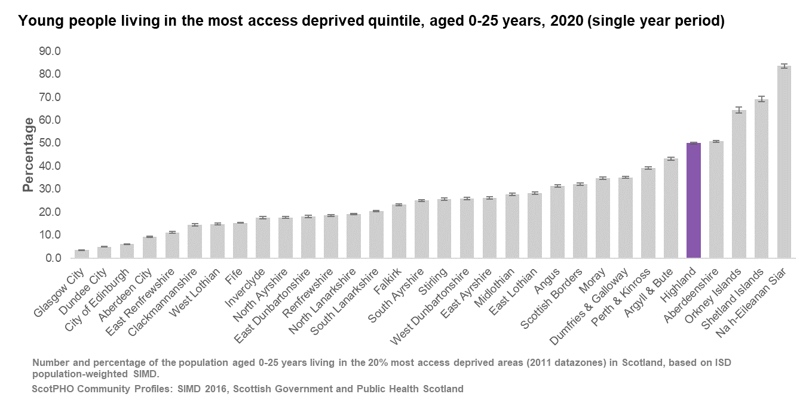

Source: ScotPHO Community Profiles – SIMD 2016, Scottish Government and Public Health Scotland

In 2022, the Scottish Government and the Scottish Rural College published *Improving our understanding of child poverty in rural and island Scotland*.[7] It identified that interventions to tackle child poverty in rural and island locations should:

* recognise higher costs of living and of service delivery in these locations
* ensure early intervention and a long term approach
* place children and families at the centre of the intervention
* explore digital approaches as a delivery mechanism, where appropriate
* involve schools as key partners
* ensure all interventions are rural and island proofed.

_______________________

|  |
| --- |
| Section 2: Action in Highland |

|  |
| --- |
| What have we done to address Child Poverty in 2021/22 |

The following summarises the key actions identified in the partnership’s 2020/21 Child Poverty Action Report against each of the core themes. Progress against each of these actions, alongside actions to address the covid specific circumstances are detailed.

|  |  |
| --- | --- |
| Theme: Income from Employment | |
| **Improvement Priority:** Work to reduce the Poverty Related Attainment Gap in Highland | |
| Area for Action | Progress |
| Support schools and communities to use Pupil Equity Fund to build a sustainable and relevant skills-based pathway for learners, pre-birth- 18 | Each school has produced its own PEF (Pupil Equity Fund) plan to meet the needs of pupils in their school. This focuses on overcoming barriers to learning and closing knowledge and skills gaps. The aim is to target support and interventions to close the gap between pupils and their peers. Examples of interventions include: additional Pupil Support Assistants, third sector mentoring and family support, targeted intervention resources and support for the cost of the school day.  Plans are monitored annually and the impact reported through standards and monitoring reports and aligned to each school improvement plan.  For secondary students at risk of disengagement and not achieving a positive destination, they are supported through mentoring and targeted programmes to aim they achieve a positive destination. |
| Evidence how communities identified through Scottish attainment challenge can be supported to enable greater engagement with learning and community opportunities | Targeted Scottish Attainment Challenge (SAC) funding and Strategic Equity Funding (SEF) has been aligned with PEF plans to raise attainment and support vulnerable and disadvantaged children and young people to achieve their potential.  Suppport has taken time to impact and embed but progress is demonstrated through ACEL and SQA performance ([Improving Outcomes for Children and Young People](https://www.highland.gov.uk/download/meetings/id/81158/item_4_improving_outcomes_for_children_and_young_people)) At primary level, there was a 10% increase in attainment on literacy and 9% in numeracy during 2021-2022. Highland was the second most improved Local Authority for literacy and numeracy primary phase in 2022. Work remains to improve performance further to be in line with the national average. |
| Engage with partners at Northern Alliance to increase data narrative around, among other factors, digital divide and lack of access to educational resources | The Digital Education & Learning Team have been supporting schools to establish a digital educational approach across all stages of the curriculum, which engages learners and delivers a high quality learning experience for all. Work has included:   * The current refresh of 22,000 Chromebooks in Highland has just been completed; supporting and sustaining the infrastructure to enable digital learning across the Highlands, and ensure that for our young people, as far as is practicable, the impacts of location, rurality, poverty and other socio-economic factors, have been mitigated. * A 1:1 model of Chromebooks for all Students from P6 -S6 and ratio of 1:5 has been deployed in P1 – P5.  Additionally, schools with under 72 pupils have been provided with 1:1 devices to support digital equity. * Personalised learning digital tools have been rolled out. This can contribute to closing equity gaps in education. A profile is a positive statement about a young person's best achievements in school, at home and in the community. Completing the profile gives the learner the opportunity to talk about their learning and achievements with parents and others, and can challenge, motivate, and support all learners. With the number of Chromebooks available to learners in Highland Schools, the use of online tools allows anytime access. * As part of the Connecting Scotland grant, Highland Council has invested in a 3-year licence for Text Help’s Read and Write software. Every pupil and educator in Highland using a Google account has access to this tool. Texthelp believes that everyone shares a fundamental need to be understood by others and sees literacy and numeracy competence as the passport to academic, social, and professional success. Read&Write is built around the principles of Universal Design for Learning (UDL), meaning that it offers benefits to ALL students as it allows them to self-select the tools, they need to support their own preferred style of learning. * An inclusive approach has been developed to take forward the digital strategy. It is critical that raising attainment isn’t just about catering for different learning styles but also about ensuring that pupils with all levels of abilities and disabilities have their needs met. To do this, an inclusive digital technology (IDT) strategy is necessary. IDT applies specifically within the educational context and describes the whole range of assistive technologies and resources used to support SEN/ASN pupils and helps learners to overcome the educational barriers they face, while encouraging independence and boosting confidence. These resources have been rolled out across Highland schools. * In partnership with local authorities, Education Scotland have published audit tools and guidance to evaluate features of highly effective digital teaching, learning and assessment. Audit tools have been rolled out to schools in Highland which measure the impact of improved use of digital tools and technology at school level. * Networks of digital leads and practitioners across both the Northern Alliance and Scotland, facilitated by Education Scotland and Google for Education are improving collaborative opportunities and by working together these networks are creating value leading to greater efficiency, shared intelligence, and innovation. * Across Highland Council Services, there is an increased expectation of accurate data, that is insight driven and outcome focused. Service collaboration, utilising data to its full potential will support improvement at all levels. This will support the attainment agenda and outcomes for young people as we use data more effectively to monitor impact of digital support. |

|  |  |
| --- | --- |
| Theme: Income from Employment | |
| **Improvement Priority:** Work to reduce the Poverty Related Attainment Gap in Highland | |
| Area for Action | Progress |
| Scottish Attainment Challenge Scotland Fund -  **Schools Programme-** Funded LA strategic plan to support 10 Highland schools with highest levels of deprivation in areas of Literacy; Numeracy and HWB. For 2021/22 there is a focus on:   * Literacy Development Officer working across target schools * Speech and Language Development Support in target schools * Numeracy Development Officer working across target schools * Care Experienced Young Persons Mentoring programme | A literacy development officer has worked across the 10 SAC schools. This has included:   * delivering training and support including Listening and Talking training materials and resources * delivering professional learning - skilling up knowledge amongst school staff. * supported moderation and benchmarking * roll out of listening and talking approaches in schools * supported Wrap Around Spelling in primary schools   Speech and Language support in schools has been impacted by covid. Planning for the delivery of this programme has taken place during 2021/22 with implementation to begin in school session 22/23.  A numeracy development officer has worked across the 10 SAC schools. This has included a focus on:   * learning and training support for teachers in use of resource materials * supported moderation of assessment across all clusters * a programme of professional learning has been delivered in collaboration with Education Scotland.   A pilot programme focused on mentoring Care Experienced Young People was undertaken during school session 21/22. The focus was on providing a mentoring offer that would promote voice and participation in relation to their own learning journey. The learning from this pilot is now being considered prior to rolling out an improved mentoring offering to care experienced young people in Highland. |
| Effective Use of Data as a Lever to attain Educational Equity  Series of improved toolkits including planning tools; reflective analysis , data dashboards and support training . Actions include:   * Improving Approaches to PEF planning * Improving Data Literacy at all Levels | Each school has produced its own PEF (Pupil Equity Fund) plan to meet the needs of pupils in their school. This focuses on overcoming barriers to learning and closing knowledge and skills gaps. The aim is to target support and interventions to close the gap between pupils and their peers.   * Plans are monitored annually and the impact reported through standards and monitoring reports and aligned to each school improvement plan. * Data focused attainment meetings have been implemented been central officers and Head Teachers and then replicated within schools. Meetings focus on understanding performance and putting faces to the data - who is meeting expectations and what are the plans to support those who are not. * This is monitored through data capture and collaborative lead officer visits and dialogue with schools with a focus on quality improvement. |
| Developing the Young Workforce – Equity of Opportunity   * Raising awareness of Developing the Young Workforce * Recruit DYW co-ordinators to work within schools to specifically target and develop young people * Implement My Future My Success approach to recruit mentors and develop programme’s of engagement with the aim of achieving positive destinations | Developing the Young Workforce:   * DYW co-ordinators recruited and are working in schools with a focus on pathways, employment and skills opportunities with a view to achieving a positive destination. * Co-ordinators working with identified cohorts of young people to identify and promote appropriate pathways and work towards positive destinations. * Events held across Highland to raise awareness of the team and role in partnership with schools, job centre and Skills Development Scotland * Work undertaken to promote understanding and share positive destination data to raise awareness of DYW team and role   My Future My Success   * Mentors recruited, trained and allocated to identified cohorts of young people who have been referred by schools. * Identification of individuals who are becoming engaged and referred to the programme * Bespoke programmes of support in place across Highland with a focus on achieving positive destinations for young people |

|  |  |
| --- | --- |
| Theme: Income from Employment | |
| **Improvement Priority:** Improve opportunities for training and apprenticeships for parents and young people as part of the Council’s Economic Prosperity Fund | |
| Area for Action | Progress |
| Support the roll out of Parental Employability Support Fund programme – targeting ‘in work’ progression for parents | The Council has recently employed key workers to work with out -of- work and under employed parents to support their progression and earning potential. The Council’s Employability Service works with the Job Centres to achieve this.  The Council’s Employability Service supported 97 parents during 2021-2022 with a range of employability support from basic skills and confidence to paid placements and employment Opportunities. These participants have mainly been out of work rather than in-work.  The main focus for parents has been delivered through the PEEP Programme.  PEEP is Learning Together Programme which focuses on different learning strands (literacy, numeracy, communication and language, health and physical development, emotional and social development ).  **Case Study – The PEEP group in Grantown** was very successful in terms of getting the engagement from parents in that area.   It supported those out of work as well as mums in work support, since some of them were due to return from maternity leave and it gave them a safe space to discuss any concerns they had.  The Peep sessions have helped to build a strong relationship with the YMCA and their engagement in the community has helped to recruit families and promote the Highland Employability Service. The Peep group has also helped to build professional relationships with health visitors in that area who have been in touch about support. |
| Support the development of the Young Person Guarantee work placement programme as a way to support job creation | 147 young people (under the age of 25 years) have been supported into employment through the Highland Employment Recruitment Offer (HERO) in 21/22 financial year.  The establishment of the strategic level Highland Employability Partnership (HEP) and 3 operational level Local Employability Partnerships (LEPs) in North Highland, West Highland and Inner Moray Firth is complete, with a range of partners actively working together.  The aim of the HEP is to work with individuals and employers to raise as many Highland residents as possible out of poverty through sustainable and fair work; supporting those who face multiple barriers into employment and enabling progression out of poverty for those already in work. |
| Develop the Modern Apprenticeship scheme for 16-65 year olds at all levels to support all sectors in Highland, including upskilling and vocational qualifications post Covid-19 | The Highland Council Modern/Graduate Apprenticeship programme is suitable for people of all ages (16 – 67yrs old). Since 2017, the apprenticeship programme has enrolled over 484 staff; 203 are current MA/GAs and 231 have completed the training. 165 have been new apprentices to the Council and 319 have been upskilling existing staff. There are now over 20 modern apprentice frameworks being utilised and a further 6 graduate apprentice frameworks. |

|  |  |
| --- | --- |
| Theme: Cost of Living | |
| **Improvement Priority:** Address food insecurity by increasing equity of access to good quality food | |
| Area for Action | Progress |
| Lobby the Scottish Government to continue the provision of the financial support for families during the school holidays | In partnership with COSLA, Scottish Government lobbied to continue financial support for food for families during school holidays post COVID. Support agreed up until June 2022. |
| Support the development of sustainable food tables and fridges in order to reduce the stigma associated with accessing food support | * Community food infrastructure plays a critical role in supporting people who are food insecure. The purpose of this mitigation is to support organisations that are responding to food insecurities – including those that do so through food parcels, community pantries or larders, food tables, community meals and other initiatives. These organisations are generally charitable, or community based and often rely on partnerships, donations and volunteers to deliver a needs-based approach. * Highland Council’s Community Support Co-ordinators have been working with groups across Highland to support the development of sustainable food tables and fridges. * A partnership arrangement has been developed with Fareshare - a UK wide charity which accesses and redistributes surplus food – to ensure access for food tables and food fridges to access supplies. * During 2021/22, the Council and FareShare distributed in excess of **195** **tonnes** of quality food to the Highlands, which is estimated to be equivalent to over **464,000 meals** with an estimated value of around **£261,000**. The vast majority of food has been distributed across the network of community and faith groups which has been used to provide cooked meals and food supplies within local communities. * Highland Third Sector Interface have developed, in collaboration with the Highland Good Food Partnership, a map to show food activity and community food provisions across Highland. The purpose of the Highland Food Activity Map is to help people find where they can buy and access food across the region. The map is for organisations within the Highland Council region who align with the [Highland Good Food Charter.](https://highlandgoodfood.scot/charter/) The map includes:   + food banks   + local food producers   + community fridges and larders   + community cafés |
| Develop strategies to increase the uptake of free-school meals | * Availability of free school meals was promoted during 2021/22 via social media and direct through school network channels. * National negotiations are ongoing on data sharing to enable automatic awards of free school meals and ensure families do not have to apply * During 2023/22 4,260 pupils were entitled to free school meals |
| Theme: Cost of Living | |
| **Improvement Priority:** Reduce the financial barriers on families | |
| Area for Action | Progress |
| Promote the uptake of clothing grants | Promoted through schools and social media channels. Shared form to jointly promote free school meals and clothing grant uptake.  National negotiations are ongoing on data sharing to enable automatic awards of free school meals and ensure families do not have to apply  During 2021/22, 4,260 pupils were entitled to clothing grants |
| Encourage the uptake of concessionary leisure schemes for children with low income backgrounds | Work has been ongoing to promote the update of the High Life Highland budget family cards, mainly through schools.  Currently there are 9,200 households across Highland that have a registered family budget card. This would mean that at least double that number have access to the scheme.  The action for the following year will be to raise awareness of the scheme through promotion to free school meals and clothing grant recipients. |
| Promote and raise awareness of fuel discounts and grants and energy advice and switching services | The welfare team have identified potential beneficiary households for energy and fuel advice and referred direct to the Energy Advice project run by CAB.  Inverness CAB have undertaken energy checks and provided advice regarding switching  1,896 families were referred for energy advice and support  During 2021/22 the Council supported households to benefit from a range of different Highland Council fuel discounts including Low Income  and Energy Support payments   - 17,405 households were supported over this period. |
| Implementation of the Northern Alliance *Cost of the School Day Toolkit* | The Cost of the Day Toolkit has been piloted in a number of schools during 2021/22 with a view to roll-out across Highland during 2022/23  A series of profession learning seminars have been held for schools staff to promote awareness and understanding of the implications of the Cost of the school day and links to closing the poverty related Attainment gap. This included:   * Leadership Profession Learning Session 14/9/22 Closing The Poverty Related Attainment Gap- Cost of The School Day. * Leadership PL Session 15/6/22 Closing The Poverty Related Attainment Gap- Breakfast for All – learning from Breakfast for All pilot project at Cauldeen Primary school. |

|  |  |
| --- | --- |
| Theme: Cost of Living | |
| **Improvement Priority:** Increase access to and uptake of affordable and flexible childcare | |
| Area for Action | Progress |
| Support and increase the uptake of 1140 hours ELC provision | All parents now have access to 1140 within their community or within reasonable travelling distance.  1140 hours is offered to all and only where parents request less do they get that.    1140 is promoted around enrolment time with press release, each individual setting advertises what they offer. Some offer drop ins or info sessions.  For eligible 2s we will be writing out 3 times per year to make the offer (info coming from end this month via SG from DWP) |
| Support the uptake of eligible 2 year old ELC provision | 1140 is promoted around enrolment time with press release, each individual setting advertises what they offer. Some offer drop ins or info sessions.  Work is ongoing to access eligibility data from national sources in order to directly target the offer to parents of eligible 2s. |
| Develop a strategy to promote awareness of   * Access to support for childcare costs * Access to tax free childcare | A strategy has been developed to promote awareness of access to childcare cost supports.  HMRC advice on access to childcare costs and tax free childcare promoted across networks in Highland |
| Explore options with partnerships to support flexible models of childcare in individual communities | Work is ongoing to support and develop flexible models of children. The Council are actively working with SCMA to recruit childminders in remote and rural communities who can then offer a flexible service. |

|  |  |
| --- | --- |
| Theme: Income from Social Security and benefits in kind | |
| **Improvement Priority:** Maximise uptake of child related social security benefits | |
| Area for Action | Progress |
| Maximise uptake of child specific benefits including   * Best Start Grants * Child payment uptake * Best start Food payment | Promotional work has been undertaken across Highland to promote all child related social security via:   * Social media * Schools * Community group network * Staff newsletters * Money matters course for professionals |
| Maximise uptake of DWP benefits, including those with childcare costs, including outcomes from the Council’s Advice & Information contract.  And  Raise awareness of entitlements and where to get support with a particular focus on changing circumstances with services, organisations, groups. | * During 2021/22 the Council’s Welfare Team and CAB Highland network continued to support families and households to access all entitlements due. * The work of the teams has been promoted across Highland through a range of networks and platforms * Support has been developed in the form of the Money Worries leaflet – available in 6 languages – Money Matters course and information provided on entitlements through the community group bulletin. * More than **23,700** residents within Highland sought support from Council-funded welfare services during the financial year 2021/22. This generated in excess of **71,400** client contacts seeking advice on a variety of issues including COVID-19, welfare, money and housing * In Highland, financial gains derived for clients during 2021/22, by these Council-funded welfare services, exceeded **£19.3m**. * During 2021/22, the Revenues & Business Support section administered welfare payments to vulnerable and marginalised residents which exceeded £78m. These payments were a mixture of regular welfare payments, one-off covid related expenditure and one-off specific awards towards mitigating cost of living challenges. |
| Implementation of health visitor financial inclusion pathway | * A joint Public Health, Welfare and Health Visitor project in 21/22, involving health visitors and the Welfare Team has nurtured a financial inclusion pathway across Highland with all Health Visitors and Family Nurse Partnership asking about financial matters at first point of contact. * A referral pathway is operating to enable Health Staff to refer to the Council’s Welfare Team. * The project was awarded a Scottish national financial inclusion award in 2021/22 for the collaborative approach, developed referral pathways and positive outcomes for family incomes. |

Section 3: What are we planning to do to address Child Poverty in 2022/23

The actions to address Child Poverty in 2022/23 are outlined below and reflect those previously agreed as part of the Integrated Children’s Service’s Plan 2021-2023, where one of the core priorities is Child Poverty. Where actions have been completed these have not been included and some have been revised to reflect work already taken and the next steps.

A new Integrated Children’s Services Plan will be developed during 2022/23 and as part of this process, the priorities and actions on child poverty will be updated to reflect the current context. The cost of living crisis, developing in the latter part of 2022 will likely impact upon the developing actions.

The partnership actions to address child are aligned to the Integrated Children’s Plan and are reported as part of the Integrated Children’s Service Plan monitoring.

|  |  |  |  |
| --- | --- | --- | --- |
| Theme: Income from Employment | | | |
| Improvement priority:  Work to reduce the Poverty Related Attainment Gap in Highland | | | |
| Actions | Measures / evaluation | Timescale | Lead |
| Target the use of SEF to fund collaborative lead officers who work directly with schools 3-18 to improve quality standards and outcomes on a particular focus on those who are disadvantaged. | Stakeholder feedback, triangulation of evidence, schools, families, partners | August 2023 | Head of Service Early Years and Primary and Head of Service Secondary |
| Target the use of SEF to fund MCR pathways programme to support care experienced children and young people to achieve a positive destination | Positive destination outcomes for care experienced young people | August 2023 | Head of Service Early Years and Primary and Head of Service Secondary |
| Set ambitious stretch aims as required by Scottish Government to ensure performance improves to be in line with the national average and develop a collaborate improvement framework to support schools to deliver the improvement. | ACEL and SQA data | August 2023 | Head of Service Early Years and Primary and Head of Service Secondary |
| Work to continue the roll-out of digital resources to support course materials and literacy and numeracy activities and to support schools register for the Digital Schools Award. | Delivery of digital resources to schools | August 2023 | Head of Service Early Years and Primary and Head of Service Secondary |

|  |
| --- |
| Theme: Income from Employment |
| Improvement priority:  Work to reduce the Poverty Related Attainment Gap in Highland |

|  |  |  |  |
| --- | --- | --- | --- |
| Actions | Measures / evaluation | Timescale | Lead |
| Scottish Attainment Challenge Fund -  **Schools Programme-** Funded LA strategic plan to support 10 Highland schools with highest levels of deprivation in areas of Literacy; Numeracy and HWB   * Continue to implement the collaborative improvement framework including targeted training and support for teachers and leaders in relation to literacy, numeracy, assessment, moderation and standardisation | Literacy Measures:   * Staff Impact questionnaires – degree of pedagogy development and delivery impact. * Baseline assessment data Attainment data 17/18, 18/19. 19/20, 20/21 including PM Benchmark, SNSA   Numeracy Measures   * Attainment data 17/18, 18/19. 19/20, 20/21 including Diagnostic assessments, SNSA * Staff Impact questionnaires – degree of pedagogy development and delivery impact. | August 2023 | Head of Service Early Years and Primary and Head of Service Secondary |
| Effective Use of Data as a Lever to attain Educational Equity  To continue the implementation of the collaborative improvement framework and raising attainment strategy. This will include:   * Improving Approaches to PEF planning * Improving Data Literacy at all Levels | Measures   * Improved ACEL and SQA data | August 2023 | Head of Service Early Years and Primary and Head of Service Secondary |
| Developing the Young Workforce – Equity of Opportunity   * Through work of the DYW co-ordinators, focus on raising attainment and develop appropriate ambitious guidance * Expanding and embedding the My Future My Success programme across Highland. | Measures   * Positive destination data * Attainment data | August 2023 | Head of Service Early Years and Primary and Head of Service Secondary |

|  |  |  |  |
| --- | --- | --- | --- |
| Theme: Income from Employment | | | |
| Improvement priority:  Improve opportunities for training and apprenticeships for parents and young people as part of the Council’s Economic Prosperity Fund | | | |
| Actions | Measures / evaluation | Timescale | Lead |
| Support the roll out of Parental Employability Support Fund programme – targeting ‘in work’ progression for parents | Number of parents supported | Aug 2023 | Economic Prosperity Fund |
| Support the development of the Young Person Guarantee work placement programme as a way to support job creation | Number of placements supported | Aug 2023 | Economic Prosperity Fund |
| Develop the Modern Apprenticeship scheme for 16-65 year olds at all levels to support all sectors in Highland, including upskilling and vocational qualifications post Covid-19 | Number of Modern Apprenticeships created | Aug 2023 | Economic Prosperity Fund |

|  |  |  |  |
| --- | --- | --- | --- |
| Theme: Costs of Living | | | |
| Improvement priority:  Address food insecurity by increasing equity of access to good quality food | | | |
| Actions | Measures / evaluation | Timescale | Lead |
| Continue to lobby Scottish Government beyond June 2022 and consider Council led support to mitigate | Feedback from the Scottish Government | August 2023 | Poverty Reduction Delivery Group |
| Support the development of sustainable food tables and fridges in order to reduce the stigma associated with accessing food support including the development of a ‘How to’ guide to support groups wishing to take this forward | Number of food tables and fridges available | August 2023 | Head of Community Support, Contact and Engagement |
| Continue to develop strategies to increase uptake of free-school meals targeted at secondary provision. | Increase in uptake of free school meal provision | August 2023 | Head of Revenues and Business Support |

|  |  |  |  |
| --- | --- | --- | --- |
| Theme: Costs of Living | | | |
| Improvement priority:  Reduce the financial barriers on families | | | |
| Actions | Measures / evaluation | Timescale | Lead |
| Promote the uptake of clothing grants and explore passporting awards | Increase in the number of families claiming clothing grants | August 2023 | Head of Revenues & Business Support |
| Encourage the uptake of concessionary leisure schemes for children with low income backgrounds through specific targeting of the opportunity to free school meals and clothing grants recipients | Increase in the number of concessionary leisure schemes | August 2023 | High Life Highland |
| Promote and raise awareness of fuel discounts and grants and energy advice and switching services | Number of households opting to be referred by the Council for energy advice.  Number of households benefiting from local fuel support schemes. | August 2023 | Head of Revenues & Business Support |
| Implementation of the Northern Alliance *Cost of the School Day Toolkit* | Number of schools using the toolkit | August 2023 | Head of Primary and Early Years Education |

|  |  |  |  |
| --- | --- | --- | --- |
| Theme: Costs of Living | | | |
| Improvement priority:  Increase access to and uptake of affordable and flexible childcare | | | |
| Actions | Measures / evaluation | Timescale | Lead |
| Support the uptake of 1140 hours ELC provision | Increase in uptake of 1140 hours | Aug 2023 | Senior Manager Early Years |
| Support the uptake of eligible 2 year old ELC provision | Increase in uptake of eligible 2 places | Aug 2023 | Senior Manager Early Years |
| Continue to promote school child payment and Scottish child disability payment | Numbers accessing both payments | Aug 2023 | Head of Revenues and Business Support |
| Explore options with partnerships to support flexible models of childcare in individual communities | Options for flexible models of childcare developed | Aug 2023 | Senior Manager Early Years |

|  |  |  |  |
| --- | --- | --- | --- |
| Theme: Income from social security and benefits in kind | | | |
| Improvement priority:  Maximise uptake of child related social security benefits | | | |
| Actions | Measures / evaluation | Timescale | Lead |
| Maximise uptake of DWP and Social Security Scotland benefits, including those with childcare costs, including outcomes from the Council’s Advice & Information contract. | Increase the numbers claiming DWP benefits and other entitlements | August 2023 | Head of Revenues and Business Support |
| Implementation of midwifery financial inclusion pathway | All midwifes referring to Welfare Support Team | August 2023 | Head of Health |

1. A 2013 study found that child poverty in the UK was costing at least £29 billion a year –<http://www.cpag.org.uk/sites/default/files/Cost%20of%20child%20poverty%20research%20update%20(2013)_0.pdf>
2. Scottish Government. Child Poverty Anaysis. [Online] <https://www.gov.scot/collections/child-poverty-statistics/>
3. Stone, J. Local indicators of child poverty after housing costs, 2020/2. Centre for Research in Social Policy Loughborough University for End Child Poverty Coalition; 2022. <https://endchildpoverty.org.uk/wp-content/uploads/2022/07/Local-child-poverty-indicators-report-2022_FINAL.pdf>
4. <https://www.jrf.org.uk/report/poverty-scotland-2022>
5. Scottish Index of Multiple Deprivation 2020v2 https://www.gov.scot/collections/scottish-index-of-multiple-deprivation-2020/
6. Minimum income standard for Remote Rural Scotland – Policy update 2016, Loughborough University [*http://www.hie.co.uk/common/handlers/download-document.ashx?id=90d6c2f6-a461-4ff8-9902-49f073765e39*](http://www.hie.co.uk/common/handlers/download-document.ashx?id=90d6c2f6-a461-4ff8-9902-49f073765e39)
7. <https://www.gov.scot/publications/improving-understanding-child-poverty-rural-island-scotland/>