Appendix 4 – LG Data Returns Governance Group - Terms of Reference
LG Data Returns Governance Group
Terms of Reference
September 2024

- Summary
  - The Local Government Data Returns Governance Group (LGDRGG) introduces a more strategic, pro-active, and coherent approach to the management of data returns, whereby decisions on current and future data reporting are made jointly by local government and Scottish Government. This approach embraces the principles of the Verity House Agreement, and the commitment to a more collaborative approach between local government and Scottish Government to delivering on our shared priorities. It will also ensure a focus on reporting which is essential to evidence improvement in outcomes in partnership, ensuring that we take account of existing data reporting and consider streamlining and reducing where possible.

- Aim of the LGDRGG
  - The (LGDRGG) is a new governance mechanism to improve arrangements for managing the lifecycle of data returns which councils are required to provide. Currently, governance arrangements for the introduction of data returns, changes to returns and the cessation of returns are managed on a case-by-case basis with individual external agencies. There is no co-ordinated review process for evaluating and approving new (or change) requests, or cyclically confirming returns are still valid. There is a need to adopt a more strategic, pro-active, and coherent approach.

  - All requests for new data reporting, changes to existing data reporting, and cessation of data reporting will be considered by the LGDRGG. The process by which requests will be received by the LGDRGG, and the information that will be contained in support of these requests is set out in Appendix 2 and Appendix 3. This process involves meaningful engagement between local government and Scottish Government officers in advance of a final proposal being presented to the LGDRGG, to build consensus and to ensure that the information required by the Governance Group to inform the decision-making process is available.

  - The aim of the LGDRGG is to:

    - Build trust around delivery, and a focus on collecting only the data that is required to evidence outcome improvement.
    - Utilise the protocol and governance mechanism to agree and implement any future reporting that is required.
    - Reduce the overall volume of data reporting, focussing on policy relevance and impact on improving outcomes and identifying and removing areas of duplication.
    - Operationalise the high-level principles developed to support reviews of relevance and usefulness of current and future data reporting.
    - Promote and ensure greater use and re-use of collected data in driving improvement in outcomes.
    - Improve the quality of data and adoption of robust data standards in order to improve confidence, usability and interoperability of data.
    - Utilise the Calendar of Returns to improve planning and co-ordination of existing reporting and to timetable in any future data reporting agreed by local government and Scottish Government.
    - Develop and operationalise ongoing hosting and updating arrangements for the Online register of data returns (ODRR).
    - Review the extent to which the Crerar recommendations have been implemented and ensure that issues in relation to the collection and reporting of data are fully linked into the evolving scrutiny landscape.

- Chairing and Membership
  - This group will be jointly chaired by COSLA and Scottish Government, and core membership of the group will include Solace and colleagues in local government and Scottish Government with expertise in data returns. Additional members will be invited to sit the group on an ad-hoc basis, when amendments to non-Scottish Government data returns are being considered. Membership details are set out in Appendix 1. Members will report progress through existing governance structures, including via Ministers, COSLA Leaders, the LGBF Board and Solace branch meetings.

- Role and Remit of Governance Group
  - The key responsibilities of the Governance Group are to:
- Consider and endorse requests to introduce new data reporting and/or reduce current data reporting, ensuring that they meet with the principles.
- Support the proposed changes to the data reporting landscape, by helping to lift any barriers to implementation which may exist.
- Monitor the implementation of agreed changes to the data reporting landscape.
- Review the impact of the new governance process on the data reporting landscape over the longer term.

  - In order to undertake this role, Governance Group members will be required to:
- Provide robust challenge, scrutiny, and suggestions, to help ensure that changes to the data reporting landscape are in line with agreed criteria and principles.
- Offer practical support and advice to help facilitate the implementation of the agreed changes.
- Ensure that requests for new data returns are agreed with external agencies based upon a common understanding of the value that the data will provide to the external agency, and the impact that the request would have on local government.
- Avoid introducing new data returns that duplicate existing data collection.
- Ensure that the reporting requirements are clear so that Councils fully understand how to provide data in order to avoid different interpretations of requirements that could lead to discrepancies in the data.
- Ensure that there are adequate, appropriate, and consistent mechanisms and controls in place to coordinate the collection of data returns.
- Ensure that any changes to the requirements for data returns are minimised, but where they are required, they are clearly communicated and understood by Councils.
- Ensure that the continued relevance of data returns is evaluated on a periodic basis, and data returns are retired if they no longer deliver value and agreement on any subsequent publication of data.
- Promote and champion the principles, ambition, benefits, and progress of the joint LG/SG Data returns governance mechanism.

  - The group will consider the following criteria to inform their decision making:
- Why do we need the data in first place (referencing political, outcome focussed, capacity and resources elements)?
- What data should be reported?
- What is the data quality?
- What data standards are applied?
- What level of data needs to be reported, i.e., detailed or light touch?
- How are we returning it and what technology is being used?
- How is it being analysed and interpreted?
- What use is being made of it (nationally and locally)?

  - The Governance Group will adhere to the following high-level principles developed to support reviews of relevance and usefulness of current and future data reporting. These principles state that data reporting must:
- Provide a clear line of sight to both NPF and locally defined outcomes.
- Deliver usefulness in informing local decision making and driving self-improvement.
- Ensure proportionality in terms of local burden and resource.
- Ensure re-use of existing data rather than replication or duplication.
- Involve automation of data collection from Local government rather than manual processes
- Involve close collaboration between local government and Scottish Government throughout the lifecycle of data returns – from development to cessation.
- Include regular review with local government to ensure fitness for purpose.
- Provide clarity for local government in terms of the purpose and use of data collected by Scottish Government, and how it is used to strengthen accountability.

- Frequency of Governance Group Meetings
  - The group will meet on a monthly basis, to ensure that decisions are taken in a timely manner. Proposals to change the reporting landscape will be prepared and shared in advance of each meeting and informal liaison meetings between the main partners will take place as and when required.

- Management of the Group
  - The Improvement Service will be responsible for providing a secretariat for the group, and for circulating proposals to change the Local government data reporting landscape in advance of the meetings.

Data returns Governance Group Membership
Jane O’Donnell (Co-Chair), Chief Executive, COSLA
Scottish Government (Co-Chair) - tbc
Louise Long, Inverclyde Council Chief Executive, Solace
Local Government data expert tbc
Scottish Government data expert tbc

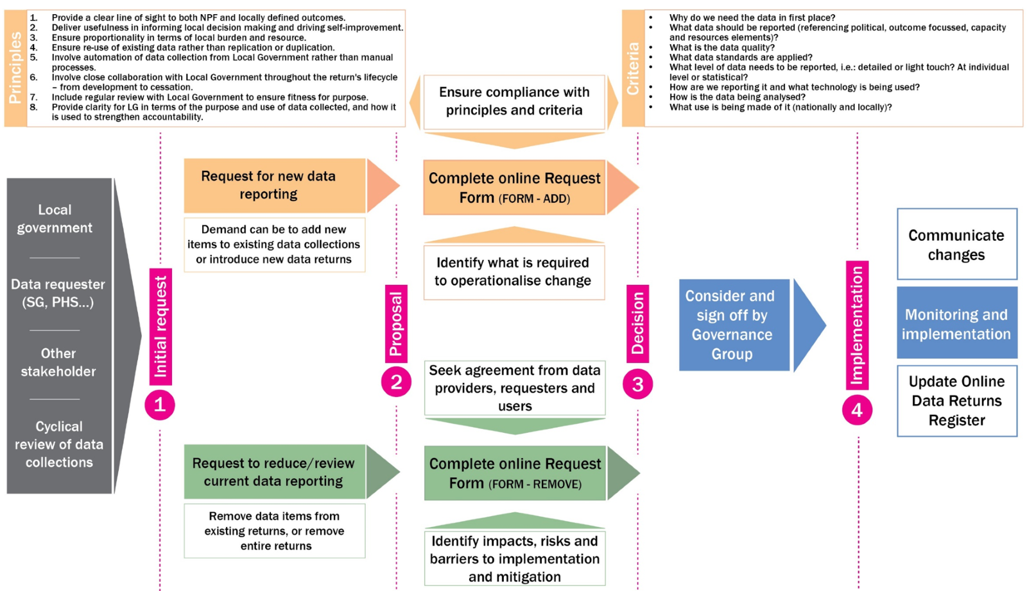
Appendix 4 (cont.) – A new governance process for the LG data reporting landscape
APPENDIX 4 – ONLINE FORMS: INTRODUCTION OF NEW RETURNS, CHANGES TO EXISTING RETURNS, & CESSATION OF RETURNS

(FORM-ADD) INTRODUCTION OF NEW RETURN OR NEW ITEMS WITHIN EXISTING RETURN

PURPOSE AND USE
Why is new data needed and how will it be used?
Please provide the rationale for introducing this data collection. This may include for example: political assurance; assurance in relation to funding; monitoring policy implementation; measuring improvement in key outcomes; understanding system capacity; informing funding allocations. How have you determined that this need cannot be met by data already submitted? If individual level data is required, why is this?
How will this data help in improving outcomes for our communities?
How will this data be useful in informing local decision making and driving self-improvement?
How will this data provide a clear line of sight to the National Performance Framework?
How will the data be analysed?
Please provide information about how the data will be analysed, including whether you intend to link this data with other datasets. Will this data be analysed at a local authority level to provide scrutiny around local variability? How have you assessed the extent to which these analyses will benefit LAs?
How will this data be published?
How, when and under which format will the data be made available back to LAs, and the wider public?
What is the anticipated life cycle of this return, what is the review schedule, and how will LG be involved?
Data returns should be reviewed at least once a year and involve LG.

DATA REQUIREMENTS
Data definitions and specifications
What data will be collected? Please include definitions and specifications for each data item collected.
Timings of data collection
When and how often will the data be collected?
Format and method of data collection
How will the data be collected, including what technology and method used?
In terms of data quality, what steps have you taken to ensure that the data collected will be fit-for-purpose and meet relevant data standards?
Please provide any relevant guidance and data specification documentation.

ASSESSING THE BURDEN/IMPLICATIONS
How have you assessed what the demand on resources will be to provide this data?
What is the overall cost to return this data from a LA perspective? Is the data easily available to produce, or will it require changes to IT systems?
What will be required to operationalise this new data collection, e.g., changes to legislation, existing work processes, IT systems?
What resources are being made available for councils to support implementation of this additional return?
Is any funding available to LAs to implement changes to their reporting tools and processes?
Please provide details in relation to timeframes and responsibilities in relation to implementation.

ENGAGEMENT
What engagement has taken place between SG and LG to collectively consider and develop this request?
Is there a consensus between data providers (LAs), data requester and data users to introduce this data collection, and if not where is the disagreement?

(FORM-REMOVE) - CESSATION OF RETURNS OR INDIVIDUAL DATA ITEMS
What data returns / data items are you proposing to stop collecting?
Why are you proposing to stop collecting this data?

Will there be an impact on the quality of service that our communities receive?

Are there any other anticipated impacts (policy development, political risk, funding decisions)

What are you proposing to do to mitigate these impacts?

What engagement has there been between data requesters, data providers and wider data users to assess the impacts of stopping this data collection?

Is there a consensus between data providers (LAs), data requester and data users to cease collecting this data, and if not where is the disagreement?

