New user access to the ELC Insights Dashboard

Updated: 02/06/2025

# New User Access

1. An existing user can request access for colleagues directly involved in ELC service delivery and planning using the Microsoft Form in the ‘Links’ section of the tool.

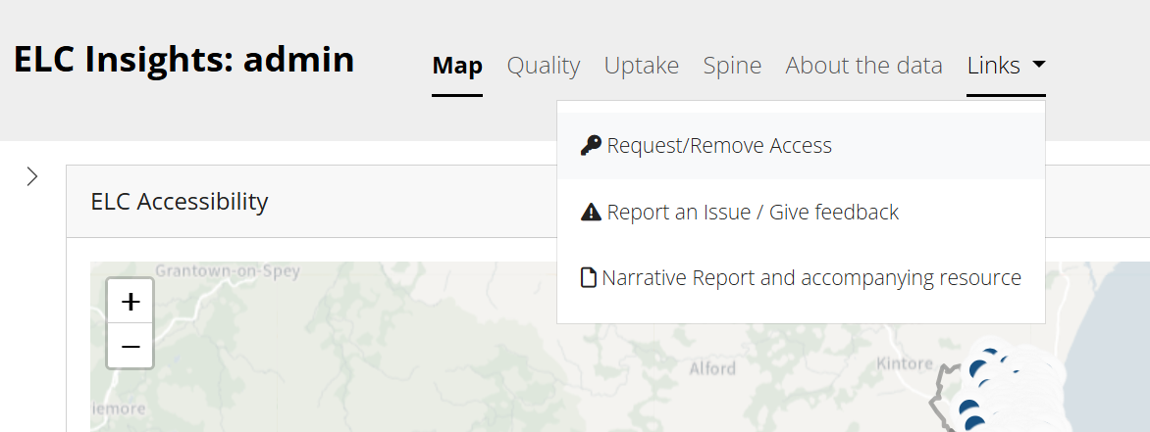

1. The Improvement Service monitors access requests and will manually trigger an invitation email to the new user (see image below). Please follow the link in the email. If you suspect the email has been lost or blocked, then the Improvement Service can email this link to you directly. **Do not attempt to access the tool or sign up using a dashboard link from a colleague, this will result in a failed log-in. In the event this has occurred, go to** **Initial Troubleshooting****.**

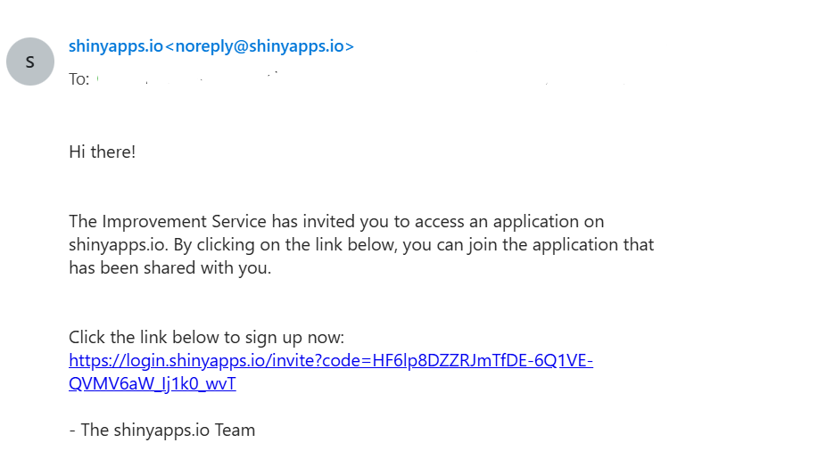

1. Click ‘**Sign Up**’ and set up a *ShinyApps* account using your work email address. Approved email domains are:

@[aberdeencity.gov.uk](http://aberdeencity.gov.uk/), @[aberdeenshire.gov.uk](http://aberdeenshire.gov.uk/), @[angus.gov.uk](http://angus.gov.uk/), @[argyll-bute.gov.uk](http://argyll-bute.gov.uk/), @[edinburgh.gov.uk](http://edinburgh.gov.uk/), @[clacks.gov.uk](http://clacks.gov.uk/), @[cne-siar.gov.uk](http://cne-siar.gov.uk/), @[dumgal.gov.uk](http://dumgal.gov.uk/), @[dundeecity.gov.uk](http://dundeecity.gov.uk/), @[east-ayrshire.gov.uk](http://east-ayrshire.gov.uk/), @[eastdunbarton.gov.uk](http://eastdunbarton.gov.uk/), @[eastlothian.gov.uk](http://eastlothian.gov.uk/), @[eastrenfrewshire.gov.uk](http://eastrenfrewshire.gov.uk/), @[falkirk.gov.uk](http://falkirk.gov.uk/), @[fife.gov.uk](http://fife.gov.uk/), @[glasgow.gov.uk](http://glasgow.gov.uk/), @[highland.gov.uk](http://highland.gov.uk/), @[inverclyde.gov.uk](http://inverclyde.gov.uk/), @[midlothian.gov.uk](http://midlothian.gov.uk/), @[moray.gov.uk](http://moray.gov.uk/), @[north-ayrshire.gov.uk](http://north-ayrshire.gov.uk/), @[northlan.gov.uk](http://northlan.gov.uk/), @[glow.orkneyschools.org.uk](http://glow.orkneyschools.org.uk/), @[orkney.gov.uk](http://orkney.gov.uk/), @[pkc.gov.uk](http://pkc.gov.uk/), @[renfrewshire.gov.uk](http://renfrewshire.gov.uk/), @[scotborders.gov.uk](http://scotborders.gov.uk/), @[shetland.gov.uk](http://shetland.gov.uk/), @[south-ayrshire.gov.uk](http://south-ayrshire.gov.uk/), @[southlanarkshire.gov.uk](http://southlanarkshire.gov.uk/), @[stirling.gov.uk](http://stirling.gov.uk/), @[west-dunbarton.gov.uk](http://west-dunbarton.gov.uk/), @[westlothian.gov.uk](http://westlothian.gov.uk/)

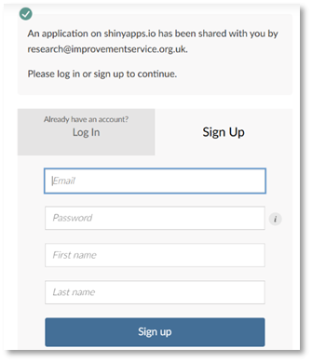

1. Finally, after sign up, the user may be presented with an ‘*Authorization Required*’ page. Click **Login** to be taken automatically to your local authority’s version of the ELC Insights Dashboard.

A screenshot of a login screen which reads 'Authorization Required -Access to this content is restricted'. And a blue 'Login' button.


1. When an authorised user of the tool leaves the council or changes role and should no longer have access, a ‘Remove Access’ request should be made via the ‘*Request / Remove Access*’ form to revoke their authorisation to access the tool (see step 1). You will be notified by email when this is complete.
2. In case of any issues please contact the Improvement Service:

[elc@improvementservice.org.uk](mailto:elc@improvementservice.org.uk)

# Initial troubleshooting

If you attempt to access the tool **before receiving an official invitation** or **use an unauthorised email address**, you may encounter issues gaining access. This is due to ShinyApps retaining session cookies that record the unauthorised attempt. To resolve this, it is necessary to delete these cookies and restart the access process.

The following guidance illustrates the steps to delete these cookies in Google Chrome and Microsoft Edge. Steps may differ for other browsers.

## Deleting cookies in Google Chrome

1. Open your browser's settings; click on the three dots next to the search bar and select "Settings"
2. Navigate to Privacy and Security (1) and then Third-party cookies (2)

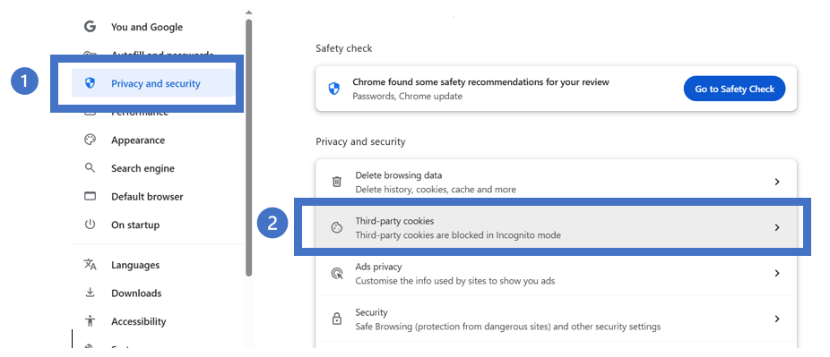

1. **Scroll down** to *See all site data and permissions* (under *Advanced*)

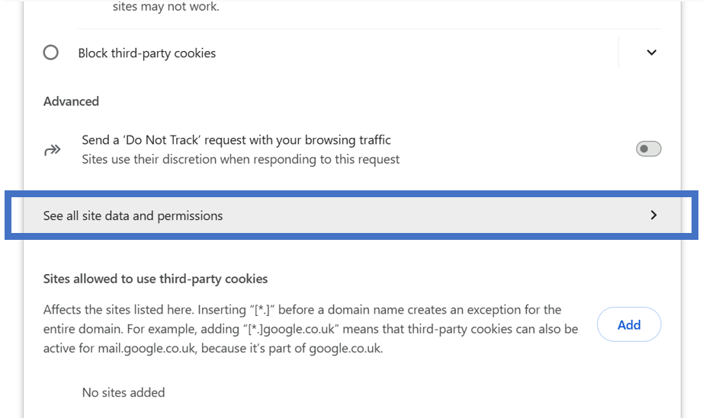

1. Search for *shinyapps* in the search bar (1) and delete all associated cookies by clicking on the rubbish bin icon (2).

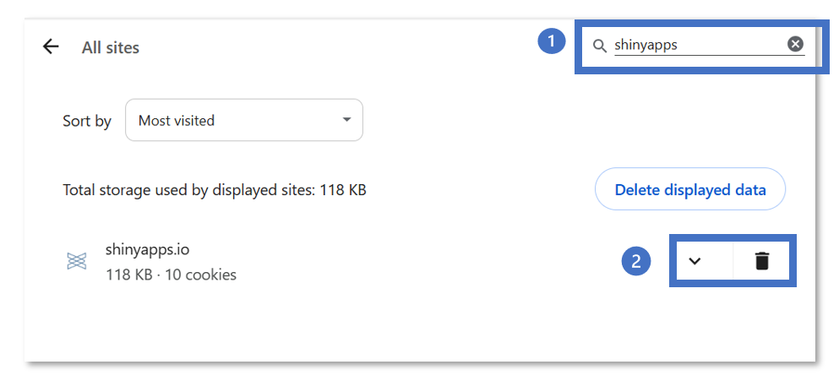

1. In the resultant pop-up click ‘Delete’ to confirm.

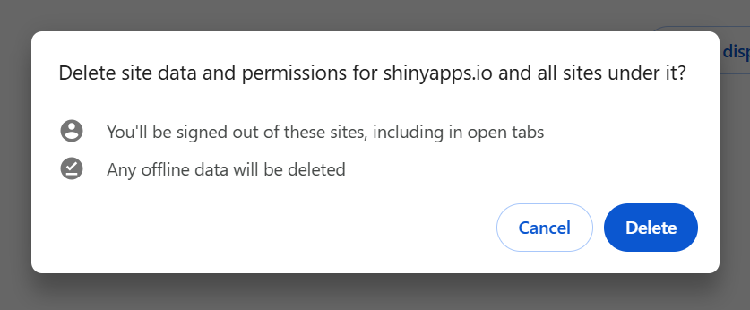

1. Then return to step 2 in the access steps above; **follow the link in the original invitation email**. If you suspect this has been lost or blocked, then the Improvement Service can email this link to you directly.

## Deleting cookies in Microsoft Edge

1. Open your browser's settings; click on the three dots next to the search bar and select "Settings"
2. Navigate to Cookies and site permissions (1) and then Cookies and site data (2)

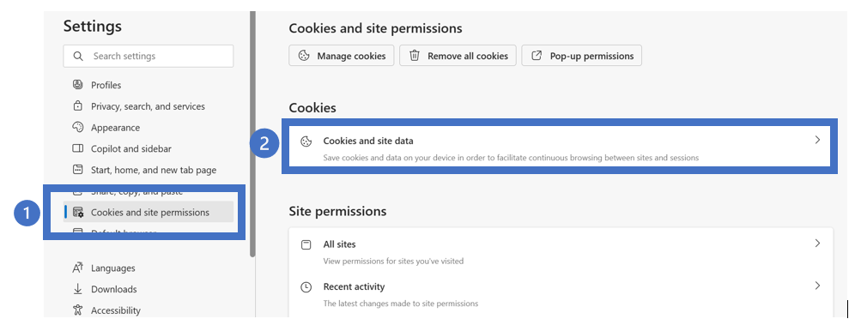

1. **Click on** *See all cookies and site data*

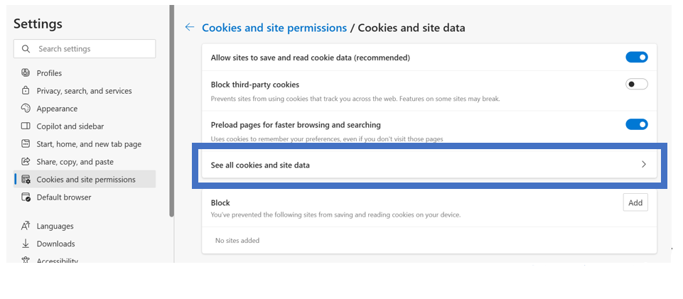

1. Search for ‘*shinyapps’* in the search bar (1). Expand the nested options (if collapsed) by clicking on the Screenshot showing location of ‘see all cookies and site data’ in the browser settings.icon and delete all associated cookies by clicking on the rubbish bin icons (2).

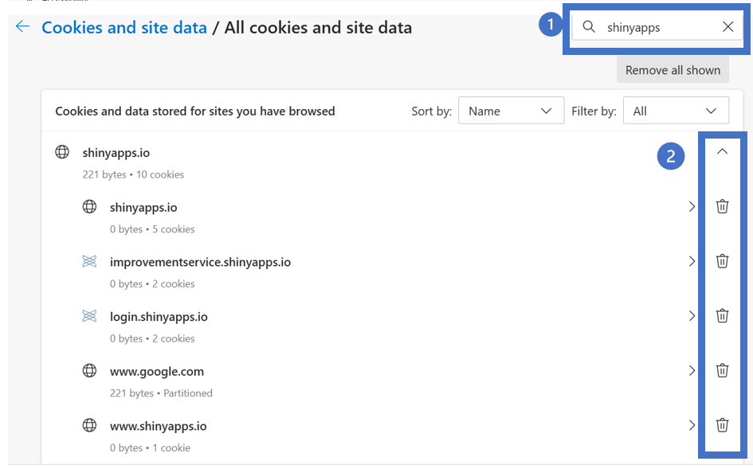

1. Return to Step 2 in the New User Access section above.