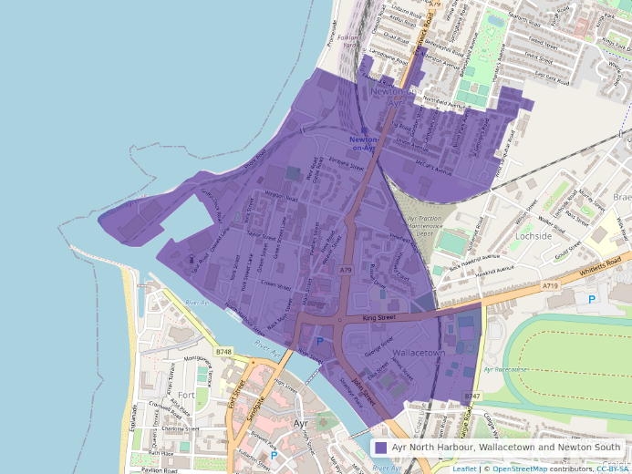
Main Points
- Ayr North Harbour, Wallacetown and Newton South is an area of high deprivation with 68% of its population classed as living in SIMD Quintile 1. This compares to 17% in South Ayrshire overall.

- People are living less of their life in good health and dying younger than in neighbouring areas and South Ayrshire.
  - Female life expectancy is 9 years lower than for South Ayrshire as a whole and 13 years lower than the area in Ayr with the highest life expectancy.
  - Male life expectancy is 8 years lower than for South Ayrshire as a whole and nearly 14 years lower than the area in Ayr with the highest life expectancy.
  - The rate of deaths aged 15-44 is more than 3 times higher than South Ayrshire.
  - The rate of early deaths from Coronary Health Disease is 2.5 times higher than South Ayrshire.

- One-third of children are living in poverty.

- There is a combination of social inequalities including:
  - 40% of the population are in receipt of out of work benefits. This compares to 18% in South Ayrshire and 16% in Scotland.
  - The crime rate is more than 3 times higher than in South Ayrshire as a whole.
  - Nearly half of households are single occupancy.

Introduction
Ayr North Harbour, Wallacetown and Newton South is an Intermediate Zone within the town of Ayr in the South Ayrshire Council area. It has a current population of 4,612 (2020).

Ayr North Harbour, Wallacetown and Newton South Profile (DRAFT)
Deaths, aged 15-44
 |  |  |  |  |  |  |  |  | The rate of deaths aged 15-44 in Ayr North Harbour, Wallacetown and Newton South
 |  |  |  |  |  |  | 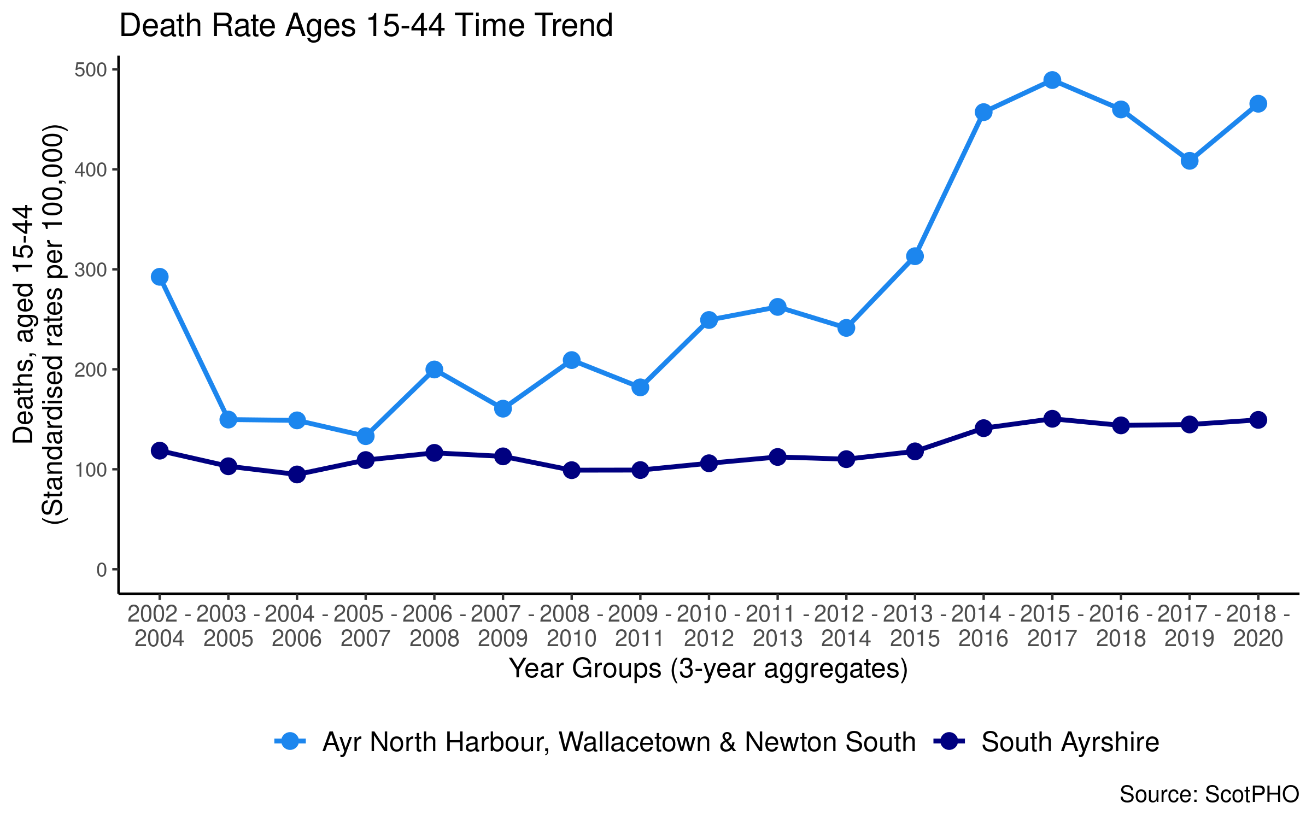 |  | has consistently been higher than South Ayrshire. Following an increase over recent years, it is currently more than three times the local authority rate.
Emergency patient hospitalisations
 |  |  |  |  |  |  |  |  | The rate of emergency patient hospitalisations in Ayr North Harbour, Wallacetown and Newton South has consistently been higher than the South Ayrshire rate and the other areas of Ayr, with the exception of Dalmilling.
 |  |  |  |  |  |  | 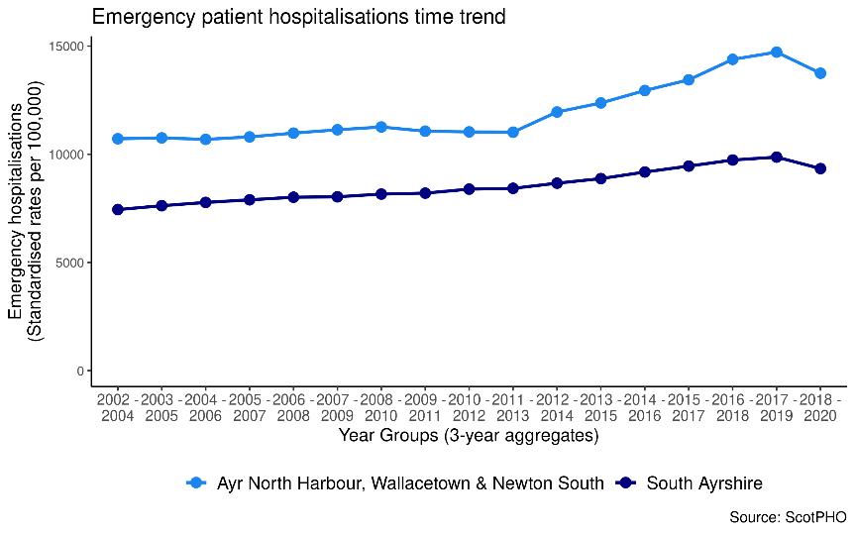 |  | It is currently almost 1 ½ times higher than South Ayrshire.
Children living in poverty
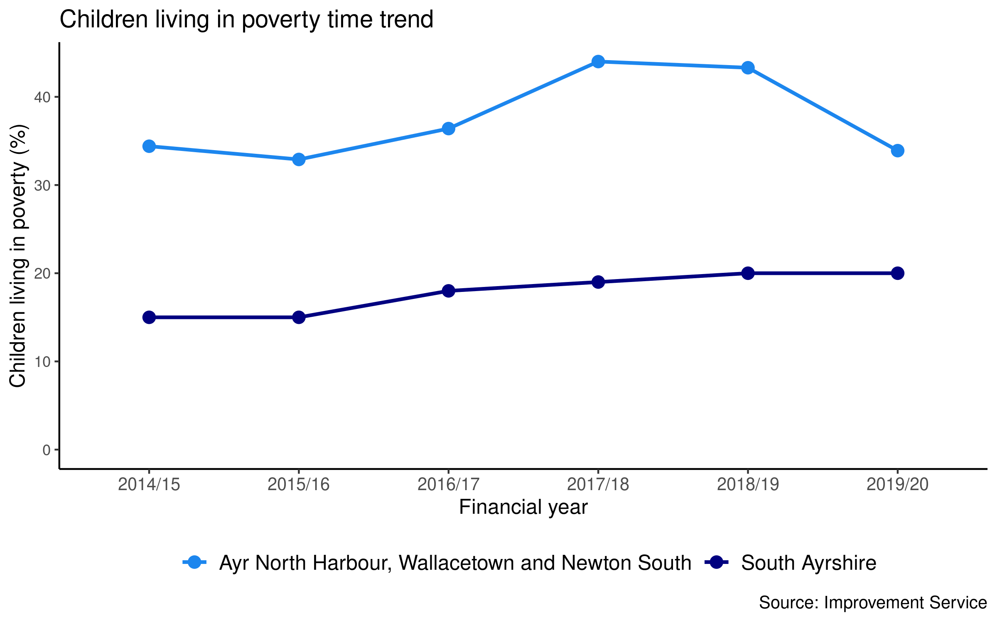

 |  |  |  |  |  |  |  |  | The percent of children living in poverty has consistently been higher in Ayr North Harbour, Wallacetown and Newton South than South Ayrshire and the other areas of Ayr (with the exception of Dalmilling in 2019/20)
 |  |  |  |  |  |  |  |  | It is currently 1.8 times higher than the percentage in South Ayrshire.
Population in receipt of out of work benefits
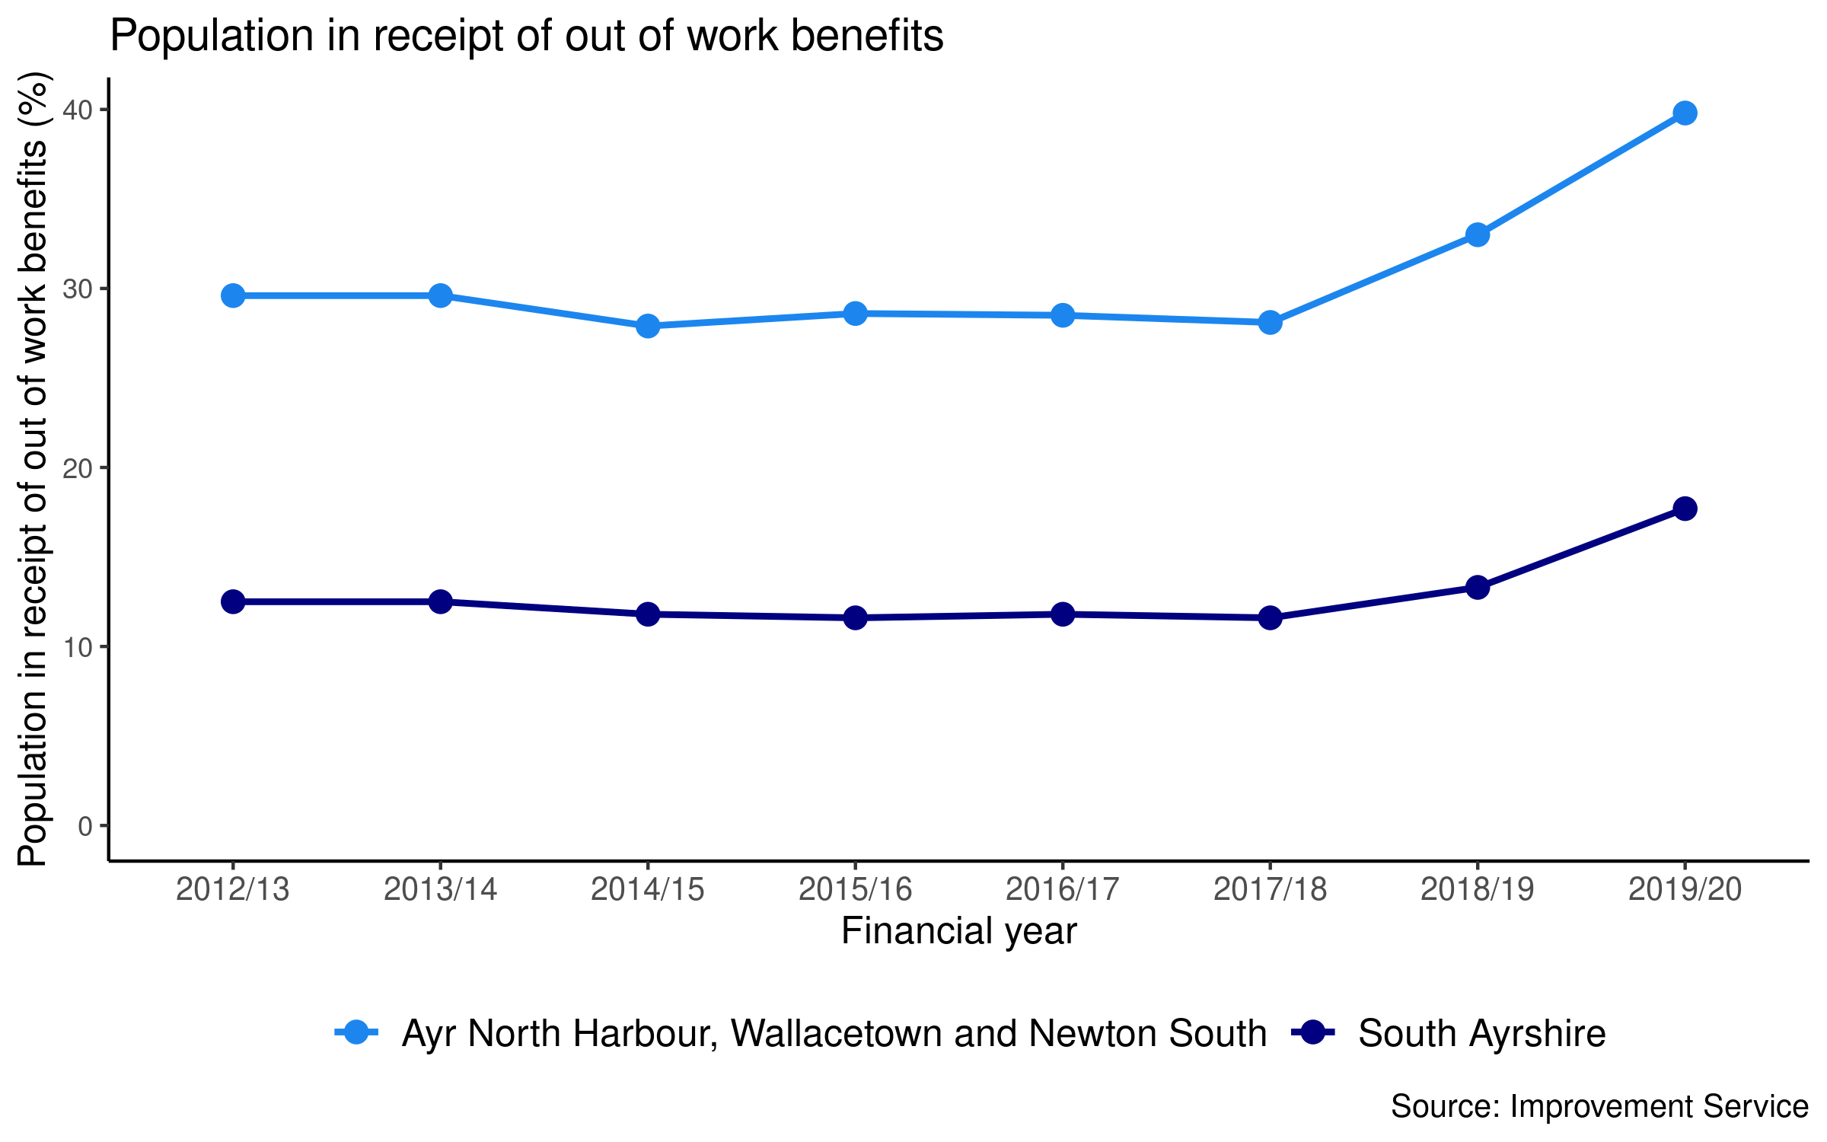

 |  |  |  |  |  |  |  |  |  | The percentage of the population in receipt
 |  |  |  |  |  |  |  |  |  | of Out of Work Benefits has consistently
 |  |  |  |  |  |  |  |  |  | been considerably higher in Ayr North Harbour, Wallacetown and Newton South than in neighbouring areas and
 |  |  |  |  |  |  |  |  |  | South Ayrshire.
 |  |  |  |  |  |  |  |  |  | It is currently 2.5 times higher than South Ayrshire.
Crime rate
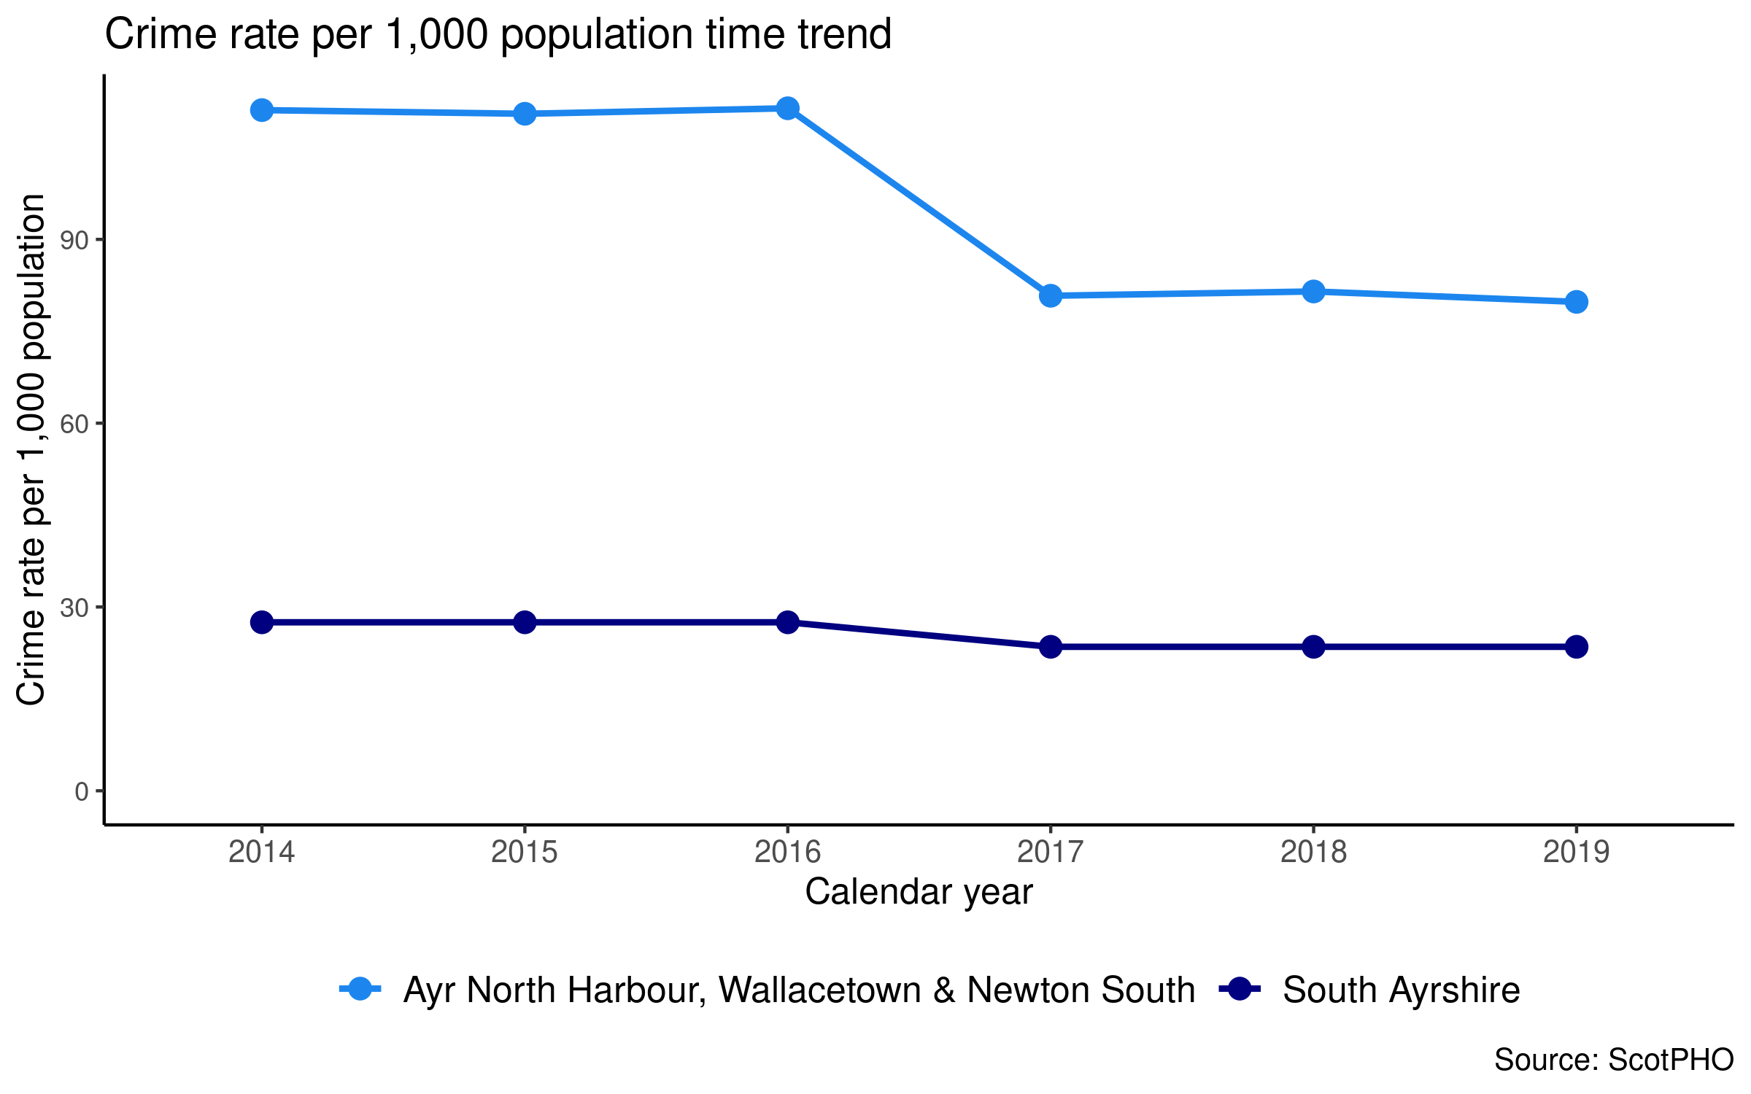

 |  |  |  |  |  |  |  |  |  | While the crime rate in Ayr North Harbour, Wallacetown and Newton South has been decreasing, it is still
 |  |  |  |  |  |  |  |  |  | higher than in neighbouring
 |  |  |  |  |  |  |  |  |  | areas and South Ayrshire and is currently more than 3 times higher than the South Ayrshire rate.
Early deaths from cancer (age <75)
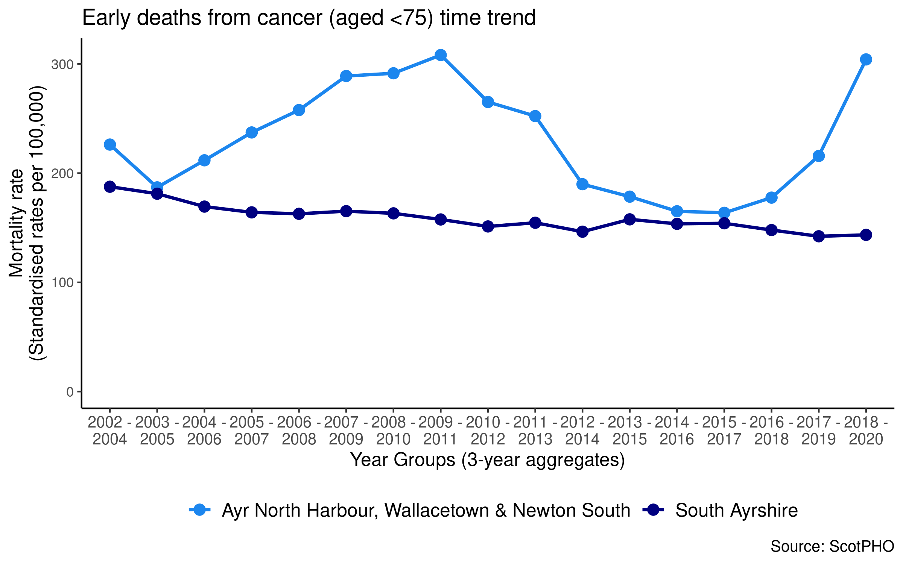

 |  |  |  |  |  |  |  |  |  | The mortality rate in Ayr North Harbour, Wallacetown and Newton South has been increasing in recent years. It is higher than
 |  |  |  |  |  |  |  |  |  | in neighbouring areas and South Ayrshire
 |  |  |  |  |  |  |  |  |  | and is currently twice the rate for South Ayrshire.
Early deaths from coronary heart disease (age <75)
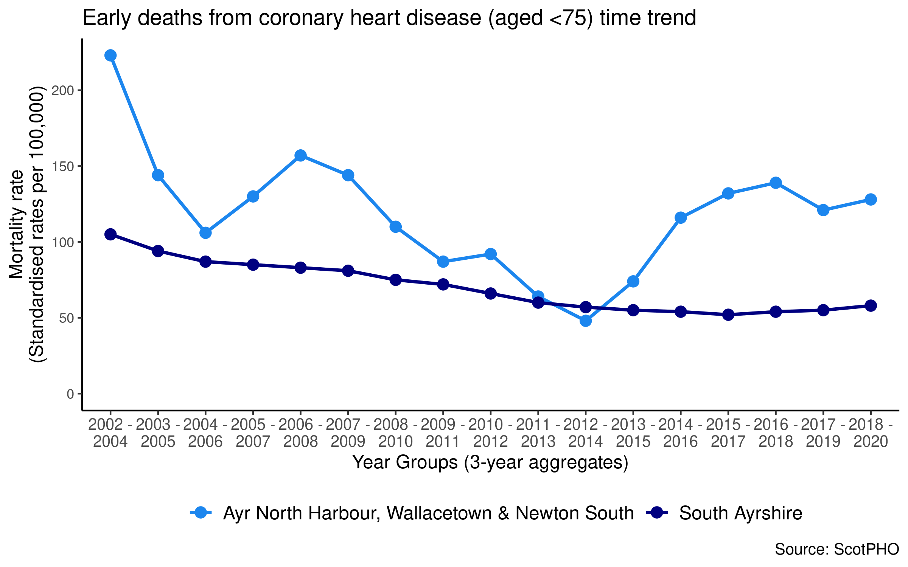

 |  |  |  |  |  |  |  |  |  | The mortality rate in Ayr North Harbour, Wallacetown and Newton South has been
 |  |  |  |  |  |  |  |  |  | increasing in recent years.
 |  |  |  |  |  |  |  |  |  | It is currently 2.5 times higher than South Ayrshire and is higher than surrounding areas of Ayr.
Development concerns at 27-30 months
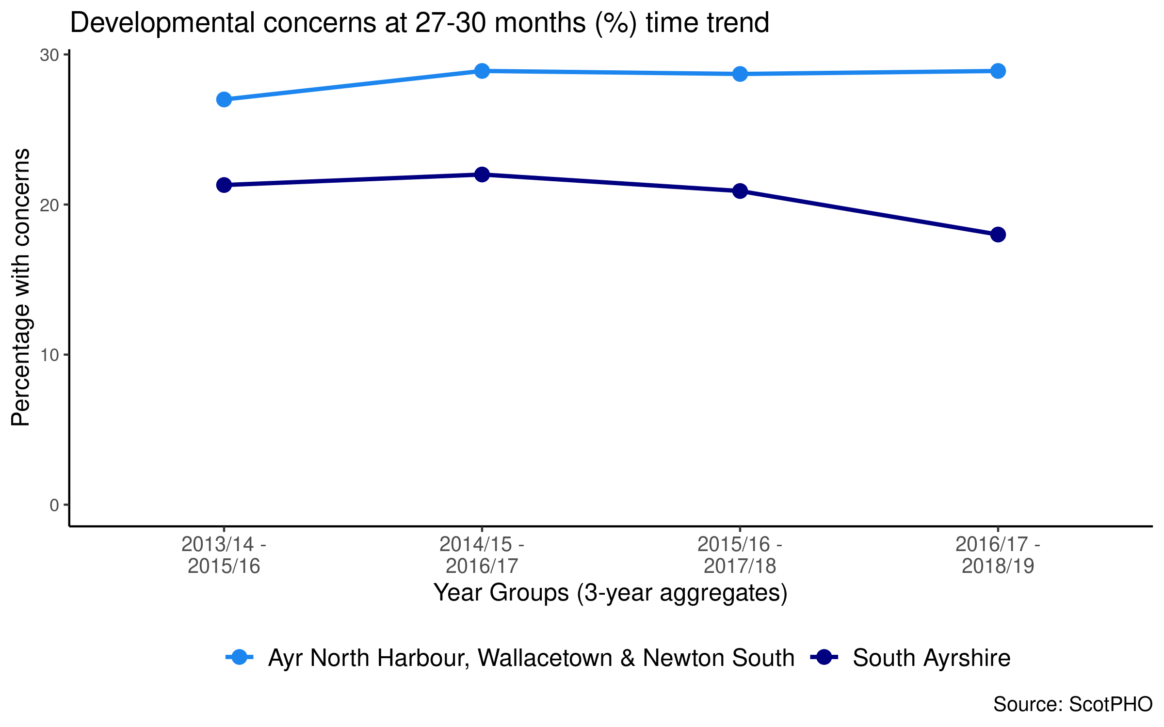

 |  |  |  |  |  |  |  |  |  | The percentage of children with developmental concerns has been consistently higher in Ayr North Harbour, Wallacetown and Newton South than South Ayrshire,
 |  |  |  |  |  |  |  |  |  | The percentage is currently higher than neighbouring areas and is 1.8 times higher than the South Ayrshire rate.
Alcohol-related hospital admissions
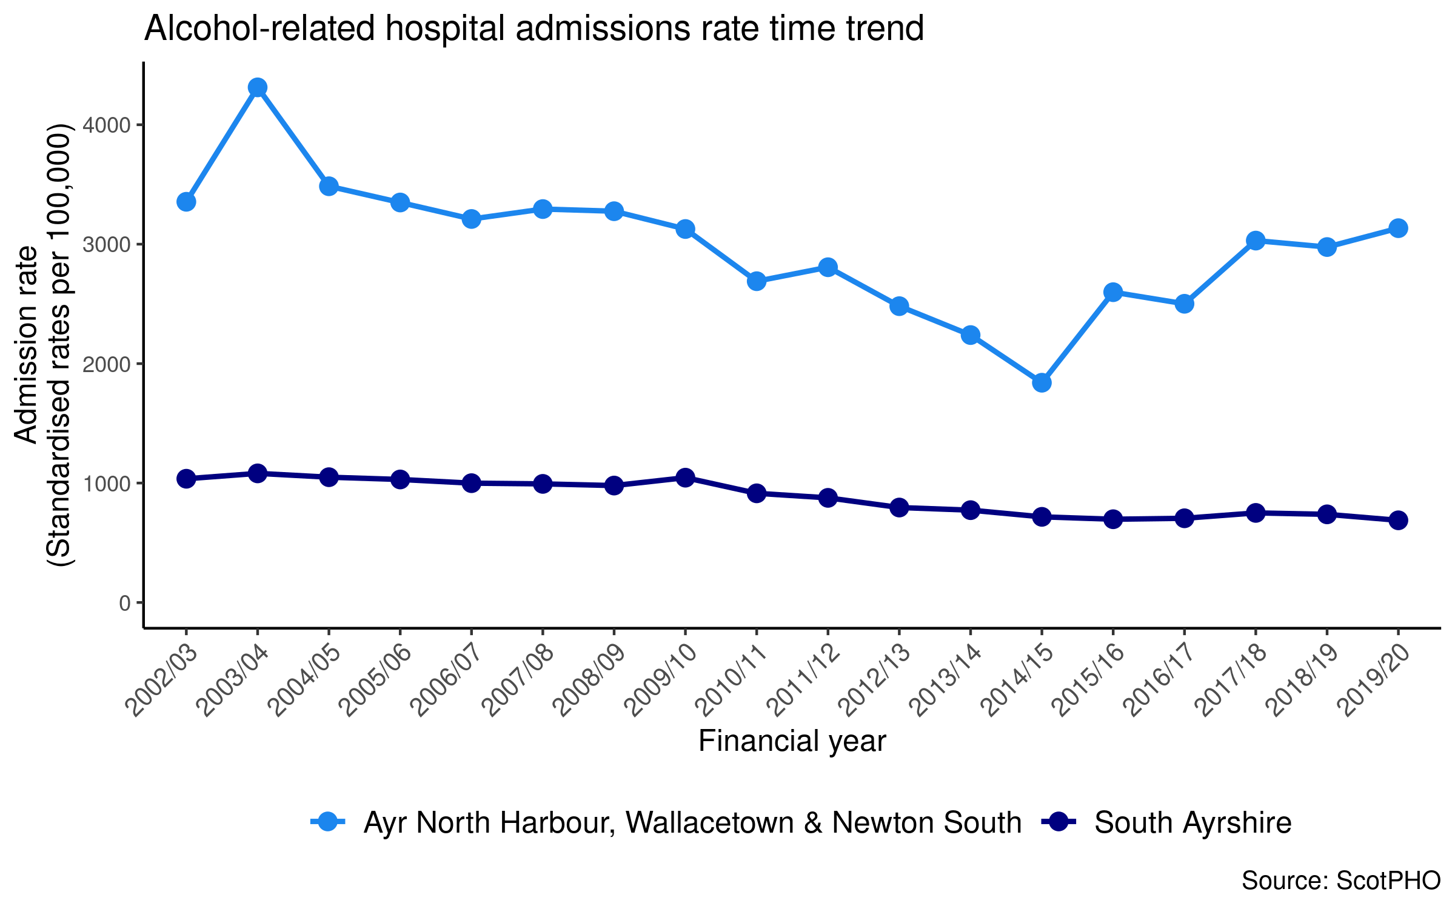

 |  |  |  |  |  |  |  |  |  | The rate of alcohol-related hospital admissions for Ayr North Harbour, Wallacetown and Newton South has been consistently higher than for South Ayrshire.
 |  |  |  |  |  |  |  |  |  | The rate is higher than neighbouring areas and is over 4 ½ times higher than South Ayrshire.

Indicators | Data Type | Time Period | Ayr North Harbour, W’town, Newton South | Alloway & Doonfoot | Ayr South Harbour & Town Centre | Belmont | Castlehill and Kincaidston | Craigie | Dalmilling | Heathfield | Holmston and Forehill | Lochside, Braehead and Whitletts | Newton North | South Ayrshire | Scotland
Demographics
Total Population | count | 2020 | 4,612 | 5,890 | 5,360 | 5,308 | 4,167 | 2,528 | 2,912 | 4,424 | 4,928 | 4,185 | 4,157 | 112,140 | 5,466,000
Gender ratio male to female | ratio | 2020 | 1:0.98 | 1:1.1 | 1:1.16 | 1:1.16 | 1:1.1 | 1:1.03 | 1:1.1 | 1:1.1 | 1:1.1 | 1:1.1 | 1:1.14 | 1:1.09 | 1:1.05
Working age population (16-64) | % | 2020 | 67 | 48 | 55 | 57 | 61 | 65 | 59 | 62 | 59 | 63 | 62 | 59 | 64
Population over 65 years old | % | 2020 | 18 | 39 | 34 | 29 | 21 | 20 | 19 | 21 | 25 | 16 | 24 | 26 | 19
Population in most deprived SIMD quintile | % | 2020 | 68.28 | 0 | 15.76 | 0 | 26.52 | 59.85 | 100 | 14.1 | 0 | 100 | 0 | 17 | 20
Housing
Total number of households | count | 2020 | 3,020 | 2,708 | 3,191 | 2,524 | 2,042 | 1,311 | 1,258 | 2,022 | 2,260 | 2,118 | 2,208 | 55,790 | 2,653,521
Occupied households | % | 2020 | 94 | 97 | 92.4 | 97.5 | 98.2 | 91.8 | 98.3 | 97.9 | 97.4 | 97.6 | 97.5 | 95.9 | 95.7
Households with a single occupant tax discount | % | 2020 | 48.9 | 27.3 | 43.1 | 34 | 36.3 | 39.6 | 35 | 38.1 | 32.9 | 40.7 | 39.8 | 35.7 | 37.9
Occupied households exempt from council tax | % | 2020 | 2.6 | 0.5 | 2.3 | 1.4 | 0.6 | 1.3 | 1.6 | 2 | 1.2 | 1.3 | 1.3 | 1.2 | 3.3
Households in council tax A-C | % | 2020 | 85.1 | 0.7 | 36.9 | 35.5 | 69.4 | 88.2 | 90.9 | 45 | 40.4 | 86.8 | 51.5 | 51.7 | 59.5
Households in council tax F-H | % | 2020 | 0.8 | 70.5 | 23.6 | 25.2 | 9.5 | 0.8 | 0 | 5.9 | 9.1 | 0.1 | 6 | 15.7 | 13.4
Economy
Population in receipt of out of work benefits | % | 2019/20 | 39.8 | 6.0 | 17.5 | 12.6 | 21.3 | 20.5 | 35.2 | 16.3 | 12.3 | 37.8 | 15.4 | 17.7 | 15.7
Attendance allowance – cases with entitlement (per 1,000 65+ pop) | rate | Sep 21 | 144.2 | 94.7 | 171.6 | 125.3 | 136.6 | 189.9 | 173.5 | 149.5 | 119.5 | 160.5 | 145 | 133.9 | 131.7
Carers allowance – cases with entitlement (per 1,000 65+ pop) | rate | Feb 21 | 33.3 | 16.3 | 21.8 | 23.4 | 30.7 | 34 | 60.8 | 27.5 | 26.9 | 62.6 | 25.3 | 29.8 | 26.6
Pension credit cases (per 1,000 60+ pop) | rate | Feb 21 | 183.3 | 24.4 | 83.4 | 51.8 | 103.3 | 156.2 | 158.4 | 119.5 | 60.2 | 160.3 | 90.7 | 85.6 | 95.6
Personal independence payment – cases with entitlement (per 1,000 16+ pop) | rate | July 21 | 124.3 | 18.8 | 55.7 | 40.6 | 78 | 74.5 | 116.3 | 71.8 | 47.1 | 148.4 | 63 | 63.8 | 64.2
People on Universal Credit (per 1,000 16+ pop) | rate | July 21 | 300.6 | 25 | 92.5 | 77.4 | 150.2 | 126.2 | 250.1 | 101.7 | 72.8 | 292.6 | 85.5 | 110.4 | 103.7
Population income deprived | % | 2019 | 30.8 | 2.8 | 11.7 | 7.7 | 14.6 | 18 | 29.6 | 12.6 | 7.7 | 29.1 | 10.4 | 12.2 | 12
Working age population who are employment deprived | % | 2019 | 25.2 | 3.0 | 11.6 | 6.4 | 10.9 | 12.8 | 20.5 | 9.0 | 6.8 | 22.2 | 9.0 | 10.1 | 9.3
Indicators | Data Type | Time Period | Ayr North Harbour, W’town, Newton South | Alloway & Doonfoot | Ayr South Harbour & Town Centre | Belmont | Castlehill and Kincaidston | Craigie | Dalmilling | Heathfield | Holmston and Forehill | Lochside, Braehead and Whitletts | Newton North | South Ayrshire | Scotland
Environment, Access, Crime
Population within 500 metres of a derelict site | % | 2017 | 91.2 | 9.8 | 53.8 | 0.6 | 0 | 6.8 | 30 | 63.7 | 0 | 100 | 44 | 32.5 | 29.8
Crime rate per 1,000 population | rate | 2019 | 79.8 | 6.4 | 68.1 | 9.8 | 13.5 | 29.1 | 40.6 | 16.4 | 18.4 | 57 | 16.9 | 23.5 | 28.6
Young people in most deprived quintile – crime SIMD domain | % | 2019 | 74.7 | 0 | 50 | 0 | 0 | 14.2 | 13.4 | 0 | 0 | 82.8 | 0 | 14.9 | 21.8
Young people in most deprived quintile – income SIMD domain | % | 2019 | 74.7 | 0 | 17.7 | 0 | 16.7 | 14.2 | 100 | 11 | 0 | 80.2 | 0 | 17 | 19.8
Young people in most deprived quintile – access SIMD domain | % | 2019 | 0 | 57.1 | 0 | 0 | 0 | 85.8 | 0 | 40.2 | 8.1 | 0 | 0 | 22.6 | 20.2
Life Expectancy & Mortality
Life expectancy, females | mean | 2016-2018 | 72.2 | 83.6 | 80 | 85.2 | 81.4 | 79.1 | 76.2 | 80.4 | 81.7 | 77.8 | 82.4 | 81.6 | 81.1
Life expectancy, males | mean | 2016-2018 | 69.2 | 82 | 74.7 | 78.7 | 75.6 | 75 | 71.5 | 75.5 | 80.5 | 73.2 | 77.2 | 77.3 | 77.2
Deaths, all ages per 100,000 | rate | 2018-2020 | 1,661 | 954 | 1,297 | 902 | 1,213 | 1,344 | 1,885 | 1,279 | 1,085 | 1,277 | 1,321 | 1,159 | 1,166
Deaths, age 15-44 per 100,000 | rate | 2018-2020 | 465.6 | 69.2 | 164.3 | 120.3 | 73.7 | 164.7 | 269 | 172.4 | 74.3 | 348.4 | 216 | 149.4 | 116.4
Early deaths from cancer, aged <75 years per 100,000 | rate | 2018-2020 | 304.2 | 139.4 | 161.3 | 101.8 | 156.4 | 125.8 | 164.5 | 161.7 | 171.7 | 164.7 | 142.6 | 143.5 | 152.8
Early deaths from CHD, aged <75 years per 100,000 | rate | 2018-2020 | 127.6 | 25.4 | 83.2 | 52 | 113.7 | 66.1 | 12.2 | 56.1 | 52.3 | 97.8 | 76.6 | 57.5 | 50.6
Indicators | Data Type | Time Period | Ayr North Harbour, W’town, Newton South | Alloway & Doonfoot | Ayr South Harbour & Town Centre | Belmont | Castlehill and Kincaidston | Craigie | Dalmilling | Heathfield | Holmston and Forehill | Lochside, Braehead and Whitletts | Newton North | South Ayrshire | Scotland
Ill Health, Behaviours, Injury
CHD patient hospitalisations per 100,000 | rate | 18/19-20/21 | 575 | 358 | 478 | 511 | 678 | 639 | 698 | 467 | 498 | 748 | 485 | 497 | 355
COPD patient hospitalisations per 100,000 | rate | 17/18-19/20 | 821 | 119 | 277 | 236 | 618 | 480 | 796 | 436 | 279 | 556 | 393 | 320 | 277
Asthma patient hospitalisations per 100,000 | rate | 17/18-19/20 | 183 | 134 | 103 | 114 | 148 | 213 | 257 | 111 | 167 | 174 | 160 | 126 | 90
Emergency patient hospitalisations per 100,000 | rate | 2018-2020 | 13,743 | 6,795 | 9,534 | 8,651 | 10,617 | 11,165 | 14,113 | 9,577 | 9,388 | 13,377 | 9,944 | 9,337 | 7,358
Multiple emergency hospital admissions, aged >65 years per 100,000 | rate | 2018-2020 | 8,768 | 4,273 | 6,762 | 5,978 | 5,896 | 7,523 | 9,302 | 7,309 | 6,948 | 6,670 | 7,531 | 6,218 | 5,206
Alcohol-related hospital admissions per 100,000 | rate | 2019/20 | 3,134 | 304 | 1,325 | 310 | 878 | 1,297 | 737 | 799 | 542 | 1,233 | 633 | 688 | 673
Unintentional injuries hospital admissions per 100,000 | rate | 2020 | 1,229 | 596 | 953 | 693 | 591 | 1,284 | 881 | 854 | 680 | 1,164 | 985 | 764 | 772
Bowel screening uptake | % | 2017-2019 | 49 | 75.7 | 59.7 | 68 | 59.3 | 57.1 | 47 | 59 | 68.1 | 48.9 | 64.1 | 63.8 | 61.6
Road traffic accident casualties per 100,000 | rate | 2017-2019 | 60.3 | 70.3 | 66.8 | 24.4 | 24 | 35.3 | 98.4 | 80.1 | 44.3 | 55.7 | 34.5 | 57.3 | 59.3
Percentage of population being prescribed drugs for anxiety, depression or psychosis | % | 2019/20 | 30.1 | 16.3 | 25.5 | 20.4 | 24.6 | 23.3 | 29.6 | 23 | 20.8 | 28.7 | 24.2 | 22 | 19.3
Indicators | Data Type | Time Period | Ayr North Harbour, W’town, Newton South | Alloway & Doonfoot | Ayr South Harbour & Town Centre | Belmont | Castlehill and Kincaidston | Craigie | Dalmilling | Heathfield | Holmston and Forehill | Lochside, Braehead and Whitletts | Newton North | South Ayrshire | Scotland
Children & Young People
Babies exclusively breastfed 6-8 weeks | % | 17/18-19/20 | 12.3 | 39.4 | 36.9 | 27.3 | 15.7 | 23.3 | 10.2 | 15.4 | 20.5 | 9.5 | 16 | 22 | 31.2
Child dental health in primary 1 | % | 2018/19 | 70.7 | 92.3 | 88.5 | 91.2 | 65.8 | 83.3 | 59.4 | 82 | 78.6 | 62.1 | 85.7 | 77.8 | 71.5
Child dental health in primary 7 | % | 2018/19 | 70 | 89.4 | 90.6 | 82.2 | 78.8 | 79.2 | 63.2 | 79.5 | 77.3 | 70.2 | 76.3 | 78.7 | 72.9
Child healthy weight in primary 1 | % | 2019/20 | 80 | 88.9 | 83.3 | 82.1 | 82.5 | 76.7 | 64 | 82.6 | 88.1 | 73.2 | 76 | 80.8 | 76.2
Children in low income families | % | 2016 | 35.9 | 3.7 | 11.3 | 10.6 | 18 | 21.5 | 40.4 | 13.5 | 11.7 | 36.3 | 12.3 | 16.6 | 16.7
Children living in poverty | % | 2019/20 | 33.9 | 6.0 | 15.9 | 16 | 23.1 | 30.4 | 36.9 | 18.5 | 15.7 | 34 | 18.4 | 20 | 18.8
Development concerns at 27-30 months | % | 16/17-18/19 | 28.9 | 10.6 | 10.3 | 15.8 | 22 | 16.1 | 22.1 | 17.1 | 15.7 | 23.6 | 17.5 | 18 | 15.9
Healthy birth weight | % | 17/18-19/20 | 84.8 | 83.6 | 84.9 | 77.2 | 81.3 | 86 | 77.7 | 85.6 | 84.5 | 83.9 | 80 | 82.2 | 84.1
Immunisation uptake at 24 months – 6 in 1 | % | 2018-2020 | 93.1 | 97.1 | 94.1 | 96.2 | 97.7 | 95.9 | 97.4 | 100 | 99.2 | 97.7 | 99.1 | 98.1 | 97.2
Immunisation uptake at 24 months – MMR | % | 2018-2020 | 91.4 | 94.2 | 90.6 | 93.8 | 96.2 | 86.3 | 94.9 | 98.4 | 98.5 | 96.6 | 95.3 | 96.2 | 94.3
Uptake of HPV vaccine in S3 girls | % | 17/18-19/20 | 73.5 | 80.9 | 88.7 | 78.9 | 80.3 | 76.9 | 60.6 | 83.3 | 81.2 | 63.3 | 75 | 81.2 | 84.8
Live births | % | 2019 | 8.4 | 3.7 | 5.7 | 6.4 | 7.9 | 5.8 | 9.2 | 8.2 | 7.9 | 11.4 | 8.1 | 7.4 | 9.1
Maternal obesity | % | 17/18-19/20 | 29.1 | 9.2 | 19.1 | 20.2 | 23.7 | 23.7 | 38.4 | 29.8 | 22.7 | 34 | 21.3 | 24.5 | 24.7
Premature births | % | 17/18-19/20 | 13.8 | 6.2 | 8.5 | 7.7 | 8.6 | 19.4 | 6.9 | 10.3 | 7 | 7.9 | 12.8 | 9.1 | 8.4

Sources and Indicators
ScotPHO – Male and Female Life Expectancy, Deaths (Aged 15-44, All ages, Early deaths from cancer, Early deaths from coronary heart disease), Bowel screening uptake, Hospitalisations (Asthma, CHD, COPD, Emergency), Multiple emergency admissions aged >65, Alcohol-related hospital admissions, Road traffic accident casualties, Population prescribed medication for anxiety, depression and psychosis, Healthy birth weight, Child dental health in P1 and P7, Child healthy weight in P1, Babies exclusively breastfed at 6-8 weeks, Children in low income families, Immunisation uptake at 24 months – 6 in 1 and MMR, Developmental concerns at 27-30 months, Live births, Maternal obesity, Premature births, Update of HPV vaccine in S3 girls, People in 15% most ‘access deprived’ areas, Population within 500 metres of a derelict site.
National Records of Scotland (NRS) – Population (Total, Gender ratio, Working age, Over 65, Living in most deprived SIMD quintile) and Households (Total, Occupied, Single Occupant tax discount, Exempt from council tax, Council tax bands A-C and F-H) .
Improvement Service – Children living in poverty, Population in receipt of out-of-work benefits, Crime Rate.
Scottish Government – Educational attainment of school leavers, Child benefit, First time mothers aged under 19, Average travel time to a GP and primary school, Children in households receiving child benefits, Highest qualification score, First time mothers under 19.
DWP Stat-Xplore – Universal Credit, Personal Independence Payment, Attendance Allowance, Pension Credit, Carers Allowance

