Suggested social posts
Short
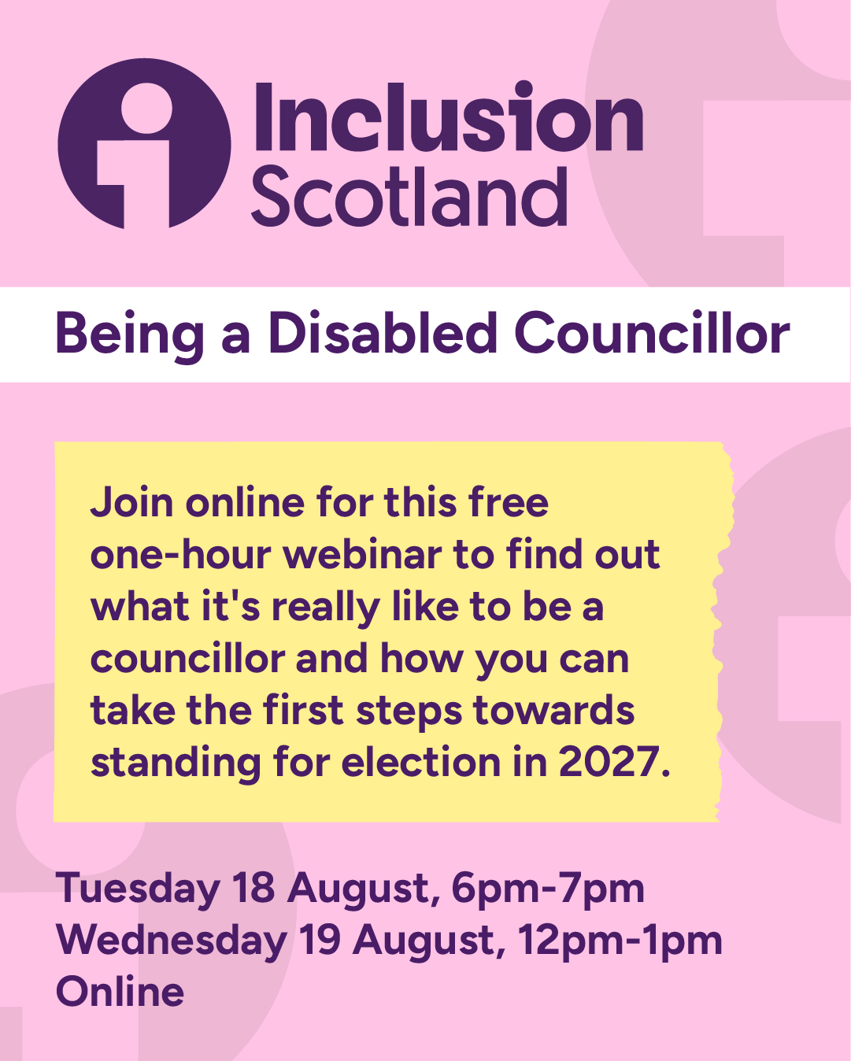
Could You Be a Disabled Councillor?
👉 Register today and discover how you could make a difference in your community.
Tuesday 18th August 6-7pm: https://us02web.zoom.us/meeting/register/R1CC57_WRNqNkbt20YR9AA
Wednesday 19th August 12-1pm: https://us02web.zoom.us/meeting/register/1GFQLqRsSsChWL9VBNHoUQ
If you have any access requirements, please email civicparticipation@inclusionscotland.org
Longer post
Could You Be a Disabled Councillor?
Disabled people are underrepresented in local government, but your lived experience, knowledge and perspective can help shape decisions that affect communities across Scotland.
Join Inclusion Scotland, COSLA and the Improvement Service for a free online webinar to learn what it's really like to be a councillor and how you can take the first steps towards standing for election in 2027.
📅 Tuesday 18 August, 6pm–7pm
📅 Wednesday 19 August, 12pm–1pm
💻 Online
During this one-hour session, you'll hear about:
✅ What councillors do and what the role involves
✅ Why disabled representation in local government matters
✅ Support available to disabled candidates, including the Access to Elected Office Fund
✅ The experiences of Cllr Janine Rennie and Cllr Katie Pragnell Lees as disabled elected representatives
✅ Opportunities to ask questions and find out more
Whether you're already thinking about standing for election or simply curious about the role, this is a great opportunity to learn more in a welcoming and supportive environment.
👉 Register today and discover how you could make a difference in your community.
Tuesday 18th August 6-7pm: https://us02web.zoom.us/meeting/register/R1CC57_WRNqNkbt20YR9AA
Wednesday 19th August 12-1pm: https://us02web.zoom.us/meeting/register/1GFQLqRsSsChWL9VBNHoUQ
If you have any access requirements, please email civicparticipation@inclusionscotland.org

