Partnership Approach to Money & Debt

Venue: Aberdeenshire Council Chambers, Woodhill House, Westburn Road, Aberdeen
Date: 26th May 2015

Introduction
The UK Government has been implementing the biggest change to the Welfare System in the last 60 years. There is also a very ambitious channel shift in the model of delivery, using the web as the main channel of engagement with claimants. There is a requirement to work in partnership with local providers who have a range of capabilities and experience of delivering employability, financial inclusion, health and housing services.

The current climate is challenging however there are a number of opportunities which can be developed through partnership working. This process can improve quality, increase capacity and can be built round the needs of people, communities and partners.

Outcomes of the Event
The event was attended by 50 participants who were given the opportunity to explored challenges, options and opportunities. The range of partners working in this sector were given the opportunity to increase partnership working by improving the links and raising awareness of services available within this area of work.

Participants participated in workshops which explored good practice at a local and national level. There evaluation and feedback will be used to inform future action plans and strategies.

It has been agreed that other partnership events and joint training courses should be offered to those working in this area. This would ensure continued development of this sector and improve partnership working.

Conference report
It was agreed at the event that a conference report would be compiled and sent to those who had participated.
This conference report provides the information on the Key Speakers including the presentation the delivered, notes from the Workshop Facilitators and also the discussions held during the Ask the Panel Session.
The participants filled in evaluation sheets as part of the event and the feedback given will be used for future programmes.

Key Speakers

Alan Wood - Head of Finance, Aberdeenshire Council
Alan has been Aberdeenshire Council’s Head of Finance since 2011. In this role Alan is responsible for the council’s finances including revenues, benefits, the council’s budget, payments, treasury and council tax collection. He is responsible for overseeing a revenue budget of £532 million and a capital plan of £1 billion.
He was born in Aberdeen and has held a number of finance roles initially with Grampian Regional Council before joining Aberdeenshire Council. Alan also held the post of Head of Procurement for a year in 2006.
More recently, Alan has served on the CIPFA (Chartered Institute of Public Finance and Accountancy) Executive Committee, is a member on several COSLA groups, and is a member of the Councils Strategic Leadership Team. He is the Council’s statutory Section 95 officer.

Sandra Sankey - Project Manager, Money Advice Outcomes, Improvement Service
Sandra joined the Improvement Service in September 2012 as Project Manager responsible for carrying out in depth research across all 32 local authorities via the Improving Outcomes in Money Advice project. Prior to this Sandra worked for Stirling Council for 9 years managing and delivering the Money Advice Service. In this time Sandra also became a member of the council of management for Money Advice Scotland.
Since Sandra first started her career with Strathclyde Regional Council in 1987 she has gained 16 years’ experience in the finance sector across many London authorities. Prior to relocating back to Scotland Sandra was the Group Revenue Manager at the London Borough of Waltham Forest Council responsible for staff management and recovery of Council Tax, Business Rates and Overpaid Housing Benefit .
As a volunteer Sandra is trustee for the board of Stirling Start Up charity which operates to assist and support individuals experiencing homelessness and financial hardship by providing home starter and wellbeing packs, listening/befriending support and crisis food packs.

Workshops

Advice & Information Service
Facilitators: Alan Busson - Gordon Rural Action and Ruta Liepina - Kincardine & Mearns CAB

Good advice can prevent outcomes that are expensive for the public purse and are disastrous for the person and families experiencing them. This workshop will explore the impact of Advice & Information Services can have for those who find themselves facing financial challenges

Case Study 1
John (ex-services) suffers from mental health issues and post-traumatic stress.
He receives letters from his local authority about rent arrears.
He has other debts too.
He found it very difficult to engage with official bodies or to hold down a job.
He had been sanctioned by DWP.
John is facing eviction.

Possible Solution
Priority – deal with eviction. In-Court Advice Service represented him at the Sheriff Court to defend proceedings for recovery of possession. The court action for repossession was dismissed and his home is now safe.
Debt Advice - Negotiate with the local authority and other official bodies and creditors.
Assist with benefit applications and negotiate with DWP. Maximise income.
Joint meeting with national charity - sought and awarded funds to clear rent arrears and a contribution to council tax arrears. Health issues.
Important to deal with other creditors
John is a single man who is in and out of employment, so likely to be one of the first tenants to be affected by the roll-out of Universal Credit. (could work to advantage?)
John is likely to require further support with budgeting and benefit claims to ensure that he doesn’t get into difficulties again.
John needs to engage with GP

From Flipcharts

Workshop 1

Causes
Inability to secure permanent employment
Mental health problems
Difficulty communicating with DWP/officialdom
Cannot afford telephone call/travel to visit
Severe financial hardship/no cash cycle
Difficulty of various organisations and ability to share information
Act on someone else’s behalf
Lack of consistency over knowledge and approaches
Lack of engagement from the client
Unwillingness to ask for help/support “burying head in the sand”

Solutions
SSAFA
Health and financial support
CAB online/Advice agency helpline
Money Advice Service in CAB/GRA
Others include local authority/Shelter
Debt Advice Pack
Review Benefit Entitlement
Review housing situation and consider potential for financial support
DHP
Review energy costs – energy adviser
Apply for housing benefit – benefits office
Support with potential eviction
GRA court team or CAB legal representation
Build up rapport with him/help/listen/befriend him

Workshop 1

Signposting
Ex-forces support group
Armed services support group
Employability group
Housing Support Worker
CAB and Gordon Rural Action etc.
Debt Advice
Literacy
Aberdeenshire Council Visiting Team

Priority
Eviction
Scottish Welfare grant access
Receive correct benefit
Job Centre – why?
Engagement
Speak to customer
Establish background

Workshop 2
ASAP through CAB – funded by Poppy Scotland
Not all over Scotland – limited funding
Link through CAB website?
Money Advice
Advice on debt, help and medical issues
Advice on housing to prevent eviction
Support group
Preventative action by government – rehabilitation

Causes
Isolation – personal and social
Lack of support/awareness of what is available
Financial hardship
No knowledge of benefits system
No knowledge of advice/information available
No knowledge of medical/psychological support available
Unaware of DWP/legal support and representation available
Not aware of/connected to service welfare organisation
Lack of self-reliance and “life skills”

Remedies
Address primary need - Stop eviction, keep roof over head, strategy to tackle arrears and pay rent
Tackle DWP/benefits solution/how can receive, benefits and welfare support i.e. crisis grant, food parcels
Signpost to support groups assisting mental health issues, strategies in place towards employability, building up confidence, self-esteem

Exploring partnership working for money advice and other services
Facilitator: Sandra Sankey and Solveig Burfeind - Project Manager, Improvement Services

The main barriers to partnership working between advice agencies:

- Technology; lack of broadband connection; lack of data sharing
- Lack of contacts; who to contact for what and how
- Location; geography; transport (between advisers and clients as well as partners)
- Lack of knowledge of services; where is the overlap
- Working in silos
- Perceptions of debt collectors as 'bad guys'; not knowing what tools collections have available; prevents partnership working
- Protectionism
- Lack of communication
- Limited resources; time constraint
- Need to clarify different roles and remit; e.g. money adviser v debt adviser
- Some individuals and organisations are less willing to engage and work in partnership than others
- Competition for funding
- The library is available to help people on line but there is very limited access to help people with the forms and the type of support they may need
- Sharing relevant information ‘need to know‘ basis
- Data protection
- Agencies who provide advice but not accredited and authorised to do so - people want to know what can be done about this

Potential solutions to improve partnership working between advice agencies:

- Sharing feedback from customers with funders; different stages of the customer journey
- Learning what works well; sharing good practice; networks to support the advice sector
- Training for more volunteers, use our libraries more effectively as they provide good training
- Key stakeholders: IRRV, COSLA, SFHS, MAS, SLAB, other funders what more can be done to share information from these networks to help support services delivering locally
- Connecting to and making best use of the Knowledge Hub to share information
- Common data sharing agreement (similar to model in Fife)
- Central point of locating partners; service directory
- Car sharing websites to improve transport issues
- Events to support networking, Co-location, shadowing
- Induction pack to Shire Services
- Advertising and promoting services
- Review of aims and objectives – are the meeting the client's needs; shared objective to improve the client's situation – understanding each other’s roles
- Managing risk around data protection
- Look at ways to work better with the regulators FCA, and umbrella organisations
- Funding and partnership planning and review what’s needed

Improved links should be established between the following organisations:

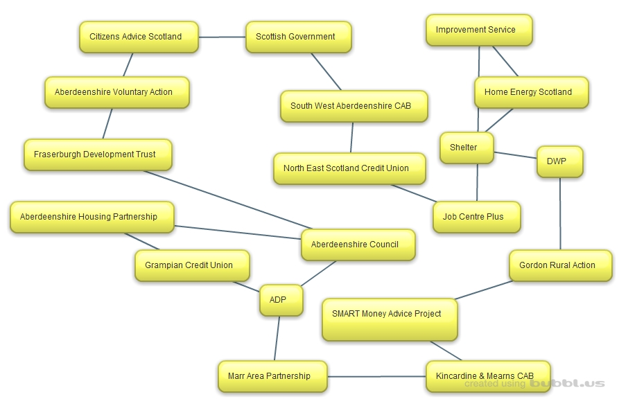

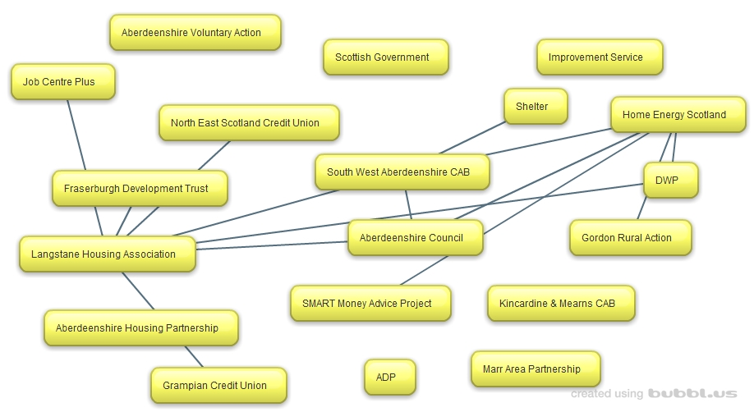

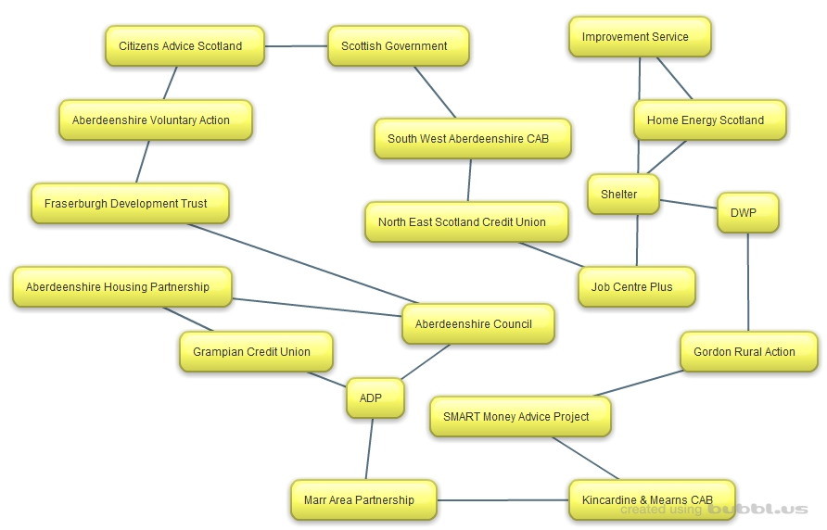

Housing/Revenues Processes
Facilitators: Graham Duthie and Shelley Paton - Revenues, Aberdeenshire Council

Council Tax – a charge on all domestic dwellings – over 115,000 in Aberdeenshire.

Liability – in simple terms, owners and tenants of properties are liable for the council tax.

Billing – annual council tax bills are issued in March each year for the following financial year which starts on 1 April. New and/or amended bills are issued twice weekly (on Mondays & Wednesdays) to take account of changes in customer’s circumstances.

Reductions – exemptions, discounts, disability banding reductions & council tax reduction (aka council tax benefit).

- Exemptions: are property based and there are situations where exemption can be awarded when a property is empty and/or unoccupied OR when occupied. Some are time-limited, some are not. For example;

Those which are not occupied,
  - Empty and/or unoccupied (Up to 6-months maximum)
  - Subject to major and/or structural repairs (Up to 12-months maximum)
  - Repossessed (No limit of time)
  - Occupier is now in prison (No limit of time)
  - Occupier is now in a hospital, nursing or care home (No limit of time)
  - Occupier is living elsewhere for the purpose of providing or receiving care (No limit of time)

Those which are occupied
  - Solely occupied by students (No limit of time).
  - Solely occupied by persons who are under 18 years of age (No limit of time).
  - Solely occupied by persons who are severely mentally impaired (No limit of time)

- Discounts: generally there are three types of discount – (1) for unoccupied properties, (2) for single person households and (3) properties with a resident who can be disregarded. Some are time-limited, some are not. For example;

Those which are unoccupied,
  - Empty and/or unoccupied (level of discount, 50%, 10% or 0%) and all are time-limited, depending on the circumstances at the property.

Those which are occupied,
  - Single person households (level of discount, 25%). No limit of time.
  - Occupied by persons who can be disregarded (all no limit of time):
    - Students
    - School Leavers & >18 but where Child Benefit is still in payment.
    - Apprentices
    - Hospital, Nursing or Care Home residents.
    - Carers
    - Prisoners
    - Severely Mentally Impaired

- Disability Banding Reduction: a reduction on a property that is a disabled person’s main residence and which has certain features to cater for the disabled persons needs.

- Council Tax Reduction (CTR): For those on low incomes, whether in paid employment or on state benefits. A means tested benefit with a £16,000 capital or savings threshold.

Amounts due – can be paid in instalments on a monthly basis. Annual instalments, begin in April and finish the following January (10 instalments).

Revenues policy is to allow 12 instalments upon request. Weekly payments can also be offered where this it assists the customer in budgeting.

Payment Methods –
- Direct Debit
- Debit/Credit Card – online or via the Automated Telephone Payment line – 0845 303 9480
- Cash & Cheque – at a Collection Office or by Post.
- Post Offices & Pay-Point outlets (Note - customer requires a plastic payment card)

Changes in Circumstances – For example, where a customer changes address, someone moves out or into their property, changes their name, wants to claim for an exemption or a discount, all these required to be notified to the Council.

Likewise, if a customer is in receipt of Council Tax Reduction and there is a change in their financial and/or household circumstances, they require to report the change.

All changes can be reported online, or in writing (via email of letter) or face-to-face by visiting a council office. (Service Point, Council Tax or Benefit Office).

Business Rates – a charge on all premises and subjects that are not domestic dwellings, e.g. Shops, Offices, Schools, Car Parks etc – over 11,000 in Aberdeenshire.

Liability – owners and tenants are liable for the charge, which is dependant on the Rateable Value placed on the property, the annual poundage rate which is set by the Scottish Government and the customer’s business circumstances.

Billing – annual business rates bills are issued in late March each year for the following financial year which starts on 1 April. New and/or amended bills are issued twice weekly (on Mondays & Wednesdays) to take account of any changes in customer’s circumstances.

Reductions – exemptions and reliefs.

Further information on all aspects of Business Rates is available on our website:

aberdeenshire.gov.uk/rates/index.asp

Sundry Debtor Invoices - Sundry Debtor Invoices are issued for a wide range of services provided and goods supplied by the Council.

Examples include:

Childcare Payment Special Waste Uplifts Overpayment of Housing Benefit
Lost Library Books Re-chargeable Housing Repairs Social Care Charges
Community Alarms Bus Passes

An invoice will clearly state the Service or Goods being charged and is payable in full upon receipt unless a Direct Debit has been set up in advance for payment to be received in instalments.

Payment Methods –
- Direct Debit
- Debit/Credit Card – online or via the Automated Telephone Payment line – 0845 303 9480
- Cash & Cheque – at a Collection Office or by Post.

Recovery Procedures

Council Tax

Recovery of Outstanding Amounts Due – where a customer falls behind with their payments they will be subject to an automatic recovery process, which means they will be issued with recovery notice(s) which are issued strictly in accordance with the requirements of council tax legislation.

The types of letters issued are as follows:

Overdue Account Notices
Final Notices
Summary Warrant Notices
Sheriff Officer Letters

Overdue Account Notices – are issued when a customer is found to be behind with or hasn’t paid their monthly instalments as stated on their Council Tax bill. This notice is in two parts.

The first allows the customer 7-days in which to bring their monthly instalments up to date. If they do this within the stipulated timescale then they can continue paying their council tax by monthly instalments.

Where a customer fails to bring their monthly instalments up to date, the second part of the notice informs them that they have lost the right to pay by monthly instalments and must now pay the full outstanding balance for the remainder of the financial year within a further 14-days. And that failure to do so will result in their account becoming subject to a Summary Warrant, which involves the addition of a 10% statutory penalty of the outstanding amount.

A maximum of 2 Overdue Account Notices can be issued in respect of any financial year. Where a customer falls behind a third time a Final Notice is issued.

Final Notices – as stated above, these are issued where a customer has already been issued with two Overdue Account Notices. This notice demands payment of the full outstanding amount due for the whole of the financial year within 14-days. It also informs them that failure to make full payment will result in their account becoming subject to a Summary Warrant, which involves the addition of a 10% statutory penalty of the outstanding amount.

Summary Warrant Notices – these are issued once an application has been made to the Sheriff Court.

A Summary Warrant Notice informs the customer of the amount of their outstanding debt, which at this stage includes a 10% penalty and demands full payment within 7-days or the debt will be passed to our Sheriff Officer who will begin legal recovery proceedings to recover the arrears due.

Business Rates

Recovery of Outstanding Amounts Due – where a customer falls behind with their payments they will be subject to the recovery process, which means they will be issued with arrears letter(s). All letters are issued strictly in accordance with the requirements of council tax legislation.

The types of letters issued are as follows:

Final Notices
Summary Warrant Notices
Sheriff Officer Letters

While there are different timescales for the recovery of Business Rates debts – than for Council Tax – the principle’s remain the same in that the issue of recovery notices and ultimately action by the Sheriff Officer must follow the requirements of legislation.

Sundry Debtor Invoices

An invoice is due for payment in full as soon as a customer receives it. If a Customer fails to make payment a reminder notice is issued automatically 28 days from the date of the invoice. This notice requests the Customer to make full payment within 7 days of the date of the notice. It also advises the Customer to contact the Council if they are unable to make payment in full and if they fail to make payment in full or contact the Council formal recovery action will be taken.

A further notice is issued after 14 days if the invoice remains due for payment. This notice informs the Customer that payment is requested immediately as failure to make payment will result in a Debt Collection Agency being instructed to collect the debt. They are advised that if legal action is required to be take they will be responsible to pay any legal costs incurred.

Payment Arrangements – at any stage of the recovery process and/or upon the issue of any recovery letter, the council will negotiate payment terms with the customer for all debt streams. Furthermore, we will, wherever possible, take a corporate approach to the recovery of multiple debts due by the customer to the Council.

Sheriff Officer - Should a customer fail to make payment or enter into a suitable payment arrangement we will instruct our Sheriff Officer to begin legal proceedings in order to recover the debt.

Scott & Company is the company currently contracted to act on the Council’s behalf to recover unpaid council tax & business rates debts.

Our Sheriff Officer will initially write to the customer to inform them that they have been instructed to recover the debt due and will give the customer the opportunity to contact them to make payment in full or by a suitable payment arrangement.

Should a customer fail to make payment the Sheriff Officer will begin legal proceedings which may lead to the following enforcement actions being taken:

Wage Arrestment Bank Arrestment Attachment of property outside the home
Exceptional attachment Order Inhibition Sequestration

Financial Inclusion a working partnership
Facilitators: Annette Johnston - Tackling Poverty & Inequalities, Aberdeenshire Council
Ricky Sheaffe-Greene – Social Regeneration Officer, Fraserburgh Development Trust

The main areas covered was highlighting the partnership and using a case study approach to ensure partners are aware of all support available to their clients.

Main areas / action points:
- Participants felt that communication from the Financial Inclusion Partnership should be improved as not everyone was aware of all the services available.
- Participants felt that shadowing other partners or having an input to team meetings would improve communication and understanding of the range of services available.
- There was a suggestion that this event should be held annually to give front line staff an opportunity to reengage with other partners and be informed of any trends / challenges or new developments.
- Participants felt that developing an integrated approach to services was a positive way forward for clients as well as face to face staff as a delay in getting the most appropriate support is not beneficial to the client or agency.
- The Fraserburgh hub model (Here for You Centre) seemed to be a positive way forward and partners would like to be kept up dated in relation to this development.
- There was a positive reaction to the Credit Unions and the services which clients can access.
- Participants felt that the event allowed them to think outside the box and they could contact other agencies for support.

Ask the Panel

The Panel
- Ritchie Johnson
Director of Communities
- Cllr Jim Gifford
Leader of Aberdeenshire Council
- Sandra Sankey
Project Manager, Money Advice Outcomes, Improvement Service
- Keith Anderson
Head of Volunteering, Training & Learning, Aberdeenshire Voluntary Action
- Alan Kane
Department of Work & Pensions

Q. How do we inform the public of all the information around this agenda?
A. Ritchie Johnston
- There is a lot of information out there – Do we have the right spread of information?
- We need to be clear we have the right range of services being delivered across Aberdeenshire.

Keith Anderson
- The new Here for You Centre opening soon in Fraserburgh will help with this.
- It is a similar concept to the Hot Spot in Peterhead and there is ongoing discussion regarding opening a hub in Stonehaven.
- Establishing more hubs like this would help with information sharing.

Cllr Jim Gifford
- We have tried all sorts of new ways to get information out there using Social Media i.e. Instagram however this does rely on people having access to the correct technology.
- An information letter is circulated with Council Tax Bills once a year, included in this is contacts for local services. We could include information on this agenda within this letter. Tweak our existing means of information sharing.

Sandra Sankey
- Important to know who are clients are – some people prefer using national helplines.
- Need to improve access for public by joining up services.

Q. The Universal Credit roll out started yesterday (25/05/15). What has been put in place to support clients?
A. Alan Kane
- Universal Credit has gone live in Peterhead, Fraserburgh and Banff job centres for new single claimants.
- Numbers will be small initially.
- We are working alongside Aberdeenshire Council for online support to those without these skills who are required to make claims online.
- Payment frequency may cause some issues and additional support is available for those who find themselves in this position.
- Basic bank accounts are being offered to clients on Universal Credit through partnerships with local Credit Unions and Banks.

Susan Donald
- There is a cross organisation group working on referral process and where to send clients for information. The three places identified are: Hot Spot, Peterhead, Here for You centre, Fraserburgh and the Benefits Office in Banff.
- Awareness raising session have taken place with over 200 staff members attending.
Cllr Jim Gifford
- Aberdeenshire Council have been working with various organisation for a number of months to be prepared for the roll out.

Q. What will happen with the information that was gathered during the workshops?
A. Ritchie Johnston
- Very supportive to see a follow up. Communication is key.
- All about resource sharing maybe need to tweak what we already do.
- Signposting and sharing workload by widening referral opportunities.
Keith Anderson
- Aberdeenshire Voluntary Action would be keen to be involved in developing what we have learned today.
Sandra Sankey
- Improvement Service would like to be involved in future developments of this agenda in Aberdeenshire.
- Use of knowledge hub as a source of information sharing.

Over all Evaluation

- Did the event meet your expectations?
Yes: 31 No: 1

Comments:
- Very good event bringing a wide range of partners together. An appetite to do more. Good coordination.
- Very useful to meet & listen to other potential partners.
- Disappointing no one from housing was at the workshop.
- Very useful. Please can we have more such events as the networking is invaluable.
- A very valuable exercise with great time allowed for us to meet others and contacts from various organisations.
- Very helpful to meet people from so many different sectors but all with common issues.

- How useful was the key note speakers. Please tick, comments are optional.
1. Very Useful  6 | 2. Useful  22 | 3. OK  3 | 4. Not Useful | 5.Really Not Useful
Comments:
- I enjoyed keynote speaker 1. Keynote speaker 2 was less relevant.
- Very thought provoking.
- Very informative.

- How Useful was the workshops. Please tick, comments are optional.
Workshop 1
Name: Advice & Information Services
1. Very Useful  6 | 2. Useful  3 | 3. OK | 4. Not Useful | 5.Really Not Useful
Comments:
- Felt a little rushed. Still informative and worthwhile.

Name: Exploring Partnership Working
1. Very Useful | 2. Useful  3 | 3. OK  2 | 4. Not Useful | 5.Really Not Useful
Comments:

Name: Financial Inclusion
1. Very Useful | 2. Useful  1 | 3. OK | 4. Not Useful | 5.Really Not Useful
Comments:

Name: Housing/Revenue Processes
1. Very Useful  1 | 2. Useful | 3. OK  1 | 4. Not Useful | 5.Really Not Useful
Comments:

Workshop 2
Name: Advice & Information Services
1. Very Useful  1 | 2. Useful | 3. OK | 4. Not Useful | 5.Really Not Useful
Comments:

Name: Exploring Partnership Working
1. Very Useful  1 | 2. Useful  5 | 3. OK | 4. Not Useful | 5.Really Not Useful
Comments:

Name: Financial Inclusion
1. Very Useful  3 | 2. Useful  3 | 3. OK | 4. Not Useful | 5.Really Not Useful
Comments:
- Found out a lot of useful information.

Name: Housing/Revenue Processes
1. Very Useful  2 | 2. Useful  1 | 3. OK  1 | 4. Not Useful | 5.Really Not Useful
Comments:

- How useful was Question time. Please tick, comments are optional.
1. Very Useful  4 | 2. Useful  14 | 3. OK  6 | 4. Not Useful  2 | 5.Really Not Useful
Comments:
- Would have found it beneficial to have been able to do all the workshops.
- I hope it doesn’t stop here – partnership working that is!!
- More information relating to services in geographical areas would have been useful. Was good to meet people but was perhaps too brief and more information sharing regarding struggles faced and how other organisations etc. can support.
- Perhaps announcement to remind of Question Time earlier wold have prompted more questions.
- Difficult to comment when so many issues/jobs about to change with restructuring. Be interesting to see what happens in future and how we can improve.
- Great networking opportunity.

