Community Planning Improvement Board
REFRESHED PURPOSE AND STRATEGIC PLAN
August 2021

- Purpose
  - This paper sets out a refreshed CPIB purpose and Strategic Plan for 2021-2023.

- Background
  - In 2018, the CPIB set out its purpose to support Community Planning Partnerships (CPPs) to deliver their statutory duties effectively and to make better and more informed decisions that improve the lives of local communities across Scotland. The CPIB aims to work with community planning partners to understand:
- the leadership, influence, services and approaches that are effective in improving outcomes and reducing inequalities for and with local communities
- the challenges for CPPs including data for evidence-based decision making and capacity
- what support, innovation and/or change is needed to make community planning work more effectively for and with local communities.
  - In recent years, the CPIB role has centred on the following three areas:
- Evidence - We aim to bring together and share evidence of what works well in community planning to influence policy, practice and reform of public services at local and national levels.
- Collaboration – We bring together national insights, innovation and improvement support to ensure capacity and resources are targeted to where they are most needed.
- Tailored support and capacity building – We offer practical support to CPPs with their challenges around leadership, governance, scrutiny, analysis and decision-making.

  - The current purpose and strategic plan have recently been refreshed to help position the CPIB to build on the progress achieved to date, and to respond effectively to the opportunities and challenges facing Community Planning during these unprecedented times.

- Refreshed CPIB Purpose & Strategic Plan

Strengthening the influencing role of the CPIB
  - In recent years, the focus for the CPIB has been on gathering and sharing evidence on what is working well and where the key barriers are for Community Planning. The CPIB has accumulated a significant bank of valuable evidence through this work, as set out in the Community Planning: Progress & Potential paper. The evidence shows that while steady and continuing improvement has been made in Community Planning, considerably more progress would be needed to meet fully the expectations of the 2015 Act and statutory guidance.

  - To help drive the required improvement in Community Planning, there is an opportunity over the coming period for the CPIB to strengthen its focus on how the evidence gathered to date is used to influence policy and practice at local and national levels. The board will consider emerging evidence and learning, and identify:
- What do partners need to do within their own organisations to facilitate and effect change?
- What do CPPs need to do to drive change?
- What does the CPIB board need to do collectively to try and influence and effect change?

Supporting Community Planning in recovery and renewal efforts
  - The impact of the Covid pandemic provides a further driver for this refocus. For the foreseeable future, the Covid pandemic has fundamentally altered the context we operate within and the pattern of need in the communities we serve. Community planning and the close local partnership working it embodies are ideally placed to underpin recovery and renewal efforts across Scotland. It is important that the CPIB evolves to reflect the challenges, risks and opportunities arising from this, and importantly supports Community Planning to seize on the opportunity to build back better.

  - The CPIB will play a valuable role in undertaking ‘deep dives’ on recovery priorities impacting on all CPIB members, for example: Inequalities; Mental Health/Wellbeing; Economic Recovery; Income and Employment; Climate Change & Sustainability; Life Chances of Children & Young People; and Place. This will aim to support work currently being undertaken across CPPs as they consider how they align and refocus priorities and targets in LOIPs and locality plans to play into longer term recovery efforts. This will enable CPIB members to get into real issues which have relevance for all partners. Deep dives will focus on the nature and extent of the challenges to gain a deeper understanding of key issues, their impact on communities and the role Community Planning can play in addressing these.

Continued focus on core elements of effective Community Planning
  - CPIB members agreed that the following strategic themes remain critically important to driving improvement in Community Planning and will therefore continue to be a focus for the CPIB going forwards:
- Strengthened leadership
- Community participation, particularly by the most vulnerable and least heard
- Effective decision making and good governance
- Innovative approaches to joint planning, service design and resourcing
- Availability and use of high-quality local data and insights to support decision making
- Innovation, improvement and sharing best practice.

Adding value
  - This proposed refreshed purpose will help CPIB meetings focus in on key themes which will help the CPIB work through how to assist stronger impact through community planning in live settings that will be challenging CPPs currently.

Role of CPIB members
  - All CPIB members will play an active role before, during and after CPIB meetings. This will involve raising awareness of the work of the CPIB within their own organisation/sector/local partnership, promoting learning and practice sharing in relation to Community Planning, and progressing actions identified to facilitate and effect change within their own organisations.
Strategic Plan
  - To support the delivery of the board’s refreshed purpose and priorities, a strategic work plan has been set out for the next 2-year period (Appendix 1). A review point will be introduced after 12 months given the ongoing uncertainty in relation to the Covid situation.

Community Planning Improvement Board - Strategic Plan 2021/2022

The success of Community Planning is defined by the impact that partners make for their communities by working together. Community planning and the close local partnership working it embodies are ideally placed to underpin recovery and renewal efforts across Scotland. Local partners will need more than ever to work together and with communities to make a positive difference for citizens and safeguard the wellbeing and life chances of our vulnerable communities. The CPIB will provide leadership to influence policy, practice and reform at local and national levels to promote good practice, innovation and improvement in Community Planning.

 | Recovery Priorities  The CPIB will undertake ‘deep dives’ on the following recovery priorities to gain a deeper understanding of key issues, their impact on communities and the role Community Planning can play in addressing these. |  | Strategic Themes  For each Recovery Priority, the CPIB will focus on what we are learning about what is working well, what the key barriers are, and what action is needed in each of the following strategic areas to drive improvement in Community Planning at local and national levels. | Agreeing Action  The CPIB will focus on what action is needed in the following three areas:
May 2021 |  | Inequalities | 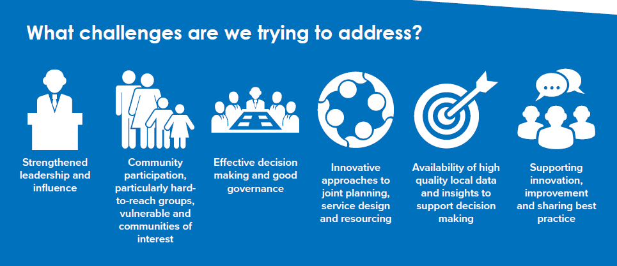 | By individual CP partners  What do partners need to do within their own organisations to facilitate and effect change?  Within local partnerships  What do CPPs need to do to drive change?  By the CPIB  What do we collectively, as a board, need to do to try and influence and effect change at a national level?
Aug 2021 |  | Climate change & sustainability
Oct 2021 |  | Promoting Children & Young People’s life chances
Feb 2022 |  | Mental health and wellbeing
May 2022 |  | Place
Aug 2022 |  | Income and Employment
Nov 2022 |  | Economic Recovery

