Terms of reference: For 2 connected anchors: Enable a functioning, trusted local and central government relationship and Unlocking Community Action

1. Purpose
Following the Delivering a future for Scottish Local Authorities think piece paper which proposes a new approach for the future operating model of Scottish local authorities, each of the anchors in the report have been assigned a CEO sponsor from within the Chief Executive Working Group. The role of the sponsor along with identified colleagues involved in the work will be to provide strategic direction and leadership to ensure that work is aligned with the direction of travel set out within the report.

There will be a sponsor for each of the six anchors in the report and to provide increased resilience for the delivery phase of the work, we have paired up connected anchors. It is recognised that each anchor is not exclusive, and work will intersect therefore a significant role for the sponsor and colleagues supporting the work will be to identify and highlight interdependencies with anchor leads and refer to the Oversight Group when appropriate. Furthermore, there will be support from the IS as a PMO approach will be in place to support the work under each anchor. This will allow the IS to be the conduit of consistency of the transformation work to ensure the alignment with the six anchors; there is a consistent approach taken to areas of work to ensure evidence-based decisions are taken on projects; interdependencies can be identified across the work; and learning is shared across each of the project and programme areas.

Already the inter-connectedness between the 2 anchors, involving re-establishing the relationship between local and central government and strengthening and re-balancing of the relationship between local government and citizens, has been established.

2. Scope
As set out in the Think Piece paper, the anchor “Enable a functioning, trusted local and central government relationship” is concerned with the need to reset the relationship between local and central government, utilising the strengths of both spheres of government to navigate the transitions society faces. Councils are well placed to both understand the local context and translate ambitious national aspiration into effective local action for their communities.

A true local and Scottish government partnership plays to the strengths of both, taking the benefits of scale, democratic accountability, and financial efficiencies from centralisation, with the deep understanding of local needs, place making, and the unique context of local government. Eroding what local government can do leaves little room to make the most of its assets, relationships, nuance, and context. Centralised policymaking would be blind without it.

As set out in the Think Piece paper, the anchor unlock community action is focused on strengthening and rebalancing the relationship between Local Government and citizens. Developed over many years there are a number of successful examples across Scotland. During the pandemic, this was further expanded and new models were tested, working with not just for communities, and amplifying the impact of work through existing community networks and initiatives.
The focus of these 2 inter-connected anchors’ will be on considering:
- What functions should local government be responsible for delivering in the current landscape of devolved government in Scotland ensuring VFM is achieved at both national and local level?
- Of the functions deemed necessary to be delivered at a local level, what different boundaries exist for the concept of “local”, reconciling between the communities which people identify with and boundaries which maximise VFM?
- Of the functions deemed to be necessary to be delivered at a local level, what scope is there for communities to be in direct control of community designed responses as an alternative to state (national or local) designed and delivered services?’ What are the required skills and capacities required within the community and within councils to encourage this approach?
- Revisiting the extent of collaboration being undertaken in terms of Commodities C and C 1 identified within the John McClelland CBE Review of Public Procurement in Scotland: Report and Recommendations and whether the collaboration is taking place at the right sphere of government and place
- In a relationship between Scottish Government and Local government founded on mutual trust and respect, how can the current approach to audit, inspection and regulation evolve to achieve the vision set out in the Crerar Review, including the strengthening of local accountability to local communities?

From the aforementioned exploration, a new form and function model for local government will emerge, which is subject to a different paradigm of independent regulation, inspection and audit and has an enhanced focus on local accountability to local communities for the services that are best delivered locally with local accountability

3. Anchor Sponsors
Monica Patterson, Chief Executive East Lothian Council (Anchor 1) and Angela Scott, Chief Executive, Aberdeen City Council (Anchor 3)

4. Roles and Responsibilities
The role of the anchor sponsor was agreed at Solace on 3 January 2023.

- Commitment to uphold the integrity of the think piece and adhere to the principles set out in this paper.
- Active engagement through a personal commitment to attend and participate in meetings/events.
- Promotion of existing plans / ways of working within own local authority that could feed into this programme of work to develop opportunities for collaboration.
- Secure the necessary service specific expertise from professional associations and/or councils.
- Ensure availability of all relevant data (held within own local authority) to enable effective functioning of the PMO and the Chief Executive Working Group

The sponsor will form a community of interest to support the delivery of the ambitions of the anchor. It is envisaged that the roles and responsibilities will develop as the projects under the anchor develop but it is envisaged that the group will:

- Work to foster collaboration across local government.
- Will remove obstacles to the successful delivery of the projects under the anchor.
- Maintain the focus of the group on the agreed scope, outcomes, and benefits of the anchor in line with the Think Piece paper.
- Champion the work under the anchor and the wider Think Piece across local government and wider.
- Escalate risks, issues, and interdependencies as appropriate.
- Ensure that right support is in place for those involved in any projects to gather the necessary data and information, this may mean that the group identify where the IS PMO can support the information gathering or may mean that any issues are escalated to the Oversight Group as per the agreed governance arrangements.
- Ongoing progress monitoring to ensure the ambitions of the work is being realised.

5. Projects
As at the point of the national “call to action “by SOLACE, areas of work that have been identified for this anchor are:

- A review of all statutory duties of councils against the duties and obligations on Scottish Government and the full range of public bodies in order to identify opportunities for maximising the financial benefits from a “once for Scotland” model, “once for the region” model or “once for the place” model as well maximising opportunities to improve services
- A review of the actual progress make against “The Crerar Review: The report of the independent review of regulation, audit, inspection and complaints handling of public services in Scotland” in order to reinvigorate the consideration of a proportionate model of independent examination which is affordable and is clear in its assumptions of the responsibilities of public sector leaders for creating self-improving systems underpinned by a sector owned architecture for supporting improvement including peer led reviews.
- A review of the untapped opportunities for further collaboration on commodities classified as C & C1 within the original McCllelland Review and to explore what is the appropriate scale at which the collaboration would maximise the benefits at.
- Development of a repository of examples of Active Communities which are leading the design of alternative community service delivery as alternatives to the responses provided by local government.
- Development of a repository of examples of how local authorities are developing the skills/capacities of staff to work alongside communities & how they and others are supporting communities to develop their skills/capacities. This will include a focus on the different ways communities are structuring themselves to take on design/delivery of community solutions.

As the work progresses this section along with associated deliverables will be further developed.

6. Timeframes
Phase 1 – Creating the Conditions/Foundations (short-term)  Now to March 24 | Phase 2 – Establishing a Delivery Framework (medium-term) | Phase 3 – Delivering new models  (long-term)
1. Placement of services closest to citizen and citizens in control of community designed responses
Complete an analysis of local government’s responsibilities, including the identification of specific statutory duties and the associated regulation and inspection frameworks

Develop a prototype showing proposals for the re-location of services between national and local level and where services could be community led at local level
2. The full implementation of Crerar for Local Government
Using the analysis above, identify the associated regulation and inspection frameworks in place against all responsibilities to quantify the level of “supervision” of the management of local government which is in place

Develop a prototype sector-led improvement model, with key components including self-evaluation, peer led review and the Local Government Benchmarking Framework.
3. Collaboration within the local government sector on procurement  Complete an analysis of current Commodity C across the sector, with a view to identifying opportunities for collaboration as well as barriers to collaboration | Develop a prototype of regional collaborative models for specific commodity C’s as well as options for an “all 32 “ model | Timelines will vary depending on whether proposal is for regional/whole sector collaboration.  Will identify a pipeline of opportunities and bring these forward for decision making within 24/25
3. Development of community-based alternative’s to statutory services
Develop a repository of examples of Active Communities which are leading the design of alternative community service delivery as alternatives to the responses provided by local government.

Develop a repository of examples of how local authorities are developing the skills/capacities of staff to work alongside communities & how they and others are supporting communities to develop their skills/capacities.

7. Governance
As agreed at Solace on28th April 2023, the governance from the work will be as follows. The anchor sponsor will be part of the Chief Executive Working Group and therefore will be able to feed in risks, issues, interdependencies, and update on progress made by the group.

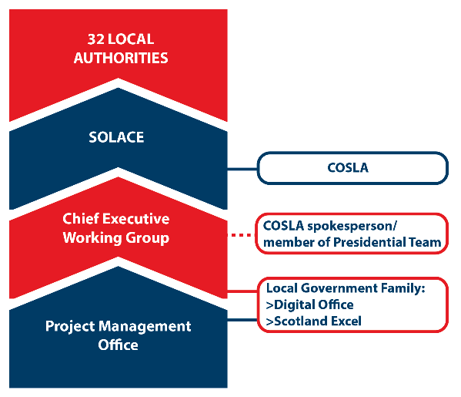

8. Deliverables
Establishment of a community of interest to drive the ambition of the anchor and wider Think Piece. This will include.
- Championing the work.
- Driving the projects that will support the anchor.
- Working to identify interdependencies and work with other anchor sponsors where appropriate.
- Ensure appropriate progress monitoring takes place.
- Identify local opportunities that could feed into the work.
- Working closely with the IS PMO to ensure that progress reporting including risks, issues, interdependencies are completed when required to ensure there is consistency across each anchor.

- The Scrutiny Coordination Group (SCG), formerly the Operational Scrutiny Group (OSG) promotes collaboration and shared learning amongst Scotland’s main public-sector scrutiny bodies with a view to improving services for the people of Scotland. The Terms of Reference for this group are being refreshed and there is reference to Crerar within it. Therefore this Blueprint workstream , via Kenneth Lawrie SOLACE portfolio lead for Audit, Inspection & Regulation , will need to have an interface with the (SCG) as we explore scope for undertaking some pilots

