Glasgow Community Planning Partnership Performance Management Framework: IS Approach to Development
Introduction
The Improvement Service (IS) has worked alongside officials from Glasgow City Council (GCC) and with the wider Glasgow Community Planning Partnership (GCPP) on the Glasgow Pathfinder Programme since 2022. Over the course of the next few years, the importance of the Community Planning Partnership’s participation in the Pathfinder increased. In 2024 the GCPP published their Local Outcomes Improvement Plan (LOIP) for the next 10 years, in which they committed to developing a new Performance Management Framework (PMF). The LOIP stated: “Partners will work together to develop this approach to ensure that performance monitoring has a clear purpose, is outcome based and efficient.”
The IS Public Service Reform (PSR) team, following our close involvement on the Pathfinder since 2022, were asked to lead the GCPP through a robust methodology and process for a creating a new Performance Management Framework (PMF).
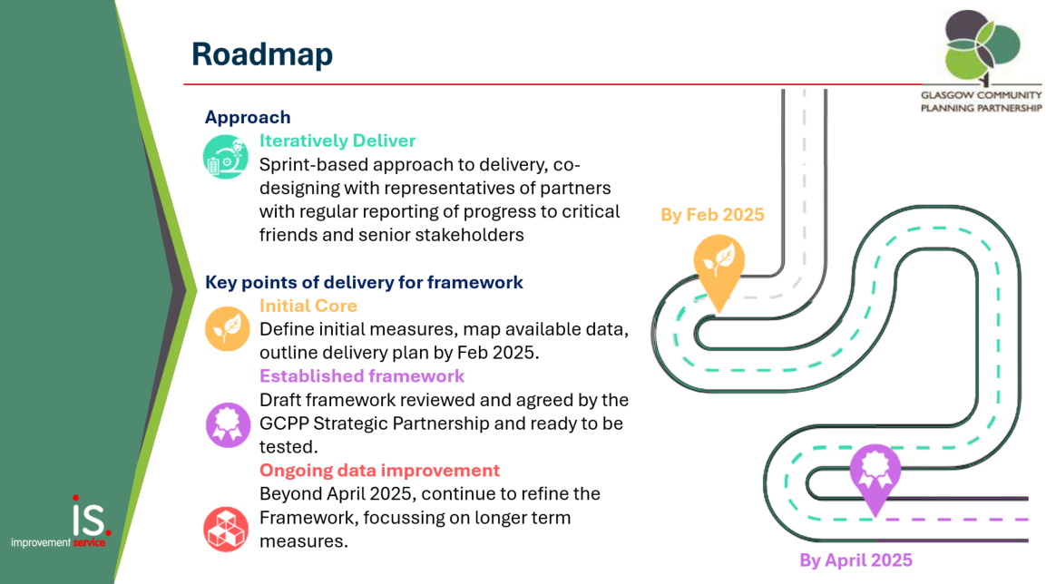
Work moved at significant pace over a six-month period and made use of an agile approach, loosely based on Dynamic Systems Development Methodology (DSDM). This uses a process of ongoing iteration and rapid development based on core principles including building incrementally from firm foundations, collaboration, continuous and clear communication, timely delivery, and a focus on quality.
Figure 1: Roadmap of Delivery for the Development of the GCPP PMF.
Context
In February 2024, the Glasgow Community Planning Partnership (GCPP) set a bold vision when it approved a ten-year Local Outcome Improvement Plan (LOIP) with a single priority commitment, – for city partners to address ‘Family Poverty – Reducing Poverty and Inequalities in Glasgow’s Communities’.

The LOIP tasked the GPCC with creating a Performance Management Framework to effectively measure progress towards its goals. In June 2024, the GCPP reaffirmed their commitment to re-shape the approach used to demonstrate impact, ensuring accountability was measured appropriately for the shared vision. It was agreed that the core elements of a Framework should go beyond existing siloed reporting structures and should capture:
- a broad range of activity that will make a difference for communities;
- the voice of our communities; and
- the extent of partnership working to facilitate change.

The GCPP were steadfast in their commitment to create a Performance Management Framework that did not rely solely on statistics. While quantitative measures were important for describing impact and informing future work, they were complemented by qualitative insights to guide action and promote change. The Partnership recognised that these measures needed to evolve over time, allowing the framework to mature alongside their collaborative efforts and culture of learning.

Despite the commitment to taking a new approach to evidencing progress, it was unclear what process would be followed to go from a blank sheet of paper into a robust Measurement Framework – this is where Improvement Service were able to step in and help.

The Approach
In Theory
The IS team adopted an agile approach, drawing inspiration from Dynamic Systems Development Methodology (DSDM). This used a process of ongoing iteration and rapid development based on core principles including; building incrementally from firm foundations, collaboration, continuous and clear communication, timely delivery and a focus on quality
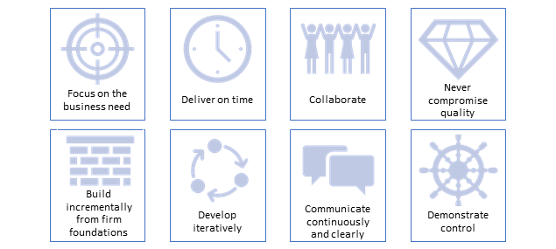
Figure 2: Dynamic Systems Development Methodology (DSDM) Principles.

In Practice
The GCPP LOIP was already in place and set the basis for this development piece of work when it began. This allowed the team to use the principles, themes and priorities set out in the LOIP as a starting point for the development of a PMF and allowed the group to work from first principles up.
A group of ‘co-designers’ representing GCPP partners were identified to undertake the detailed work to shape the Framework using a series of intensive IS and GCC facilitated ‘sprints’. Three separate blocks of ‘sprints’ were undertaken between September 2024 and February 2025, and each six-week sprint consisted of 3 workshops, held 2 weeks apart with tasks for the co-designer group in between.
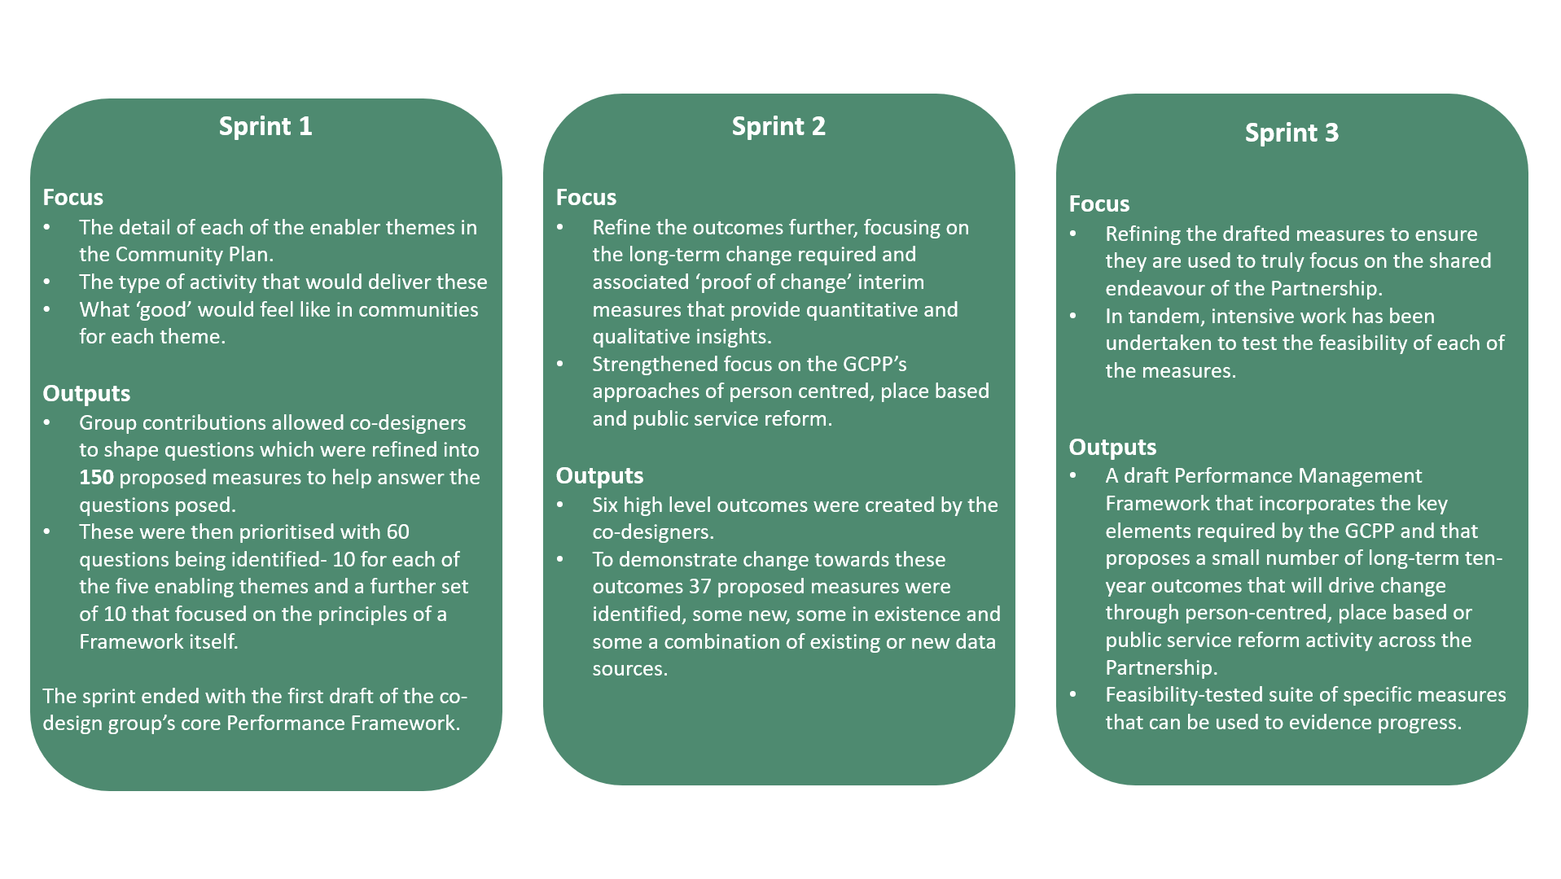
The Framework developed incrementally as co-designers, including partner staff with detailed data expertise, have shaped, tested, learned and refined. These are summarised below.
Figure 3: Summary of the focus and output of each of the 3 sprint sessions.
In turn, the co-designers were supported by a ‘Critical Friend’ group, comprising of strategic leaders and decision makers from across the partnership, who provided the opportunity to secure input on progress, challenges and barriers and affords the space to reinforce or reset as appropriate. At the end of each of the three sprints, IS facilitated a meeting of this group; during which time they had the opportunity to provide strategic oversight and guidance as the PMF was being developed; ensuring that it remained in line with the shared vision set out in the LOIP.
At the end of the process facilitated by IS, a draft Performance Management Framework was agreed by the GCCP Strategic Partnership, the most senior forum in the GCPP, and will be piloted, tested, and refined further from April 2025. The final drafted Framework incorporates both a small number of long-term ten-year outcomes as well as feasibility-tested specific measures that would evidence progress.
Learnings
The commitment of GCPP colleagues to adopting this methodology was vital to the success of the agile approach, enabling rapid, iterative consideration of ideas and development. The dedicated project and administrative support provided by IS was essential in capturing, processing, and swiftly distilling feedback for the group. Maintaining discipline in refining over 1,000 inputs over the course of the process into meaningful and measurable outputs was also crucial to ensuring clarity and focus as the sprints progressed. Furthermore, having a clear vision from the outset was fundamental in guiding the process and keeping efforts aligned with the overall objectives, further supported by the independent Critical Friend Group.
Summary
The approach applied by IS to develop the PMF required partners to embrace and co-design a new way to measuring success. Through the support of the IS, both the co-design group and the Critical Friend Group were encouraged, supported and challenged to think and act differently. During the facilitated sprints, IS guided the co-design team through the process from identifying over 1,000 inputs to distilling these into clear, measurable outcomes. Due to the unique position of IS in this work, feedback was able to be captured, refined and fed back into the process. By coordinating the Critical Friend Group, IS were also able to ensure that PMF remained aligned with the single priority outlined in the LOIP and set a robust foundation to build upon.
Although not without its challenges, everyone involved welcomed the approach, recognising it as an opportunity to re-image how GCPP demonstrates success. The success of the initiative relied on those involved in the development being fully committed to the approach by dedicating the appropriate time and capacity to the process, and on the complete commitment of each GCPP organisation.

